Senior Project Report
Nway’s Love Vet Clinic Management System

Htin Aung Lynn (6726116)
Kyaw Zayar Lin (6726118)
May Myat Bhone Shwe (6632720)

Asst. Prof. Dr. Darun Kesrarat (Advisor)

ITX3009/CSX3010 Senior Project 1 (1/2025)
Senior Project Approval

Project title: Nway’s Love Vet Clinic Management System

Academic Year: 1/2026

Authors: Htin Aung Lynn (6726116)
Kyaw Zayar Lin (6726118)
May Myat Bhone Shwe (6632720)

Project Advisor: Asst. Prof. Dr. Darun Kesrarat

The Senior Project committee’s cooperation between the Department of Computer Science and Information Technology, Vincent Mary School of Engineering, Science and Technology, Assumption University had approved this Senior Project. The Senior Project in partial fulfilment of the requirement for the degree of Bachelor of Science in Computer Science and Information technology.

Approval Committee:

…………………………..
(Asst. Prof. Dr Darun Kesrarat)
Project Advisor

…………………………..  (A. Jinchun Lu)  Committee Member |  | …………………………..  (Dr. Shujaat Ali Zaidi)  Committee Member

Abstract

Nway’s Love Vet Clinic – Pet Clinic Management Application is a proposed digital management system designed to improve the daily operations of Nway’s Love Vet Clinic (နွေးမေတ္တာ တိရစ္ဆာန်ဆေးကုခန်း). The clinic has provided veterinary healthcare services for more than seven years and officially reached its seventh anniversary on 25 April 2026. As clinic services expand, manual processes for appointments, medical records, vaccinations, inpatient care, laboratory tests, grooming services, product sales, and inventory management can become difficult to maintain consistently.
The proposed system centralizes major clinic activities into web application. Pet owners can use the client-facing application to book appointments, manage pet profiles, review relevant information, and receive reminders. Veterinarians can access medical records, document diagnoses and treatments, and manage digital prescriptions. Clinic staff can manage queues, grooming and spa services, inventory, product sales, records, and reports. Administrators are responsible for user management and overall system access.
The proposed technology stack consists of Flutter for the application interface, Node.js for backend services and API logic, MySQL and Neon for database management, and Figma for UI/UX design. The system is intended to reduce paperwork, organize information, minimize manual errors, improve communication, and provide a more structured workflow for both clinic personnel and pet owners.

TABLE OF CONTENTS
Abstract 3
Chapter 1: Project Overview 10
1.1 Introduction 10
1.2 Clinic Information 10
1.3 Problem Statement 11
1.4 Scope of the Project 11
1.5 Objectives 12
Chapter 2: Related Work and System Context 13
2.1 Current Operational Context 13
2.2 Need for a Centralized System 13
Chapter 3: Proposed Methodology 14
3.1 Methodology 14
3.2 Solving the Problem 14
3.3 Building the System – Key Features 15
3.4 Technology and Architecture 16
3.5 ROI Analysis 16
Chapter 4: Design of the System 16
4.1 Functional Requirements Specification 16
4.1.1 Stakeholders 17
4.1.2 Actors and Responsibilities 17
4.1.3 Use Cases 17
4.2 System Design 22
4.2.1 Data Flow / Workflow 22
4.2.2 Entity Relationship Diagram 35
4.2.3 Class Diagram 44
4.2.3.1 Supporting Classes 44
4.2.3.2 Appointments and Clinical Operations 45
4.2.3.3 Users, Pets and Booking 46
4.2.3.4 Communication and Administration 47
4.2.4 Data Dictionary 51
4.3 System Architecture 65
4.4 Technology Used 66
4.5 Site / Navigation Structure 68
4.6 UX/UI Design 71
4.6.1 Login 72
4.6.2 Main UI Design of Pet Owners Side 73
4.6.2.1 My Pets 73
4.6.2.2 Clinic Page 74
4.6.2.3 Booking Processes 75
4.6.2.4 Product Page (Pet Owners) 79
4.6.2.5 Profile Page (Pet Owners) 81
4.6.3 Main UI Design of Doctor Side 83
4.6.3.1 Dashboard 83
4.6.3.2 Write a Post and Manage Posts 84
4.6.3.3 Appointments 86
4.6.3.4 Profile 87
4.6.4 Main UI Design of Staff Side 89
4.6.4.1 Dashboard 89
4.6.4.2 Management 91
4.6.4.3 Appointments, Home Visit & Emergency Cases 92
4.6.4.4 Inventory 95
4.6.4.5 Medical Records 97
4.6.5 Main UI Design of Admin Side 98
4.6.5.1 Dashboard 98
4.6.5.2 Management 100
4.6.5.3 Users and Roles 101
Chapter 5: Result and System Demonstration 102
5.1 Functionality Overview 102
5.2 Authentication View 103
5.3 Pet Owner Home View 103
5.4 Appointment View 103
5.5 Pet Profile and Medical Record View 103
5.6 Vaccination and Reminder View 104
5.7 Queue and Emergency View 104
5.8 Home Visit View 104
5.9 Billing and Payment View 104
5.10 Product and Inventory View 105
5.11 Reporting View 105
5.12 Veterinarian View 105
5.13 Clinic Staff Dashboard 106
5.14 Admin Dashboard 106
5.15 Expected Benefits 106
Operational Benefits 107
Benefits for Pet Owners 107
Benefits for Clinic Staff and Veterinarians 107
Chapter 6: Conclusion 107
6.1 Achievements 107
6.2 Future Work 108
6.3 Conclusion 108
Chapter 7:References 109

TABLE OF FIGURES
Figure 1: Use Case Diagram (Pet Owner) 18
Figure 2: Use Case Diagram (Staff) 19
Figure 3: Use Case Diagram (Doctor) 20
Figure 4: Use Case Diagram (Admin) 21

Figure 5: DFD for User Login and Role-Based Access 22
Figure 6: DFD for Password Recovery 23
Figure 7: DFD for Profile, Security, and
Notification Settings 23
Figure 8: DFD for Pet Profile Management (Pet Owner) 24
Figure 9: DFD for Appointment Booking and Tracking
(Pet Owner) 24
Figure 10: DFD for Queue Status and Queue History
(Pet Owner) 25
Figure 11: DFD for Home Visit Booking and Tracking
(Pet Owner) 25
Figure 12: DFD for Emergency Service Request and
Tracking (Pet Owner) 25
Figure 13: DFD for Pet-Care Service Booking (Pet Owner) 26
Figure 14: DFD for Pet Reminder Management (Pet Owner) 26
Figure 15: DFD for Medical and Treatment History
Viewing (Pet Owner) 27
Figure 16: DFD for Products and Clinic Information
Viewing (Pet Owner) 27
Figure 17: DFD for Doctor Appointment and Queue Management 28
Figure 18: DFD for Doctor Consultation and
Medical Record Update 28
Figure 19: DFD for Doctor Emergency and Home-Visit Handling 28
Figure 20: DFD for Doctor Health-Post Management 29
Figure 21: DFD for Doctor Profile, Credentials,
and Availability 29
Figure 22: DFD for Staff Appointment and Walk-In Management 30
Figure 23: DFD for Staff Live Queue Management 30
Figure 24: DFD for Staff Patient and Medical Record
Management 31
Figure 25: DFD for Staff Inventory Management 31
Figure 26: DFD for Staff Emergency and Home-Visit
Coordination 32
Figure 27: DFD for Staff Payment Management and Reporting 32
Figure 28: DFD for Staff Messaging 33
Figure 29: DFD for System Administrator User and
Role Management 33
Figure 30: DFD for System Administrator Doctor Verification 34
Figure 31: DFD for System Dashboard, Alerts, Reports,
and Audit Logs 34

Figure 32: ERD for Accounts and Access Diagram 36
Figure 33: ERD for Pets and Booking Diagram 37
Figure 34: ERD for Clinical Operations Diagram 38
Figure 35: ERD for Content, Communication, and
Administration Diagram 39

Figure 36: Supporting Class Diagram 44
Figure 37: Supporting Class Diagram Detail 1 44
Figure 38: Supporting Class Diagram Detail 2 44
Figure 39: Appointments and Clinical Operations
Class Diagram 45
Figure 40: Appointments and Clinical Operations
Class Diagram Detail 1 45
Figure 41: Appointments and Clinical Operations
Class Diagram Detail 2 46
Figure 42: Users, Pets and Booking Class Diagram 46
Figure 43: Users, Pets and Booking Class Diagram Detail 1 47
Figure 44: Users, Pets and Booking Class Diagram Detail 2 47
Figure 45: Communication and Administration Class Diagram 48
Figure 46: Communication and Administration
Class Diagram Detail 1 48
Figure 47: Communication and Administration
Class Diagram Detail 2 49

Figure 48: System Architecture Diagram 65
Figure 49: Sitemap Diagram 68
Figure 50: Sitemap Diagram Detail 1 (Pet Owner) 68
Figure 51: Sitemap Diagram Detail 2 (Staff) 69
Figure 52: Sitemap Diagram Detail 3 (Doctor) 70
Figure 53: Sitemap Diagram Detail 4 (Admin) 71

Figure 54: Login – Screen 1 72
Figure 55: My Pets – Screen 1 73
Figure 56: My Pets – Screen 2 73
Figure 57: Clinic Page – Screen 1 74
Figure 58: Clinic Page – Screen 2 74
Figure 59: Booking Processes – Screen 1 75
Figure 60: Booking Processes – Screen 2 75
Figure 61: Booking Processes – Screen 3 76
Figure 62: Booking Processes – Screen 4 76
Figure 63: Booking Processes – Screen 5 77
Figure 64: Booking Processes – Screen 6 77
Figure 65: Booking Processes – Screen 7 78
Figure 66: Booking Processes – Screen 8 78
Figure 67: Product Page (Pet Owners) – Screen 1 79
Figure 68: Product Page (Pet Owners) – Screen 2 79
Figure 69: Product Page (Pet Owners) – Screen 3 80
Figure 70: Profile Page (Pet Owners) – Screen 1 81
Figure 71: Profile Page (Pet Owners) – Screen 2 81
Figure 72: Profile Page (Pet Owners) – Screen 3 82

Figure 73: Dashboard – Screen 1 83
Figure 74: Dashboard – Screen 2 83
Figure 75: Write a Post and Manage Posts – Screen 1 84
Figure 76: Write a Post and Manage Posts – Screen 2 84
Figure 77: Write a Post and Manage Posts – Screen 3 85
Figure 78: Appointments – Screen 1 86
Figure 79: Profile – Screen 1 87
Figure 80: Profile – Screen 2 88

Figure 81: Dashboard – Screen 3 89
Figure 82: Dashboard – Screen 4 90
Figure 83: Management – Screen 1 91
Figure 84: Appointments, Home Visit &
Emergency Cases – Screen 1 92
Figure 85: Appointments, Home Visit &
Emergency Cases – Screen 2 92
Figure 86: Appointments, Home Visit &
Emergency Cases – Screen 3 93
Figure 87: Appointments, Home Visit &
Emergency Cases – Screen 4 93
Figure 88: Appointments, Home Visit &
Emergency Cases – Screen 5 94
Figure 89: Inventory – Screen 1 95
Figure 90: Inventory – Screen 2 96
Figure 91: Medical Records – Screen 1 97

Figure 92: Dashboard – Screen 5 98
Figure 93: Dashboard – Screen 6 99
Figure 94: Management – Screen 2 100
Figure 95: Users and Roles – Screen 1 101
Figure 96: Users and Roles – Screen 2 102

TABLE OF TABLES
Table 1: Clinic Information 11
Table 2: Stakeholders 17
Table 3: Actors and Responsibilities 17
Table 4: ERD Diagram 42
Table 5: ERD Diagram Relationship 44
Table 6: Class Diagram 51

Table 7: App_Accounts Data Dictionary 52
Table 8: Owner_Profiles Data Dictionary 52
Table 9: Doctor_Profiles Data Dictionary 52
Table 10: Staff_Profiles Data Dictionary 52
Table 11: Admin_Profiles Data Dictionary 53
Table 12: Pets Data Dictionary 53
Table 13: Appointments Data Dictionary 54
Table 14: Queue_Entries Data Dictionary 54
Table 15: Walk_In Data Dictionary 54
Table 16: Home Visit Data Dictionary 55
Table 17: Emergency_Requests Data Dictionary 55
Table 18: Pet_Care_Bookings Data Dictionary 56
Table 19: Medical_Records Dictionary 56
Table 20: Payments Data Dictionary 57
Table 21: Inventory Data Dictionary 57
Table 22: Reminders Data Dictionary 57
Table 23: Notification_Settings Data Dictionary 58
Table 24: Owner_Notifications Data Dictionary 58
Table 25: Appointment_Reminders Data Dictionary 59
Table 26: Health_Posts Data Dictionary 59
Table 27: Health_Posts_Drafts Data Dictionary 59
Table 28: Clinic_Messages Data Dictionary 60
Table 29: Doctor_Notifications Data Dictionary 60
Table 30: Support_Tickets Data Dictionary 60
Table 31: History_Reviews Data Dictionary 61
Table 32: Saved_First_Aid_Guides Data Dictionary 61
Table 33: Clinic_Directory Data Dictionary 61
Table 34: Password_Reset_Codes Data Dictionary 62
Table 35: Password_Reset_Audit Data Dictionary 62
Table 36: Device_Tokens Data Dictionary 62
Table 37: App_Sessions Data Dictionary 63
Table 38: Doctor_Verifications Data Dictionary 63
Table 39: Audit_Logs Data Dictionary 63
Table 40: Doctor_Appointment_State Data Dictionary 64
Table 41: Queue_Daily_Counters Data Dictionary 64
Table 42: Technology Used 66

Chapter 1: Project Overview

1.1 Introduction
The Pet Clinic Management Application is a digital veterinary management system developed for Nway’s Love Vet Clinic (နွေးမေတ္တာ တိရစ္ဆာန်ဆေးကုခန်း). The purpose of the system is to improve clinic operations and provide better healthcare service management for pets.
Nway’s Love Vet Clinic has been providing veterinary healthcare services for more than seven years and officially reached its seventh anniversary on 25 April 2026. As the clinic continues to expand its services, managing appointments, doctor schedules, pet medical records, vaccination information, inpatient care, laboratory results, grooming services, products, and inventory through manual processes can require considerable time and effort.
The proposed application digitalizes these activities and provides a centralized platform for pet owners, veterinarians, clinic staff, and administrators. The system is designed to support appointment booking, pet profile management, medical record management, queue management, emergency handling, home visits, products, inventory management, and reporting.
The system also aims to improve communication between the clinic and pet owners. Instead of depending mainly on paper records and repeated manual communication, important information can be organized digitally and accessed according to the user's role.

1.2 Clinic Information

Table : 1 Clinic information
Information | Details
Client Name | Nway’s Love Vet Clinic  (နွေးမေတ္တာ တိရစ္ဆာန်ဆေးကုခန်း)
Business Type | Veterinary Clinic
System Type | Web Application
Clinic Experience | 7 Years
Opening Hours | 9:00 AM – 12:00 PM / 4:00 PM – 7:00 PM
Operating Days | Open Daily
Official Facebook | နွေးမေတ္တာ-Vet Clinic  https://www.facebook.com/share/1D8rTb62Ke/?mibextid=wwXIfr
Location | Chinwin Street, Mingalar Dipa Quarter, Pobba Thiri Township, Naypyidaw, Myanmar

The operating schedule and service information above are based on the client information provided for this project.

1.3 Problem Statement

The clinic currently faces several operational challenges associated with manual management processes. These challenges can affect the speed of service, consistency of records, and the ability of staff to coordinate different clinic activities.
· Manual appointment booking process.
· Difficulty managing doctor schedules and available time slots.
· Long waiting times for customers.
· Paper-based pet medical records.
· Risk of losing pet medical history and treatment records.
· Difficulty tracking vaccination schedules.
· No centralized reminder and notification system.
· Difficulty managing inpatient and day-care services.
· Manual recording of laboratory test results.
· Increased workload for clinic staff.
· Difficulty managing home-visit services.
· Manual inventory and product management.
· Limited communication between clinic staffs and pet owners.

1.4 Scope of the Project

The scope of the Nway’s Love Vet Clinic Management System covers the development of a mobile and web-based application designed to support the main operational activities of the veterinary clinic. The system focuses on organizing clinic information, reducing manual work, and providing different functions according to the responsibilities of each user.
The system includes the following major areas:
- Appointment management, including appointment booking, cancellation, and rescheduling.
- Doctor schedule management and assignment based on treatment requirements.
- Queue management for normal and emergency cases.
- Emergency case handling, including priority over the normal queue.
- Home-visit management for eligible treatments.
- Pet profile management and digital medical records.
- Vaccination tracking and vaccination due-date management.
- Appointment and vaccination reminders.
- Billing and digital invoice management.
- Laboratory result recording.
- Grooming and spa service management.
- Product sales management for medicine, pet food, and accessories.
- Inventory management, including stock levels, expiry dates, and low-stock alerts.
- Reporting, including appointment, emergency, vaccination, service, sales, and inventory reports.
- Excel export for supported reports.
- Announcement and information-sharing functions.
- Role-based access for Pet Owners, Veterinarians, Clinic Staff, and Administrators.
The system is intended to provide a centralized platform where clinic personnel can manage operational information while pet owners can access relevant services and pet information. The proposed scope is based on the modules and functions identified in the project requirements. Senior Project

1.5 Objectives

· Digitalize clinic management operations.
· Simplify appointment booking processes.
· Manage pet medical records systematically.
· Improve communication between clinic staff and pet owners.
· Provide vaccination and appointment reminder systems.
· Reduce paperwork and manual errors.
· Improve doctor schedule management.
· Support inpatient and treatment management.
· Manage pet products efficiently.
· Improve overall clinic service quality and customer satisfaction.

Chapter 2: Related Work and System Context

2.1 Current Operational Context
Nway’s Love Vet Clinic currently handles several important clinic activities that require coordination between clinic staff, veterinarians, and pet owners. These activities include appointment booking, doctor scheduling, queue management, medical records, vaccination tracking, home visits, grooming and spa services, product showcase, and inventory management.
Some of these activities can require manual recording and communication. For example, appointments may initially be handled through phone calls or walk-in requests, while medical information and other clinic records may require staff to enter and update information manually. The clinic also needs to coordinate doctor availability because doctors have rotational off days and assignments may depend on the treatment or operation required.
The clinic also needs to manage different types of cases. Normal cases follow a first-come-first-served queue, while emergency cases can receive priority. Home-visit services are also available for certain treatments during the defined service period from 12:00 to 14:00.
In addition, pet healthcare information needs to be maintained over time. Medical records contain information such as breed, age, weight, and medical history, while vaccination records include vaccination information and the next vaccination date. The system therefore needs to provide authorized clinic personnel with organized access to this information.

2.2 Need for a Centralized System
The existing operational challenges demonstrate the need for a centralized management system. Managing appointments, medical records, vaccination information, inventory, and other services separately can increase the amount of manual work required by clinic staff.
A centralized system can bring these activities together and allow information to be stored in a structured manner. Appointment information can be connected with pet and veterinarian information, while medical records, vaccination records, invoices, products, and inventory can be managed through related system modules.
The proposed system also uses role-based access to separate the responsibilities of different users. Pet owners can access their pet-related services, veterinarians can work with clinical information, clinic staff can manage operational activities, and administrators can manage users and system-level access. This helps ensure that each user can access the functions required for their responsibilities. Senior Project
By centralizing these activities, the system is expected to reduce paperwork, reduce repetitive manual data entry, improve information retrieval, and provide a more organized workflow for the clinic.

Chapter 3: Proposed Methodology

3.1 Methodology
The development methodology for the Nway’s Love Vet Clinic Management System is based on identifying the clinic's operational requirements and designing the system around those requirements. The development process focuses on understanding the existing workflow, identifying problems, defining system requirements, designing the system structure, and implementing the required functions.
The proposed development process can be divided into the following stages:
- Requirement Analysis
Identify the clinic's current activities, problems, stakeholders, and system requirements.
- System Design
Design the system architecture, database structure, user roles, system workflow, and main modules.
- UI/UX Design
Use Figma to design the interfaces, navigation flows, prototypes, and screen layouts before implementation.
- System Development
Develop the mobile and web interfaces, backend services, database, and required system functions.
- Testing and Evaluation
Test the implemented functions against the defined functional and non-functional requirements.
The methodology focuses on creating a system that is usable, reliable, secure, and capable of supporting the clinic's future expansion. The project requirements identify security, performance, usability, scalability, and reliability as important non-functional requirements.

3.2 Solving the Problem
The proposed system solves the clinic's operational problems by replacing fragmented manual activities with centralized digital processes. Instead of maintaining different records and handling different activities separately, the system provides connected modules for appointments, pet information, medical records, vaccinations, billing, inventory, and reporting.For appointment management, the system provides digital appointment information and supports cancellation and rescheduling. Doctor schedules can also be managed according to availability and treatment requirements. This can help staff organize available time slots and reduce scheduling difficulties. Senior Project
For medical information, the system provides digital pet profiles and medical records. Authorized clinic personnel can record and access medical information, while pet owners cannot directly modify official medical records. Vaccination information can also be recorded and used to identify upcoming vaccination requirements. Senior Project
The system also addresses operational activities such as inventory and billing. Product information can include price, stock, and expiry date, while stock levels can be monitored and low-stock alerts can be supported. Digital invoices can include consultation fees, treatment charges, and product purchases. Senior Project
Through these functions, the system aims to reduce paperwork and manual errors while improving the organization and accessibility of clinic information.

3.3 Building the System – Key Features
The Nway’s Love Vet Clinic Management System is organized into several modules. Each module focuses on a specific clinic activity while sharing information with other parts of the system.
The main features include:
- Appointment Management: Allows appointments to be booked, cancelled, and rescheduled according to clinic rules.
- Doctor Management: Supports doctor schedules and assignment based on availability and treatment requirements.
- Queue and Emergency Management: Maintains the normal queue while allowing emergency cases to receive priority.
- Home Visit Management: Manages eligible treatments provided at the pet owner's location.
- Pet Management: Stores pet profiles including breed, age, weight, and other relevant information.
- Medical Record Management: Allows authorized personnel to record diagnoses, treatments, medical history, and related clinical information.
- Vaccination Management: Records vaccination information and upcoming vaccination dates.
- Reminder System: Provides appointment and vaccination reminders.
- Billing Management: Generates digital invoices for consultation, treatment, and product charges.
- Laboratory Management: Records laboratory test results.
- Grooming and Spa Management: Supports the management of grooming and spa services.
- Product Management: Manages products such as medicine, pet food, and accessories.
- Inventory Management: Tracks stock, expiry dates, sales, and low-stock conditions.
- Reporting: Provides appointment, emergency, vaccination, service, sales, and inventory reports, with Excel export support.
- Announcement System: Provides a centralized method for sharing clinic announcements.
These features are designed to work together as one centralized system rather than as separate manual processes.

3.4 Technology and Architecture
The proposed system uses a client-server architecture consisting of the application interface, backend services, and database. This structure separates the user interface from the application logic and data storage, making the system easier to organize and maintain.

3.5 ROI Analysis
The Return on Investment (ROI) of the proposed Nway’s Love Vet Clinic Management System is mainly based on improving operational efficiency and reducing manual work. The system can reduce paperwork, improve appointment and queue management, organize medical records, provide better inventory control, and make billing and reporting more efficient.
Although the system requires costs for development, maintenance, database services, staff training, and equipment, these costs can be balanced by the long-term benefits of reducing administrative workload and improving clinic operations.Overall, the system is expected to provide long-term value by saving time, reducing manual errors, improving information management, and increasing the quality and efficiency of services provided by the clinic.

Chapter 4: Design of the System

4.1 Functional Requirements Specification
The functional requirements describe the main functions that the Nway’s Love Vet Clinic Management System should provide. The system is designed to support pet owners, veterinarians, clinic staff, and administrators by organizing the clinic’s daily operations in one centralized system.

4.1.1 Stakeholders

Table : 2 Stakeholders
Stakeholder | Description
Pet Owners | Book appointments, view pet information, receive reminders, check invoices, and access available clinic services.
Veterinarians | Manage appointments, view pet medical records, update treatment information, and handle consultations and emergencies.
Clinic Staff | Manage appointments, queues, billing, products, inventory, vaccination information, and daily clinic operations.
Administrator | Manage system users, clinic information, system data, reports, and overall system operations.

4.1.2 Actors and Responsibilities

Table : 3 Actors and Responsibilities
Actor | Responsibilities
Pet Owner | Login, manage pet profiles, book or cancel appointments, view medical information, receive reminders, and browse products.
Veterinarian | View assigned appointments, access medical records, update treatment records, manage vaccination information, handle emergency cases and announcements.
Clinic Staff | Manage appointments, queues, home visits, products and inventory, vaccination records.
Administrator | Manage/register users, system information, staff access, reports, and overall system management.

4.1.3 Use Cases

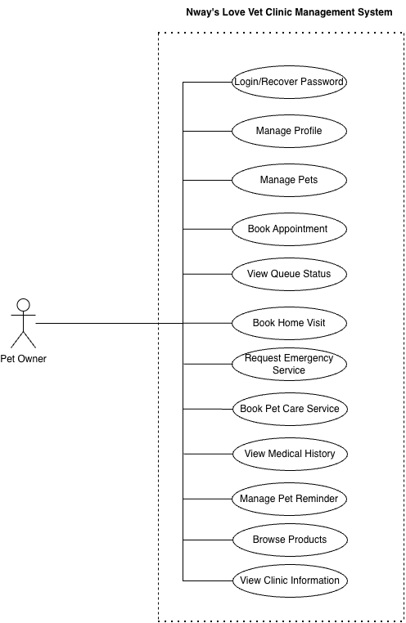
Fig : 1 Use Case Diagram (Pet Owner)
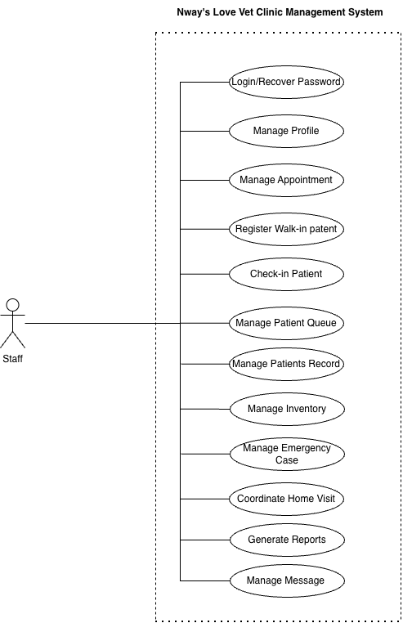
Fig : 2 Use Case Diagram (Staff)
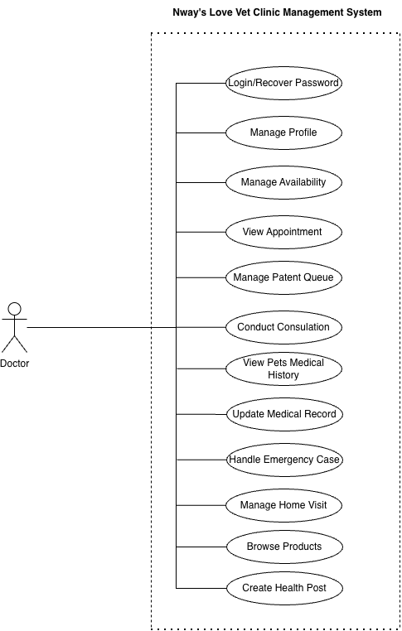
Fig : 3 Use Case Diagram (Doctor)
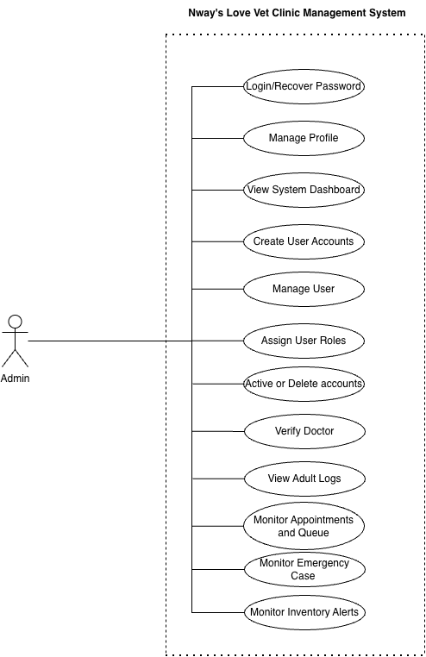
Fig : 4 Use Case Diagram (Admin)

4.2 System Design
The system design describes the structure, workflow, database, and interaction between the different components of the Nway’s Love Vet Clinic Management System.

4.2.1 Data Flow / Workflow
The general workflow of the system begins when a user logs into the application. Based on the user's role, the system provides access to the appropriate functions.
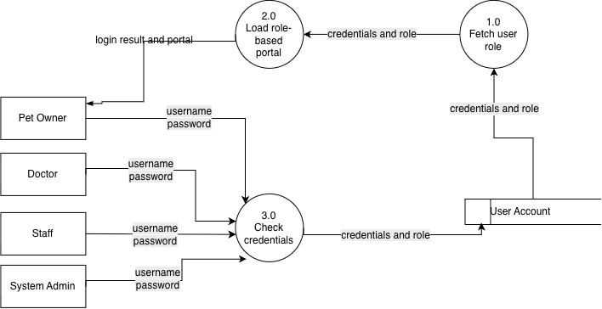
Fig : 5 DFD for User Login and Role-Based Access
A user enters a username, email, or phone number and password. The application validates the credentials against the user account data, identifies the account role and status, and opens the correct Pet Owner,Doctor, Staff, or System Admin portal.

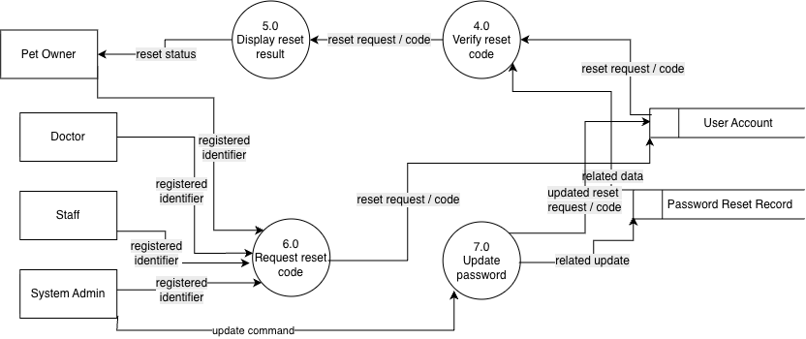
Fig : 6 DFD for Password Recovery
A user requests password recovery using a registered identifier. The system locates the account, creates and sends a reset code, verifies the submitted code, and stores the new password after successful validation.
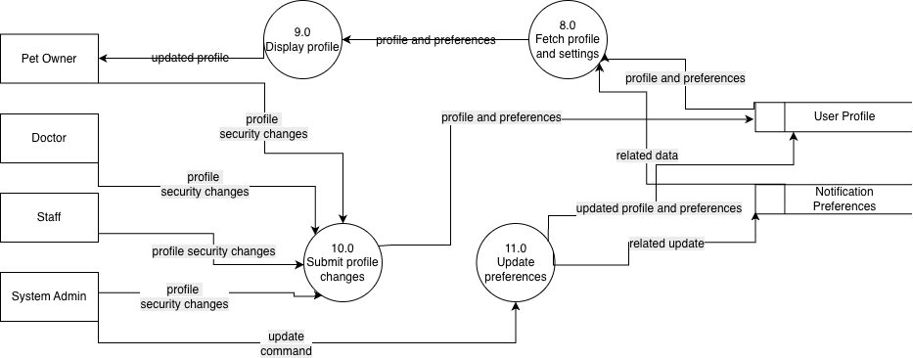
Fig : 7 DFD for Profile, Security, and Notification Settings
Authenticated users view and update their profile, photo, contact information, password, security options, and role-specific notification preferences. Validated changes are saved and returned to the account interface.
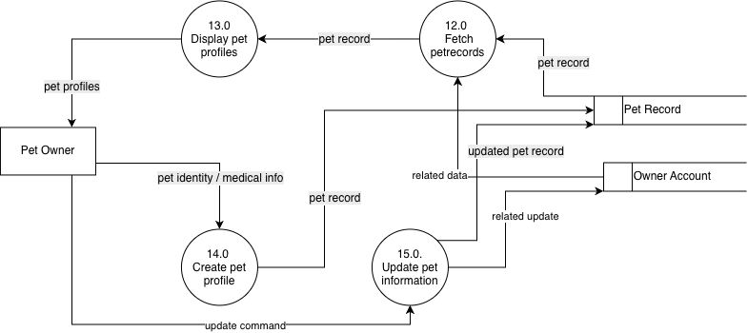
Fig : 8 DFD forPet Profile Management (Pet Owner)
The pet owner creates, views, and updates pet profiles containing the pet's name, species, breed, sex, weight, photo, vaccine information, and other medical details. Every pet record remains linked to the authenticated owner account.
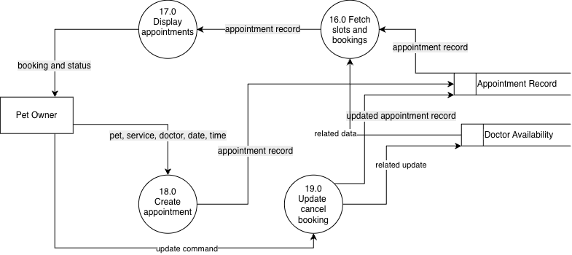
Fig : 9 DFD for Appointment Booking and Tracking (Pet Owner)
A pet owner selects a pet, service, veterinarian, date, time, and reason. The application checks doctor availability, stores the booking, and displays appointment details and subsequent confirmation, rescheduling, cancellation, or completion status.
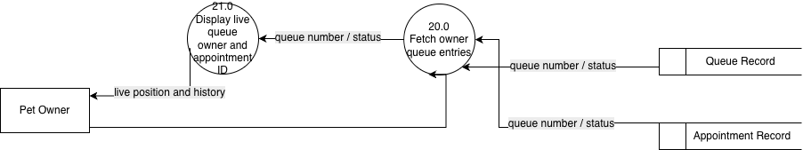
Fig : 10 DFD for Queue Status and Queue History (Pet Owner)
The pet owner opens the queue screen to retrieve active and historical queue entries linked to the owner's appointments. The application displays the queue number, service group, doctor, current status, and previous queue activity.
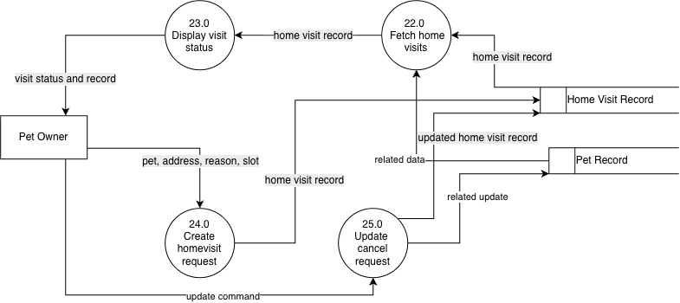
Fig : 11 DFD for Home Visit Booking and Tracking (Pet Owner)
The pet owner submits a home-visit request with the selected pet, address, contact details, reason, preferred date, and time. The system stores the request and displays assignment, progress, completion, and the resulting home-visit medical record.
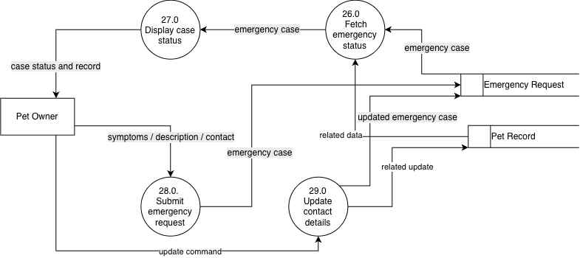
Fig : 12 DFD for Emergency Service Request and Tracking (Pet Owner)
A pet owner reports an emergency by selecting a pet and providing symptoms, a description, and contact details. The application stores the case and displays staff review, acceptance, arrival, treatment, and the completed emergency medical record.

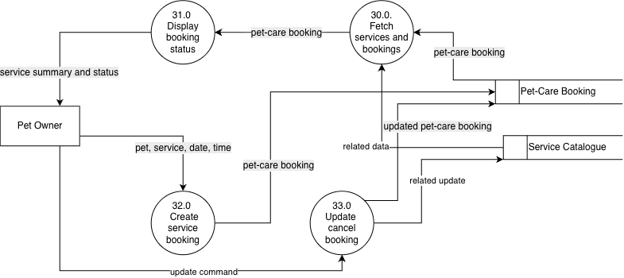
Fig : 13 DFD for Pet-Care Service Booking (Pet Owner)
The pet owner selects a grooming, bathing, nail-trimming, boarding, or wellness service and submits the pet, date, and time information. The system stores the service booking and returns its summary and current status.
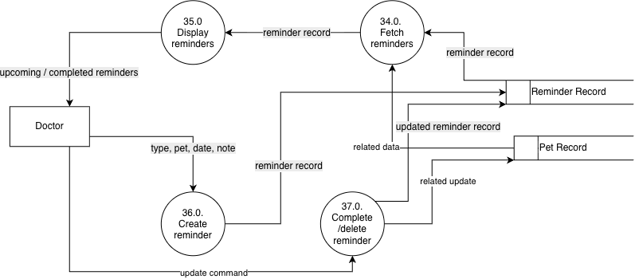
Fig : 14 DFD for Pet Reminder Management (Pet Owner)
The pet owner creates reminders for medicine, vaccines, checkups, or other care tasks. The application stores each reminder, retrieves upcoming and completed items, and records completion or deletion commands.
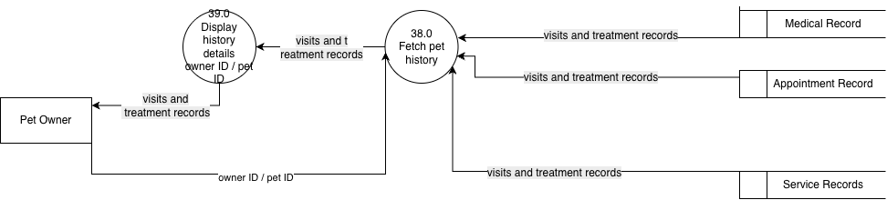

Fig : 15 DFD for Medical and Treatment History Viewing (Pet Owner)
The pet owner requests a selected pet's history. The application combines clinic appointments, diagnoses, prescriptions, vaccinations, home visits, emergencies, pet-care services, and queue records and displays detailed historical information.
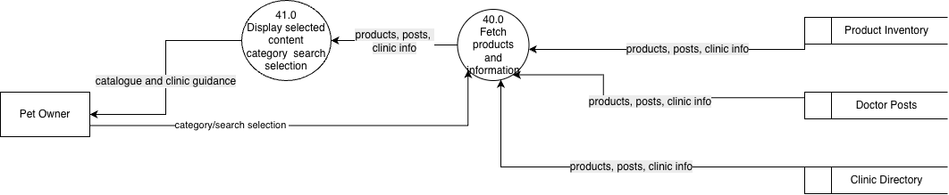
Fig : 16 DFD for Products and Clinic Information Viewing (Pet Owner)
The pet owner browses products, doctor profiles, medical services, health posts, first-aid guides, clinic contact information, and available service categories. The application retrieves and displays the selected information without changing operational records.

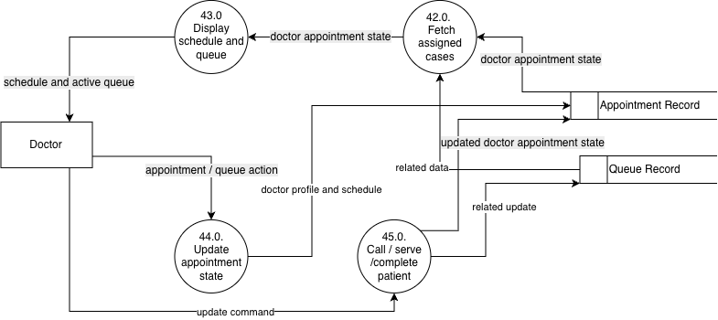
Fig : 17 DFD for Doctor Appointment and Queue Management

The doctor retrieves assigned appointments and the live patient queue, opens patient details, and records workflow actions such as calling the next patient, starting a consultation, marking a patient missed, or completing the visit.
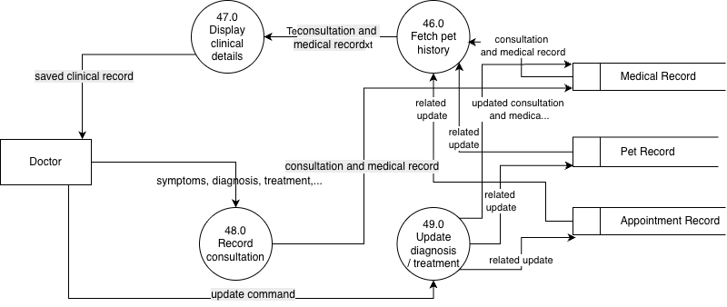
Fig : 18 DFD for Doctor Consultation and Medical Record Update
During a consultation, the doctor reviews the pet profile and previous history, records symptoms and findings, enters diagnosis, treatment, prescription, vaccination, and follow-up details, and stores the completed medical record.

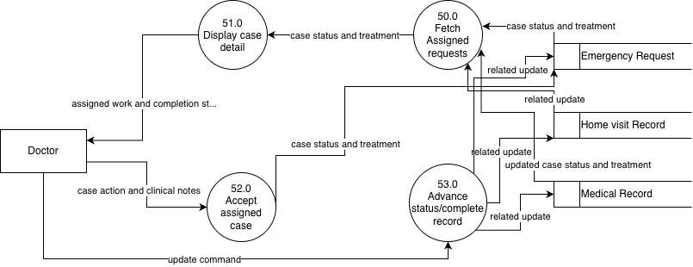
Fig : 19 DFD for Doctor Emergency and Home-Visit Handling
The doctor views assigned emergency cases and home visits, reviews owner and pet details, advances the service status, contacts the owner when needed, and records treatment and completion information for the final medical record.
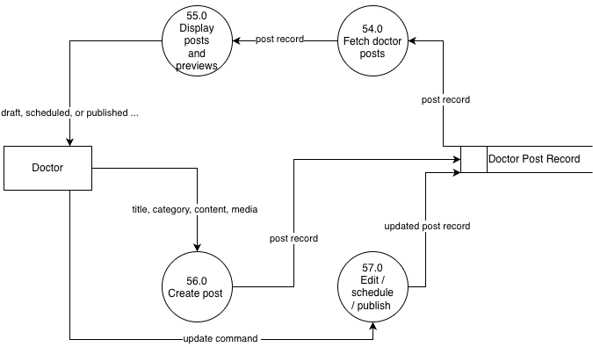
Fig : 20 DFD for Doctor Health-Post Management
The doctor creates health-information posts containing a title, category, content, cover image, and attachments. Drafts can be previewed, edited, scheduled, published, or deleted, and published posts become available to pet owners and staff.
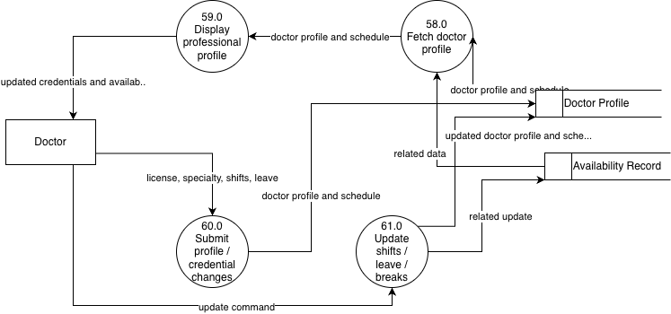
Fig : 21 DFD for Doctor Profile, Credentials, and Availability
The doctor maintains contact details, specialty, qualifications, license information, weekly availability, shifts, breaks, and leaves. The application validates and stores these details for appointment scheduling and public doctor profiles.
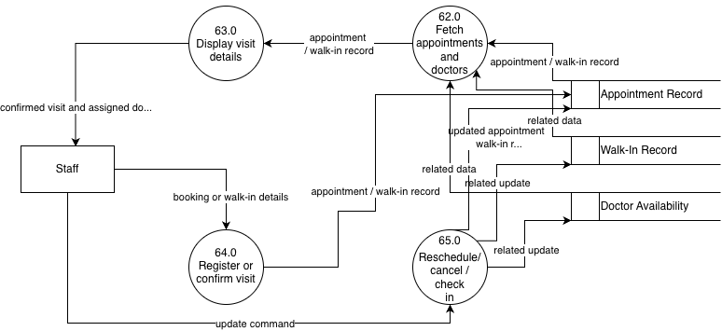
Fig : 22 DFD for Staff Appointment and Walk-In Management
Staff retrieve appointment requests, confirm or reschedule bookings, assign doctors, contact owners, cancel visits, check in scheduled patients, and register walk-in patients before sending them to the live queue.
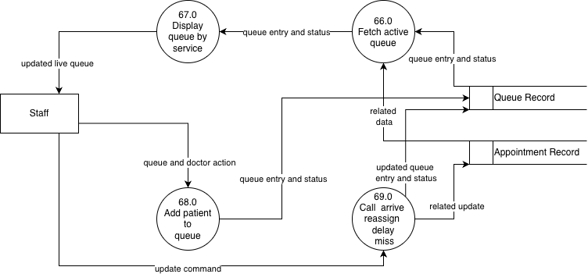
Fig : 23 DFD for Staff Live Queue Management
Staff manage the real-time patient queue by service group and status. They add checked-in patients, call patients, mark arrival, reassign doctors, announce delays, mark missed visits, and monitor completion.
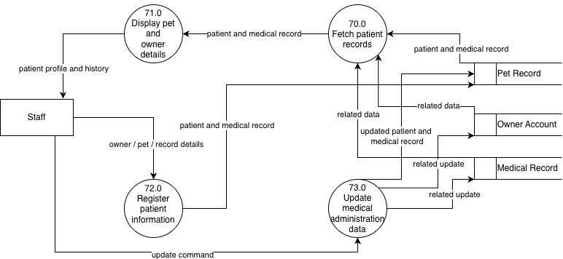

Fig : 24 DFD for Staff Patient and Medical Record Management
Staff search pet owners and patients, open pet profiles, review treatment history, and maintain administrative medical-record details needed for clinic operations while preserving the doctor's clinical entries.
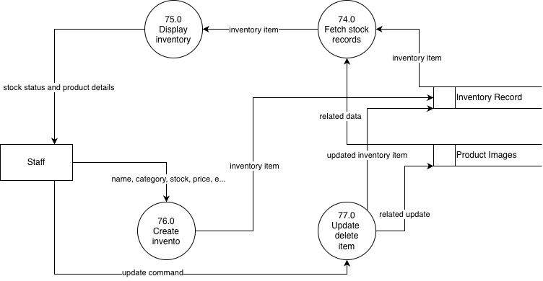
Fig : 25 DFD for Staff Inventory Management
Staff create, view, search, update, and remove inventory items. Each record includes product images, category, brand, pet type, price, stock, reorder level, expiry date, and description, allowing the system to identify low-stock and expired items.
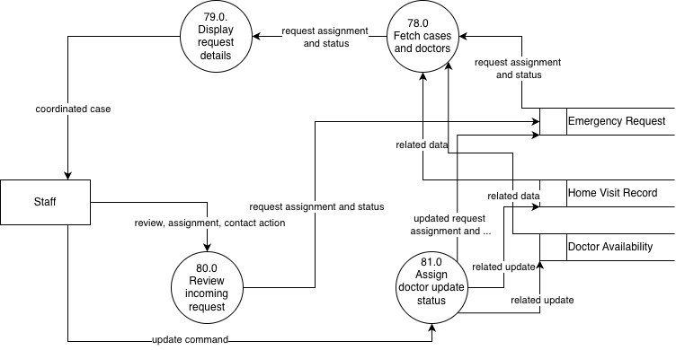
Fig : 26 DFD for Staff Emergency and Home-Visit Coordination
Staff review incoming emergency and home-visit requests, contact the owner, select an available doctor, assign the case, and update acceptance, arrival, scheduling, and completion-related administrative status.

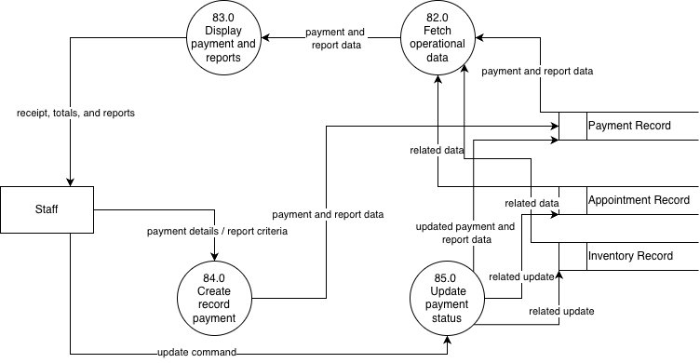
Fig : 27 DFD for Staff Payment Management and Reporting
Staff record and review payments and generate operational reports from appointment, service, payment, and inventory information. The system returns report results and stores the latest payment status for clinic accounting.
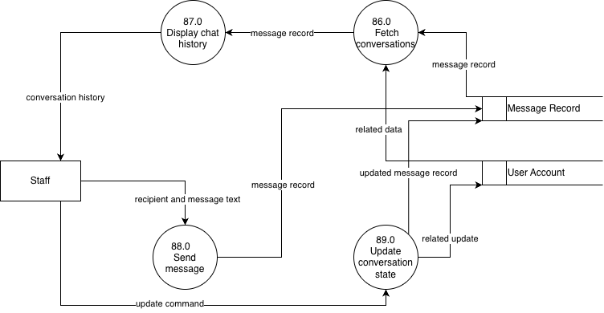
Fig : 28 DFD for Staff Messaging
Staff retrieve user conversations, open a selected thread, and send messages. Each message is stored with
sender, recipient, conversation, and time information so the complete communication history can be
displayed and traced.
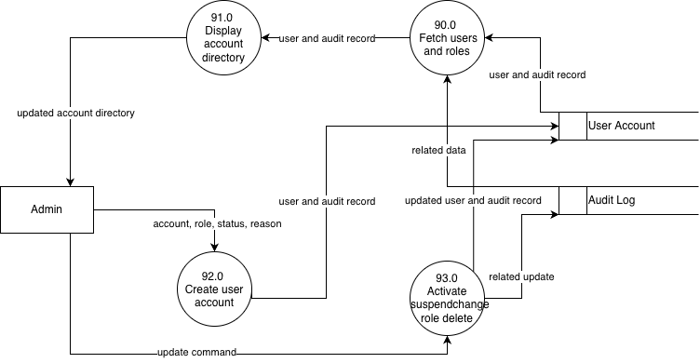
Fig : 29 DFD for System Administrator User and Role Management
The System Administrator creates accounts, searches and views users, assigns roles, activates or suspends accounts, changes account roles, and deletes accounts. Every sensitive action is recorded in the audit log.
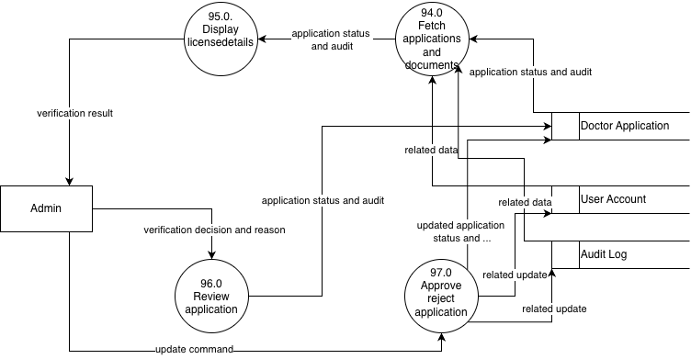
Fig : 30 DFD for System Administrator Doctor Verification
The System Administrator retrieves pending doctor applications, reviews contact details, qualifications, license number, expiry date, specialty, and submitted documents, and then approves or rejects the application with a recorded reason.

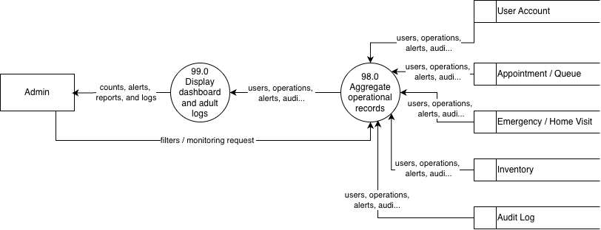
Fig : 31 DFD for System Dashboard, Alerts, Reports, and Audit Logs
The System Administrator monitors totals for users, doctors, staff, owners, appointments, and queue entries; reviews doctor-verification, emergency, low-stock, and expiry alerts; and searches the append-only audit trail of sensitive administrative actions.

4.2.2 Entity Relationship Diagram
The Entity Relationship Diagram (ERD) represents the relationships between the main data entities used by the system.
1. Accounts and Access
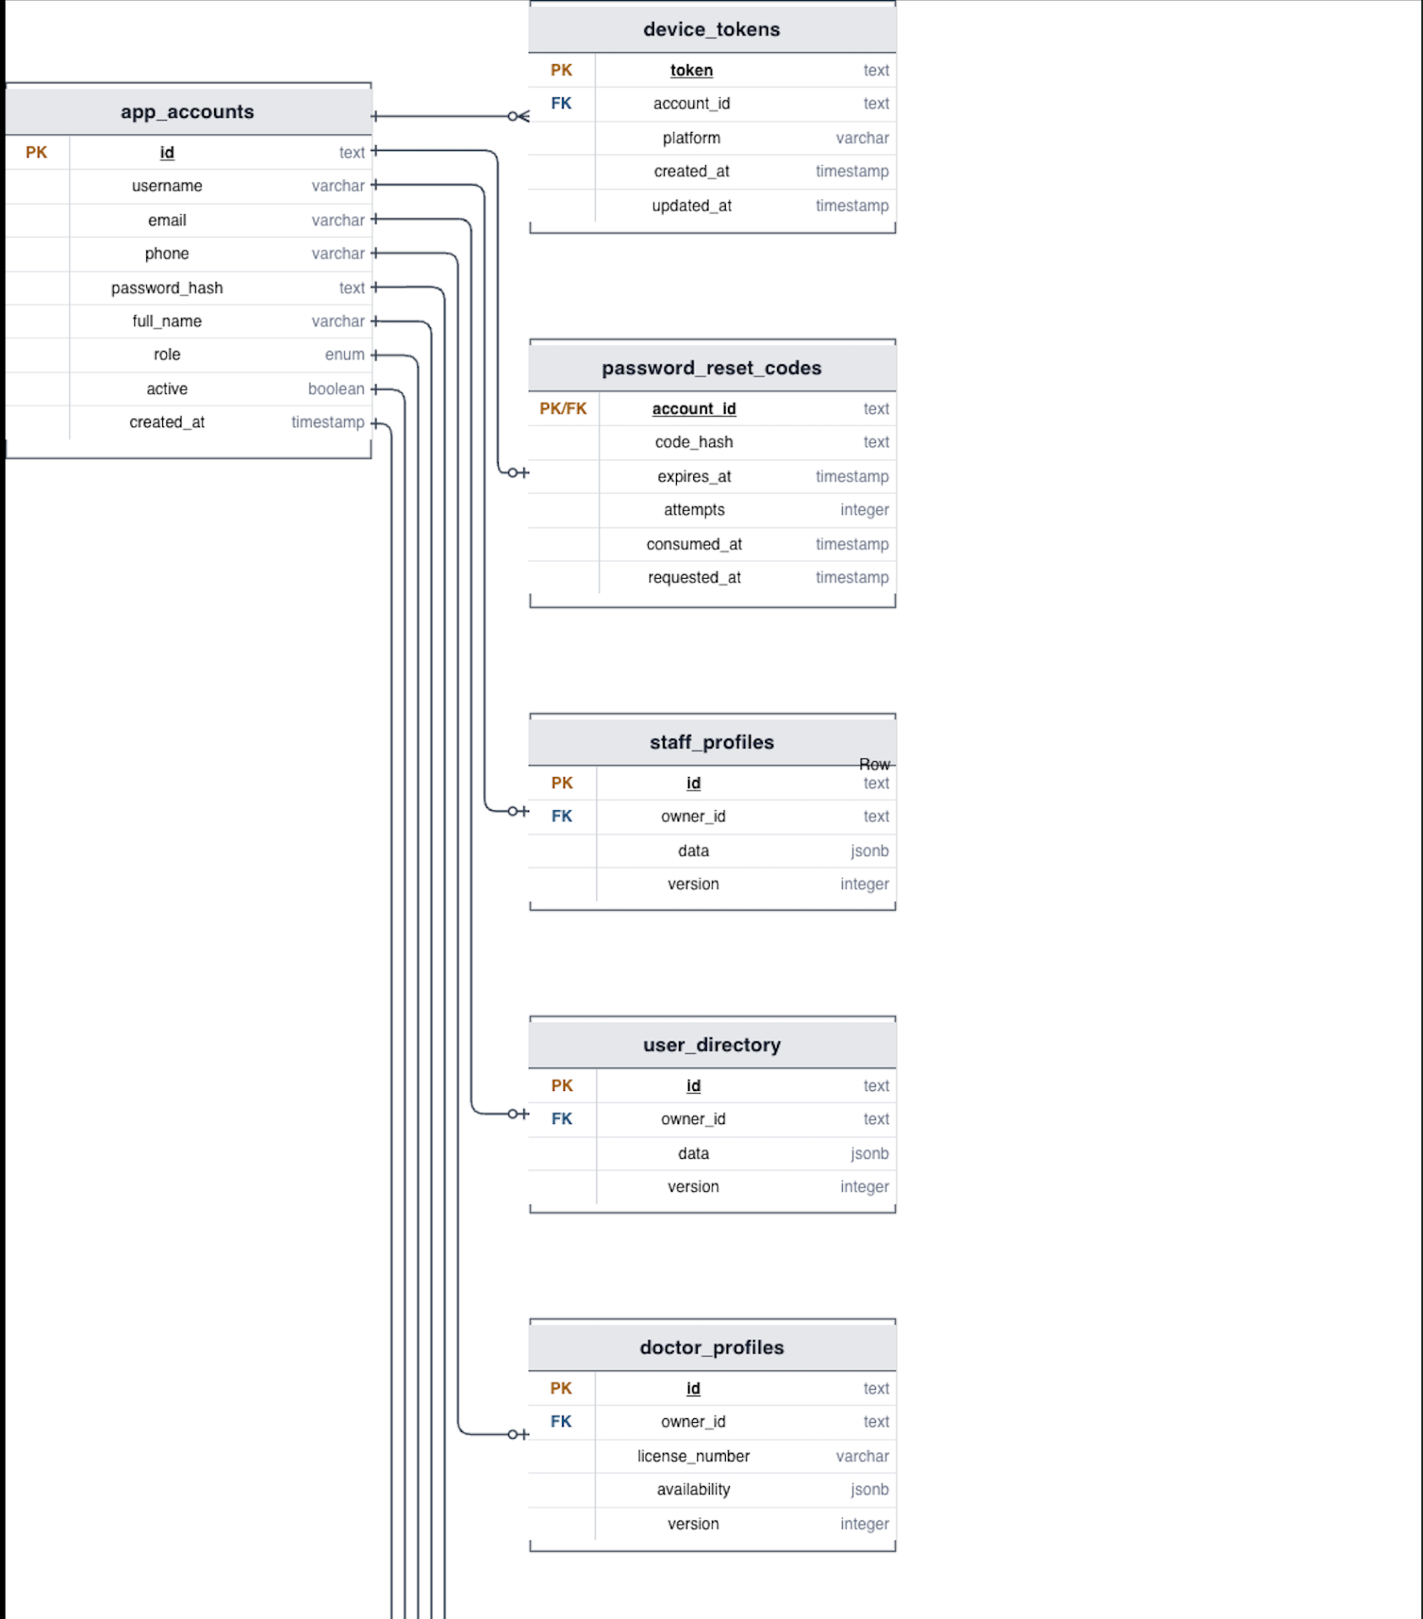

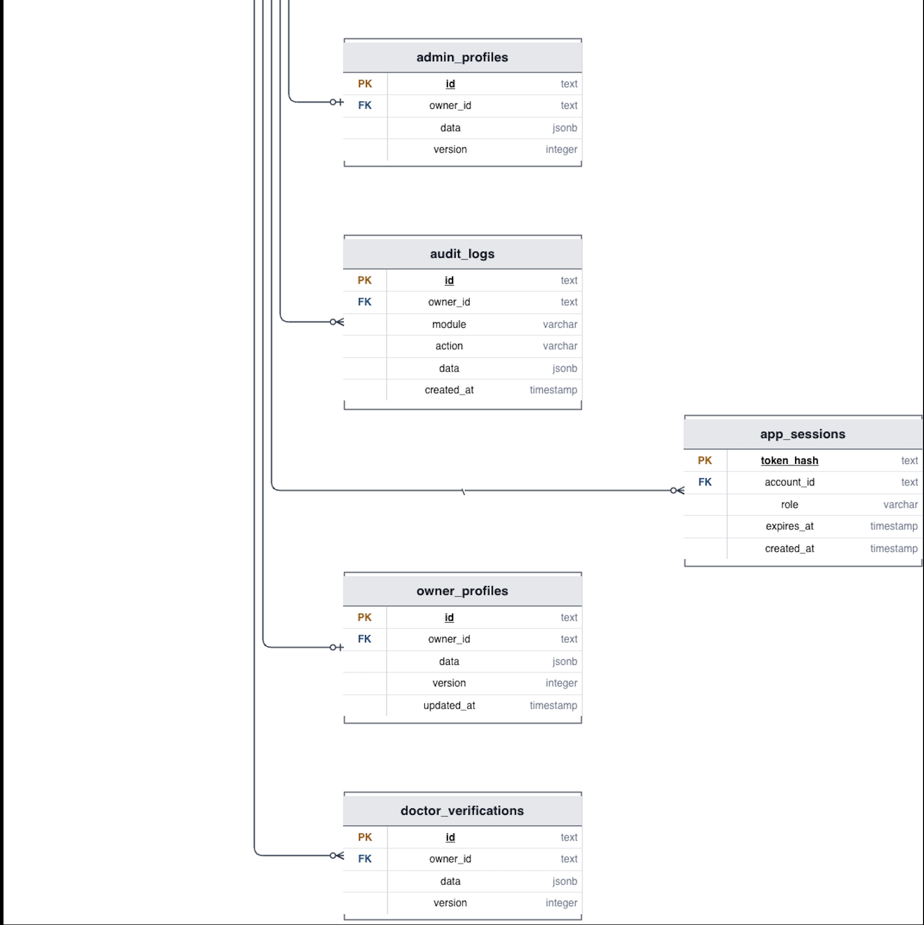
Fig : 32 ERD for Accounts and Access Diagram
The Accounts and Access section manages authentication, authorization, profiles, and security information. The app_accounts table is the main table containing usernames, email addresses, phone numbers, password hashes, full names, roles, account statuses, and creation dates. One account can have multiple sessions, password-reset requests, device tokens, and audit-log entries. Depending on the user’s role, the account can also have an owner, doctor, staff, or administrator profile. The doctor_verifications table stores doctor-verification information, while the user_directory table provides centralized user information.

2. Pets and Bookings
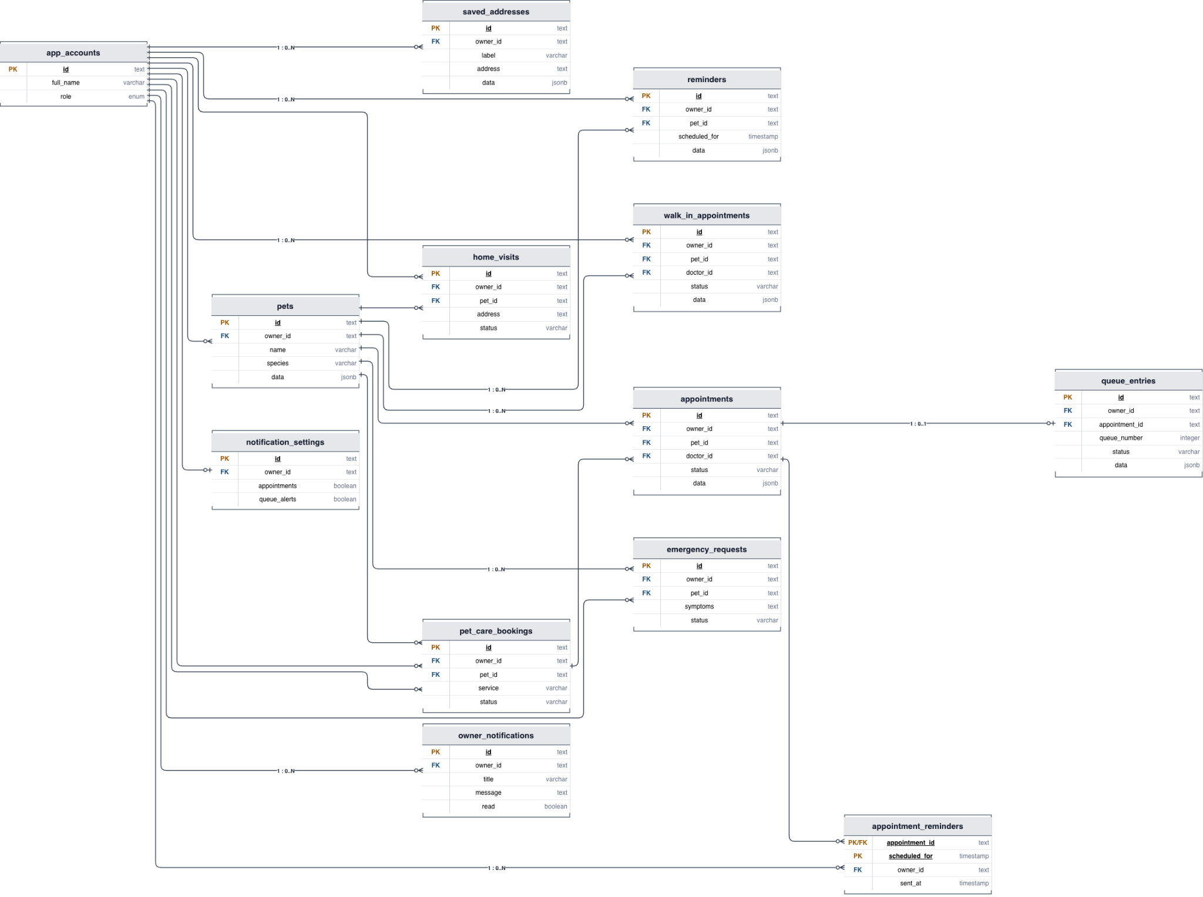

Fig : 33 ERD for Pets and Booking Diagram
The Pets and Bookings section manages pets and the services requested by their owners. One account can own multiple pets, while each pet belongs to one owner. A pet can have multiple scheduled appointments, walk-in appointments, home visits, emergency requests, care-service bookings, and reminders. The appointments table connects an owner, pet, and doctor. The queue_entries table assigns queue numbers to appointments, while appointment_reminders schedules appointment notifications. Saved addresses, notification settings, and owner notifications support the owner’s booking and communication experience.

3. Clinical Operations
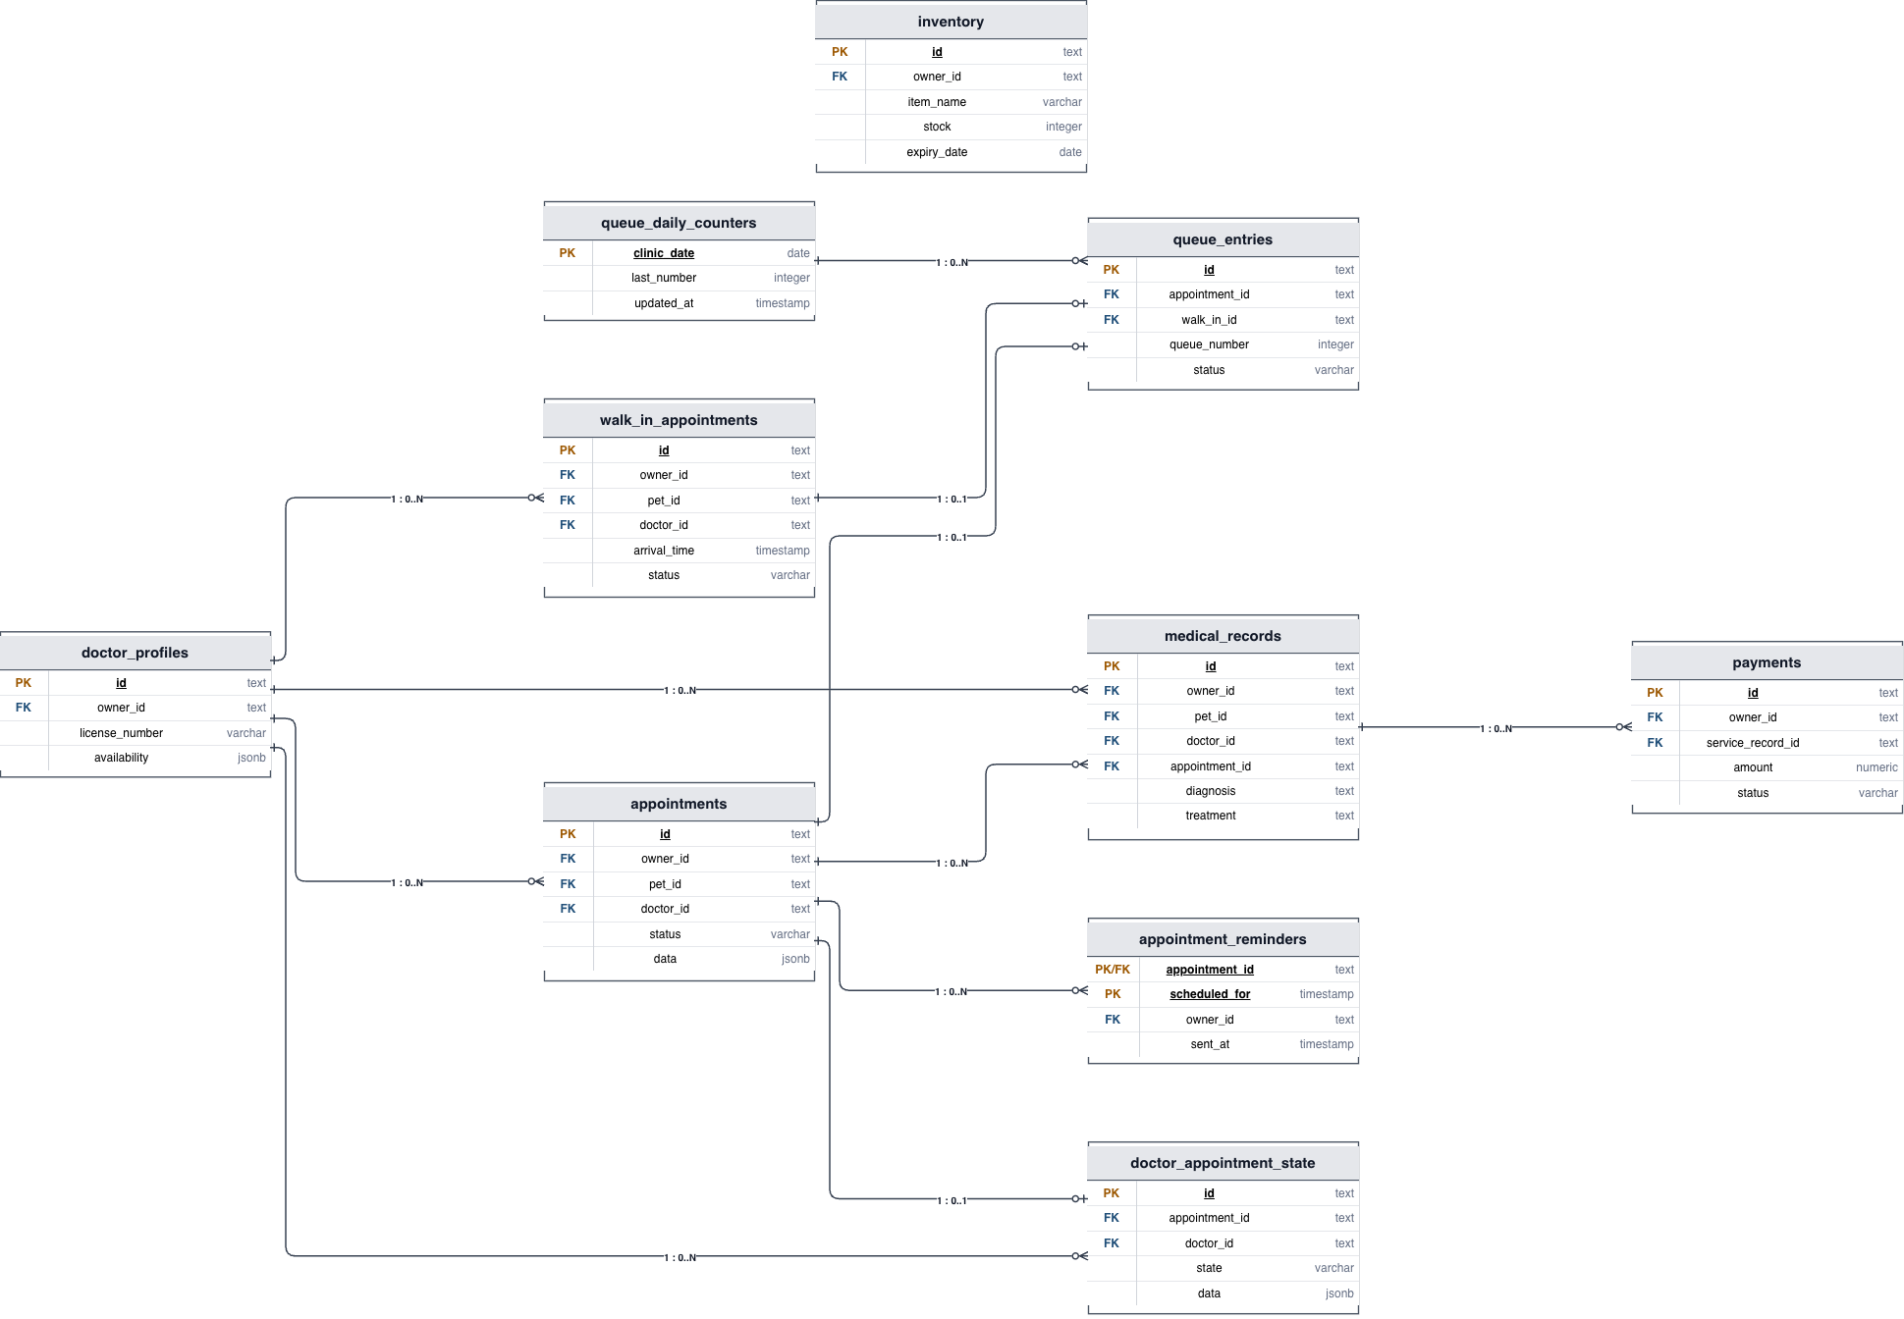
Fig : 34 ERD for Clinical Operations Diagram
The Clinical Operations section represents the clinic’s daily medical workflow. Doctors are assigned to appointments through the doctor_profiles and appointments tables. After a consultation, the clinic creates a medical_records entry containing the diagnosis and treatment. A related payment can then be stored in the payments table. Walk-in patients are recorded in walk_in_appointments and placed into the clinic queue through queue_entries. The doctor_appointment_state table tracks the current condition of an appointment, while queue_daily_counters maintains daily queue numbers. The inventory table stores clinic items, stock quantities, and expiration dates.

4. Content
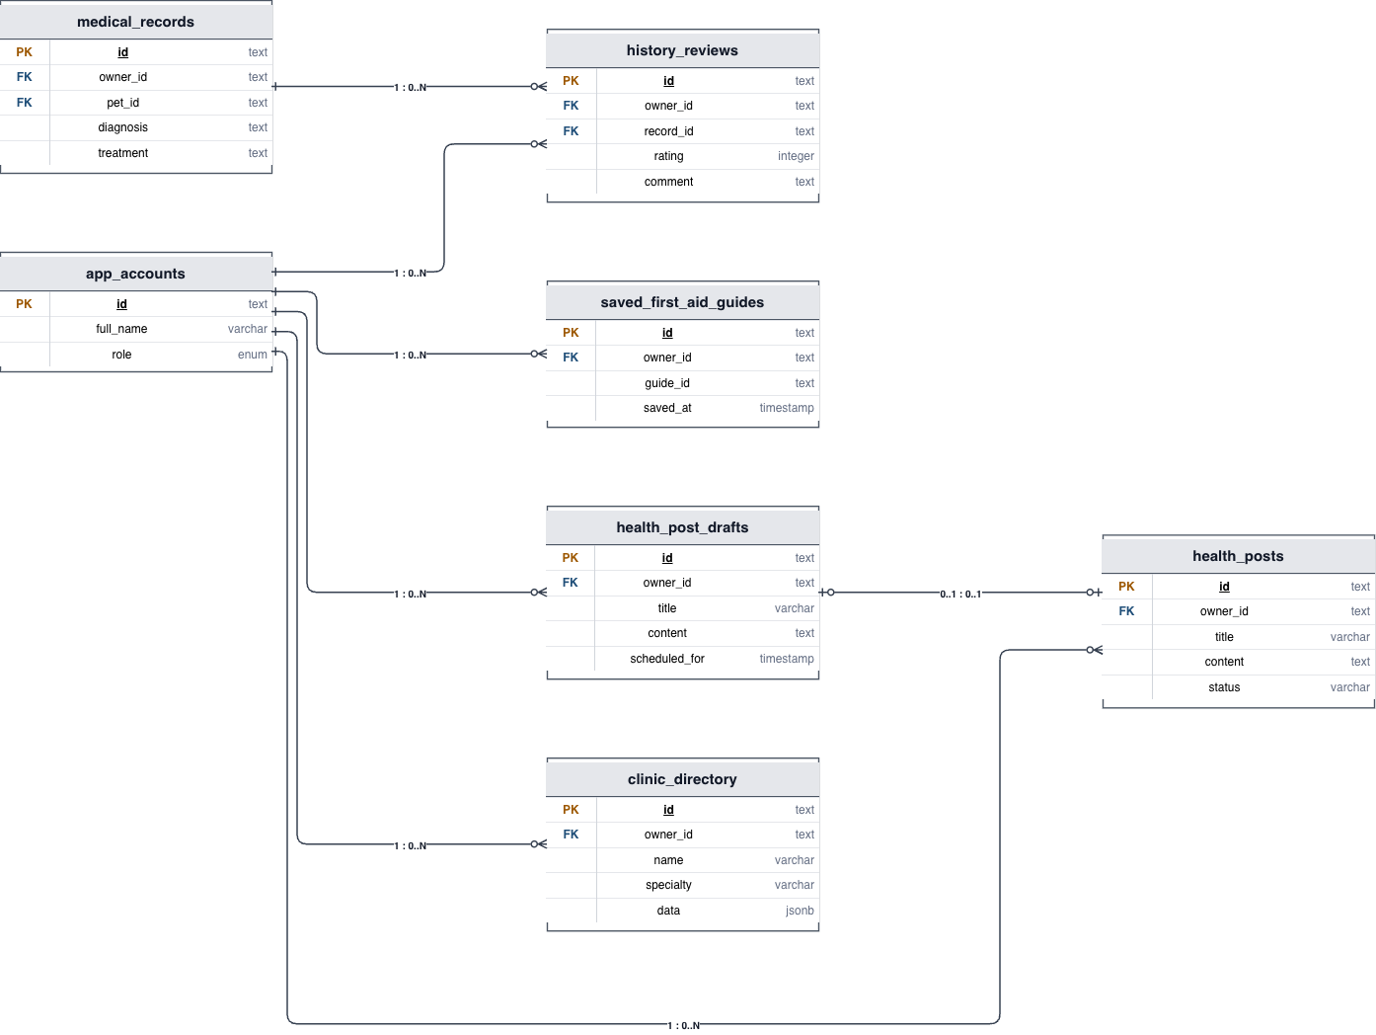
Fig : 35 ERD for Content
The Content section manages educational and informational material. The health_posts table stores published health articles, while health_post_drafts stores unfinished or scheduled articles. Users can save first-aid guides through saved_first_aid_guides and write ratings and comments through history_reviews. The clinic_directory table stores clinic names, specialties, and other clinic information. Medical records are also referenced in this section so reviews can be associated with completed services or treatment histories.

5.Administration
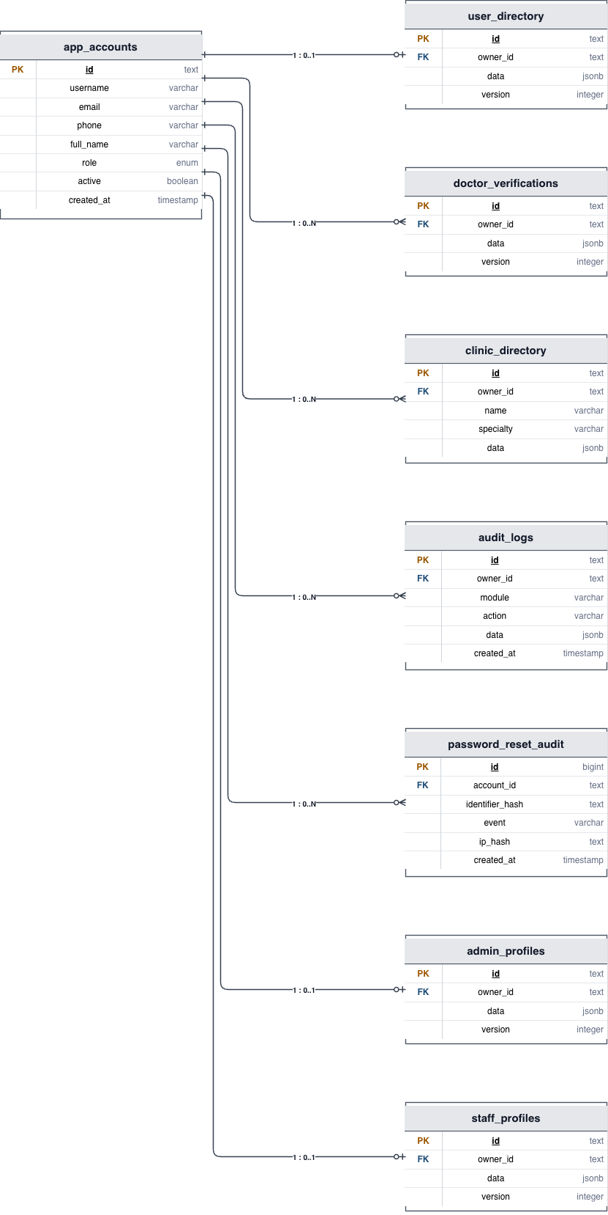
Fig : 36 ERD for Administration
The Administration section supports system management and governance. Administrators use app_accounts, admin_profiles, and staff_profiles to manage users and employees. The user_directory provides a centralized account listing, while doctor_verifications helps administrators confirm doctor credentials. The clinic_directory allows administrative management of clinic information and specialties. The audit_logs table records actions performed throughout the system, and password_reset_audit records password-reset activity for security monitoring.

Entity | Description | Relationships
App_Accounts | Main user account and access information for pet owners, veterinarians, staff, and administrators. | App_Sessions, Password_Reset_Codes, Device_Tokens, Owner_Profiles, Doctor_Profiles, Staff_Profiles, Admin_Profiles, Audit_Logs, Pets, Appointments
Owner_Profiles | Stores pet owner profile information. | App_Accounts, Pets, Appointments, Home_Visits, Emergency_Requests, Notifications
Doctor_Profiles | Stores veterinarian profile and verification information. | App_Accounts, Appointments, Medical_Records, Doctor_Appointment_State
Staff_Profiles | Stores clinic staff profile information. | App_Accounts
Admin_Profiles | Stores administrator profile information. | App_Accounts
Pets | Stores information about pets registered by owners. | Owner_Profiles, Appointments, Home_Visits, Emergency_Requests, Pet_Care_Bookings, Medical_Records, Reminders
Appointments | Stores scheduled veterinary appointments. | Pets, App_Accounts, Doctor_Profiles, Queue_Entries, Reminders, Appointment_Reminders, Doctor_Appointment_State
Queue_Entries | Stores clinic queue information and appointment queue status. | Appointments
Walk_In_Appointments | Stores walk-in appointment information. | Pets, Doctor_Profiles, Queue_Entries
Home_Visits | Stores veterinary home visit information. | Owner_Profiles, Pets
Emergency_Requests | Stores emergency requests for pets. | Owner_Profiles, Pets
Pet_Care_Bookings | Stores additional pet-care service bookings. | Owner_Profiles, Pets
Medical_Records | Stores pet medical history, diagnosis, and treatment information. | Pets, Doctor_Profiles
Payments | Stores payment information for clinic services. | App_Accounts, Service information
Inventory | Stores clinic product and stock information. | App_Accounts
Reminders | Stores appointment and pet-care reminders. | App_Accounts, Pets, Appointments
Notification_Settings | Stores user notification preferences. | App_Accounts
Owner_Notifications | Stores notifications received by pet owners. | App_Accounts
Appointment_Reminders | Stores reminders related to appointments. | Appointments, App_Accounts
Health_Posts | Stores health-related posts published by the clinic. | App_Accounts
Health_Post_Drafts | Stores health-related posts before publication. | App_Accounts
Clinic_Messages | Stores clinic communication messages. | App_Accounts
Doctor_Notifications | Stores notifications for veterinarians. | App_Accounts
Support_Tickets | Stores user support requests. | App_Accounts
History_Reviews | Stores user reviews and ratings. | App_Accounts
Saved_First_Aid_Guides | Stores first-aid guides saved by users. | App_Accounts
Clinic_Directory | Stores clinic directory information. | App_Accounts
Password_Reset_Codes | Stores temporary password reset codes. | App_Accounts
Password_Reset_Audit | Records password reset activities. | App_Accounts
Device_Tokens | Stores device tokens used for notifications. | App_Accounts
App_Sessions | Stores user login sessions. | App_Accounts
Doctor_Verifications | Stores veterinarian verification information. | Doctor_Profiles / App_Accounts
Audit_Logs | Records important system activities for auditing. | App_Accounts
Doctor_Appointment_State | Stores veterinarian-related appointment state information. | Appointments, Doctor_Profiles
Queue_Daily_Counters | Stores daily queue numbering information. | Clinic date / queue management
Table : 4 ERD Diagram Table

Relationship | Type | Explanation
App_Accounts → App_Sessions | One-to-Many | One account can have multiple login sessions.
App_Accounts → Password_Reset_Codes | One-to-Many | One account can have multiple password reset codes.
App_Accounts → Device_Tokens | One-to-Many | One account can have multiple registered devices.
App_Accounts → Owner_Profiles | One-to-One | Each owner profile belongs to one account.
App_Accounts → Doctor_Profiles | One-to-One | Each doctor profile belongs to one account.
App_Accounts → Staff_Profiles | One-to-One | Each staff profile belongs to one account.
App_Accounts → Admin_Profiles | One-to-One | Each administrator profile belongs to one account.
App_Accounts → Audit_Logs | One-to-Many | One account can generate multiple audit records.
App_Accounts → Pets | One-to-Many | One owner account can register multiple pets.
Pets → Appointments | One-to-Many | One pet can have multiple appointments.
Doctor_Profiles → Appointments | One-to-Many | One veterinarian can manage multiple appointments.
App_Accounts → Appointments | One-to-Many | One owner can make multiple appointments.
Appointments → Queue_Entries | One-to-One | An appointment can have a queue entry.
Pets → Home_Visits | One-to-Many | One pet can have multiple home visits.
Pets → Emergency_Requests | One-to-Many | One pet can have multiple emergency requests.
Pets → Pet_Care_Bookings | One-to-Many | One pet can have multiple care bookings.
Pets → Medical_Records | One-to-Many | One pet can have multiple medical records.
Doctor_Profiles → Medical_Records | One-to-Many | One veterinarian can manage multiple medical records.
App_Accounts → Reminders | One-to-Many | One owner can receive multiple reminders.
Pets → Reminders | One-to-Many | One pet can have multiple reminders.
Appointments → Reminders | One-to-Many | One appointment can have reminder records.
App_Accounts → Notification_Settings | One-to-One | Each owner has notification settings.
App_Accounts → Owner_Notifications | One-to-Many | One owner can receive multiple notifications.
Appointments → Appointment_Reminders | One-to-Many | One appointment can have multiple reminder records.
Appointments → Doctor_Appointment_State | One-to-Many | An appointment can have appointment-state records.
Doctor_Profiles → Doctor_Appointment_State | One-to-Many | One doctor can have multiple appointment-state records.
App_Accounts → Health_Posts | One-to-Many | One account can manage multiple health posts.
App_Accounts → Health_Post_Drafts | One-to-Many | One account can create multiple draft posts.
App_Accounts → Clinic_Messages | One-to-Many | One account can be associated with multiple clinic messages.
App_Accounts → Doctor_Notifications | One-to-Many | One doctor account can receive multiple notifications.
App_Accounts → Support_Tickets | One-to-Many | One account can submit multiple support tickets.
App_Accounts → History_Reviews | One-to-Many | One account can create multiple reviews.
App_Accounts → Saved_First_Aid_Guides | One-to-Many | One account can save multiple first-aid guides.
App_Accounts → Password_Reset_Audit | One-to-Many | One account can have multiple password-reset audit records.
Table : 5 ERD Diagram Relationship Table
4.2.3 Class Diagram
The Class Diagram illustrates the main classes and their relationships within the Nway’s Love Vet Clinic Management System. It represents users, pets, appointments, clinical operations, communication, and administration. The diagram is organized into Supporting Classes, Appointments and Clinical Operations, Users, Pets and Bookings, and Communication and Administration, showing how these system components interact.
4.2.3.1 Supporting Classes
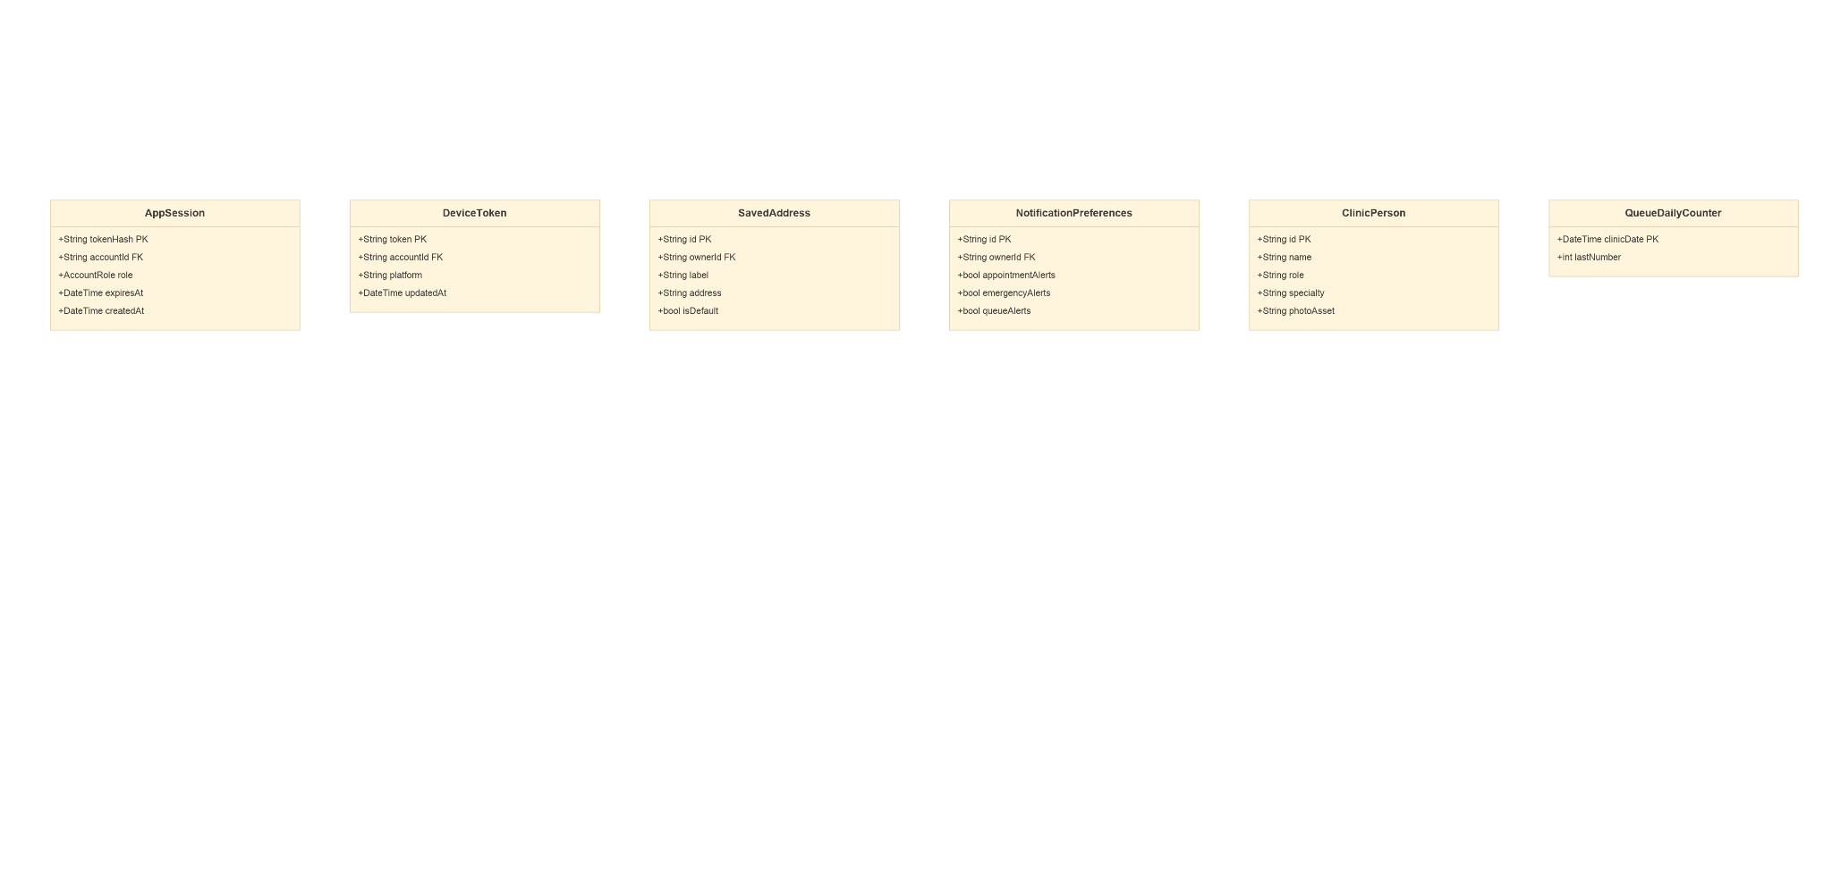
Fig : 37 Supporting Class Diagram
Fig : 38 Supporting Class Diagram Detail 1
Fig : 39 Supporting Class Diagram Detail 2

4.2.3.2 Appointments and Clinical Operations
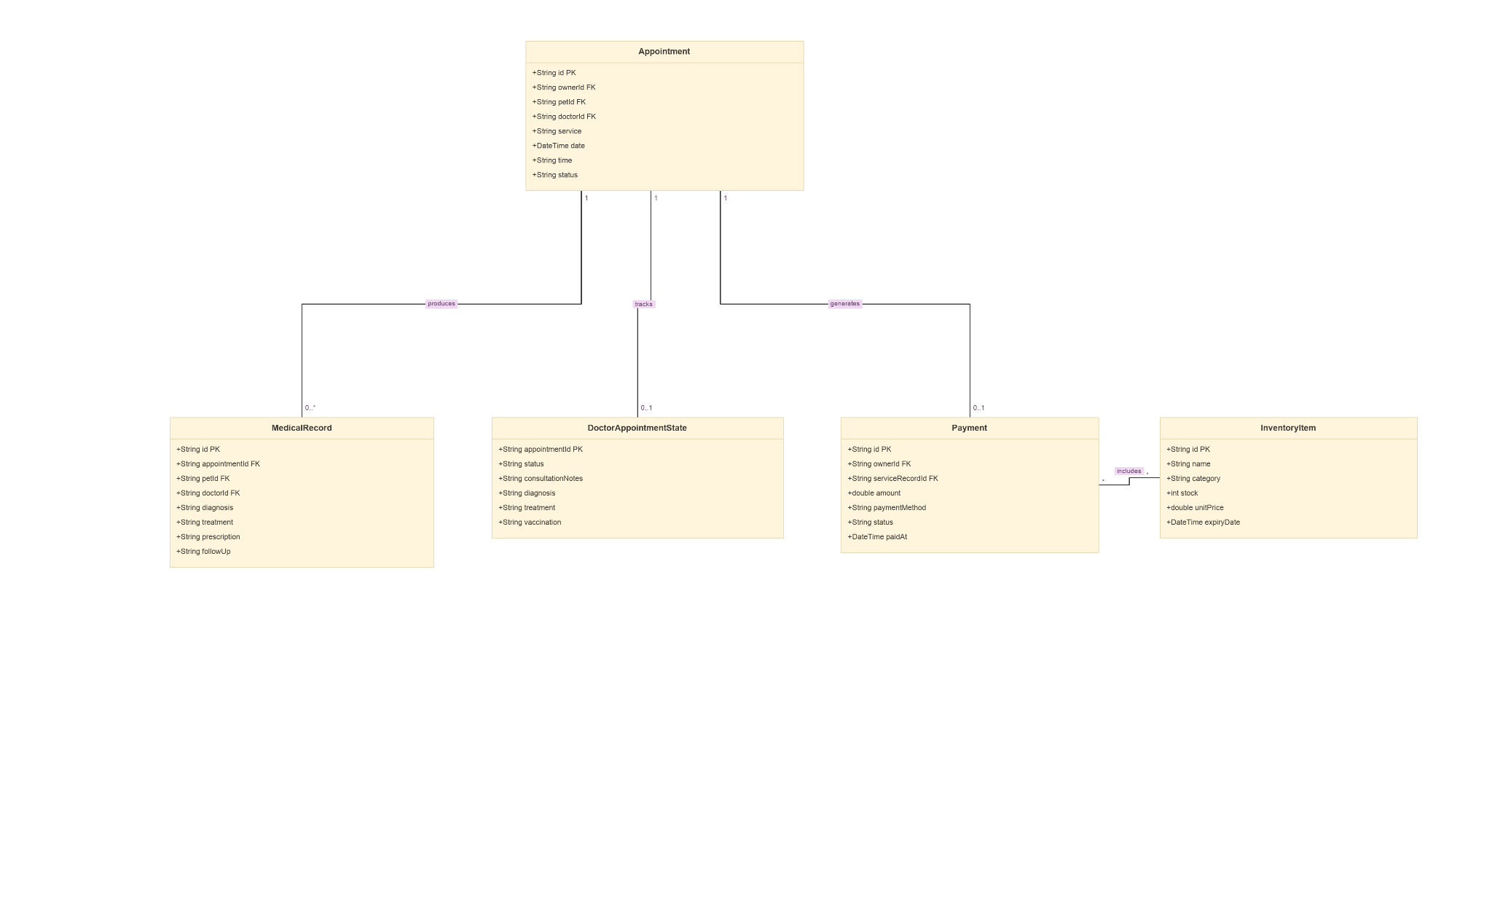
Fig : 40 Appointments and Clinical Operations Class Diagram
Fig : 41 Appointments and Clinical Operations Class Diagram Detail 1
Fig : 42 Appointments and Clinical Operations Class Diagram Detail 2

4.2.3.3 Users, Pets and Booking
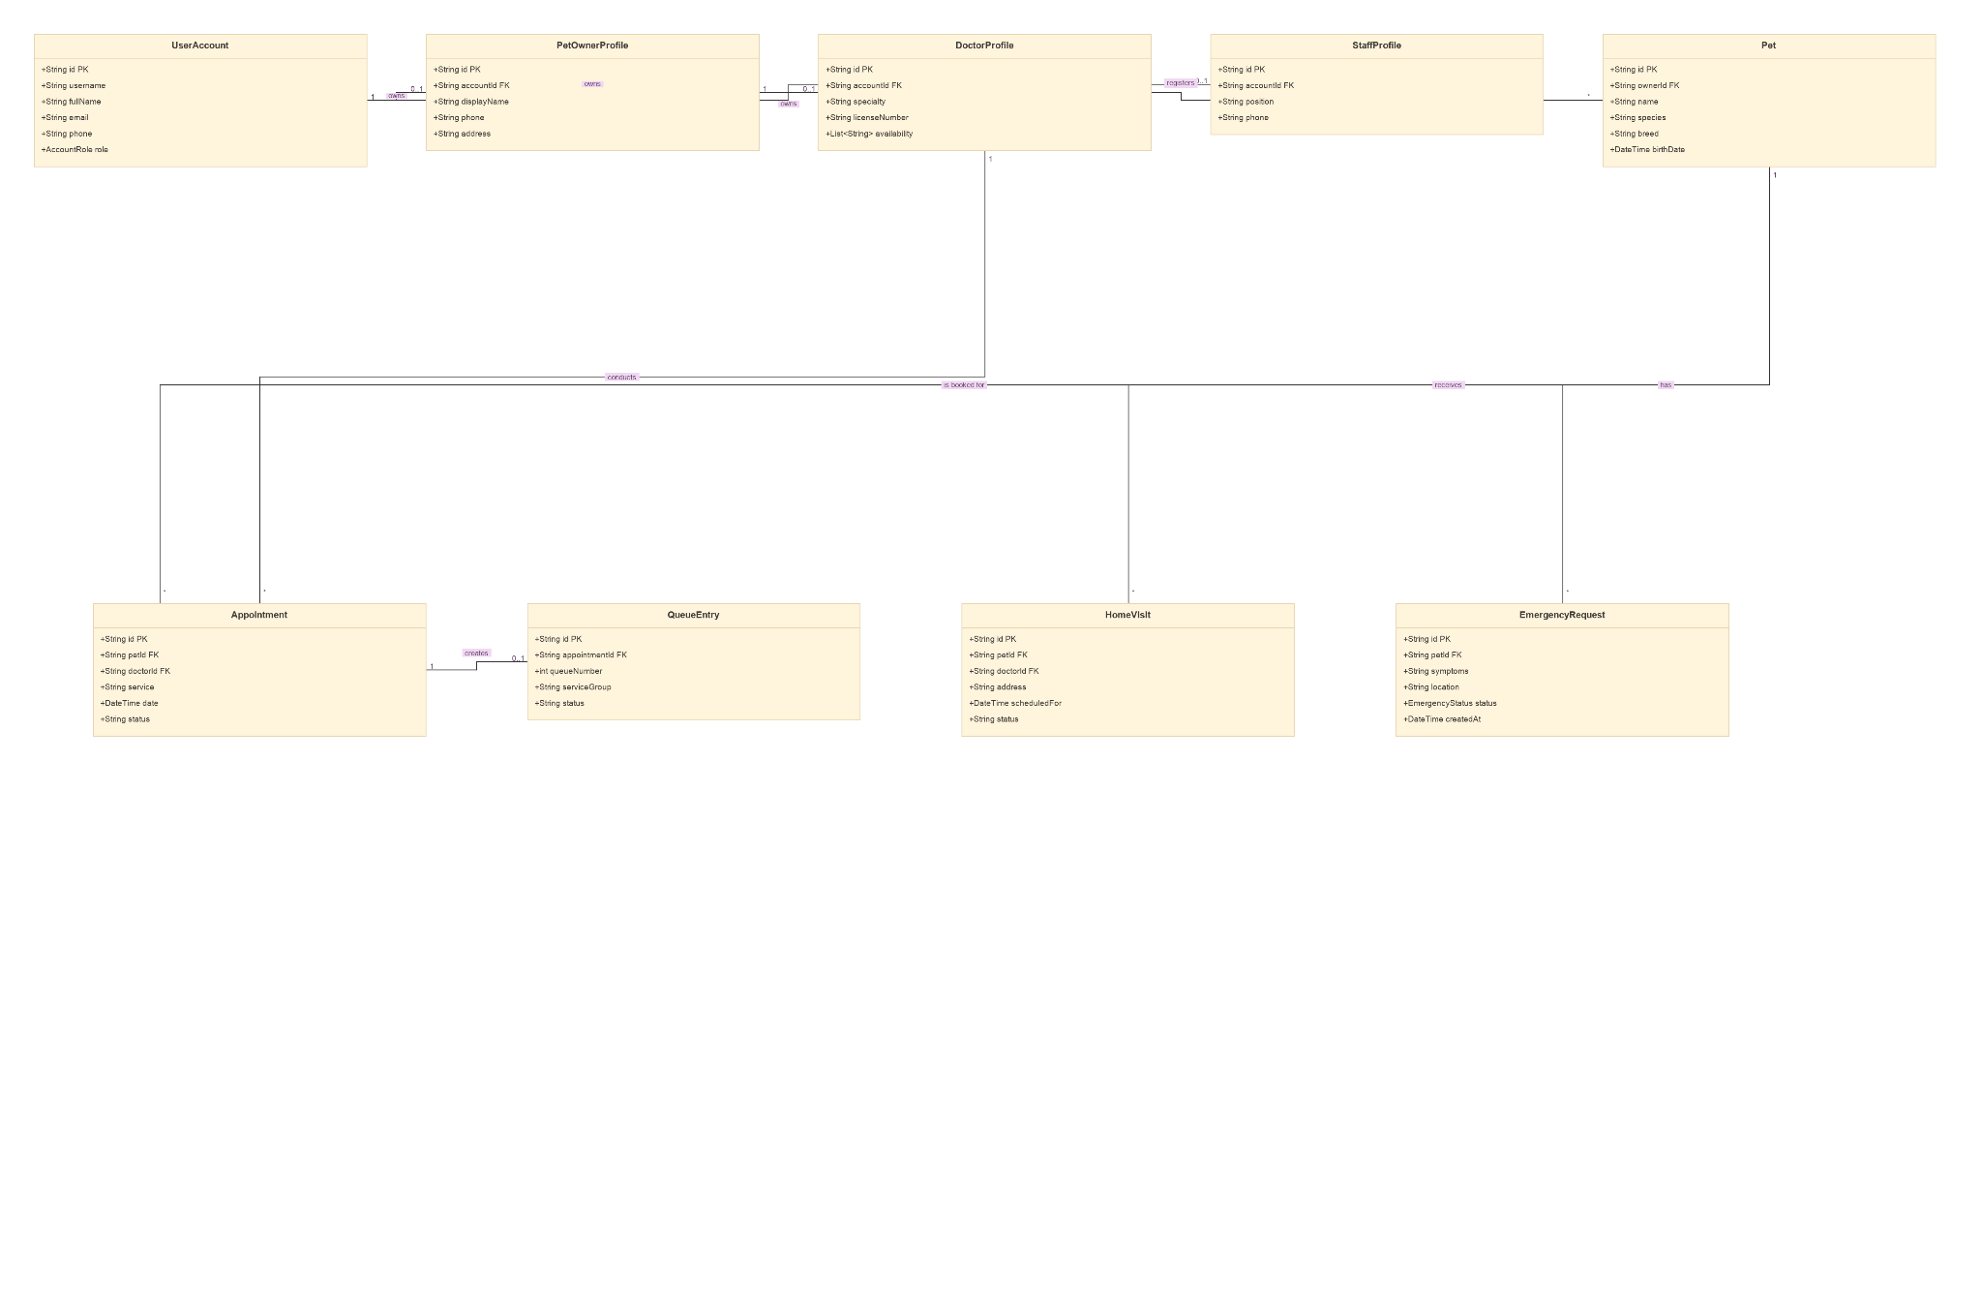
Fig : 43 Users, Pets and Booking Class Diagram
Fig : 44 Users, Pets and Booking Class Diagram Detail 1
Fig : 45 Users, Pets and Booking Class Diagram Detail 2
4.2.3.4 Communication and Administraction
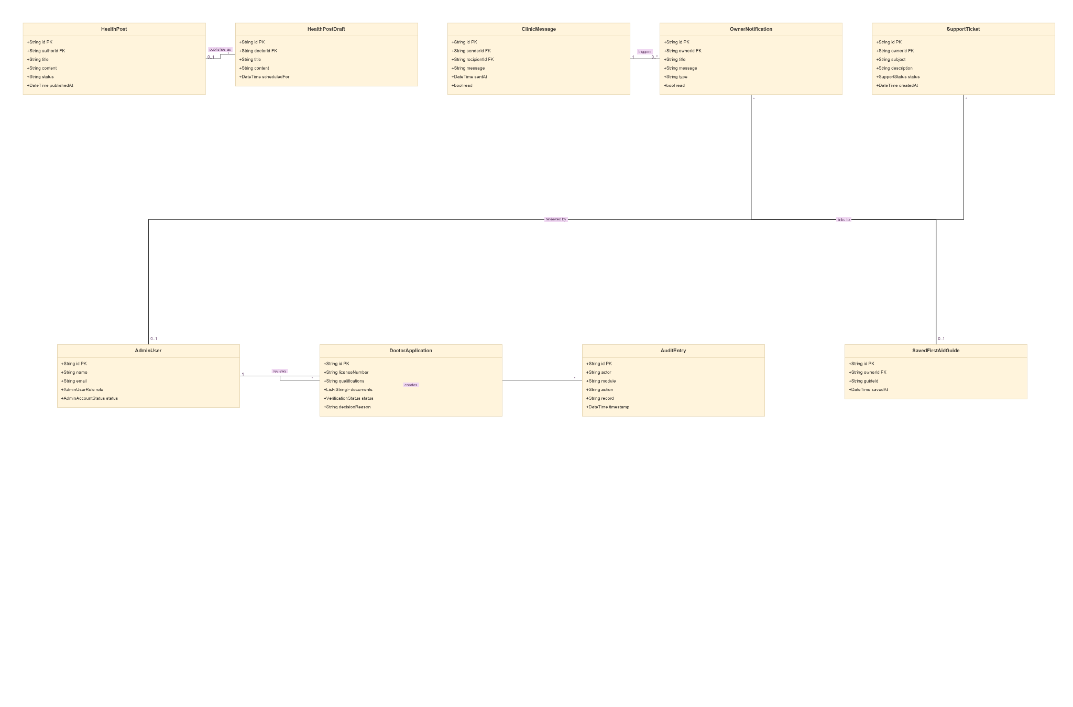
Fig : 46 Communication and Administration Class Diagram
Fig : 47 Communication and Administration Class Diagram Detail 1
Fig : 48 Communication and Administration Class Diagram Detail 2

Class | Description | Relationship / Interaction
UserAccount | Represents the main user account and stores username, name, email, phone, and role information. | Connects with PetOwnerProfile, DoctorProfile, and StaffProfile.
PetOwnerProfile | Stores the personal information of a pet owner, including phone and address. | Belongs to UserAccount and owns Pet records.
DoctorProfile | Represents a veterinarian and stores specialization, license number, and availability. | Belongs to UserAccount and manages Appointments and MedicalRecords.
StaffProfile | Represents clinic staff and stores staff position and contact information. | Belongs to UserAccount and supports clinic operations.
Pet | Represents a pet registered in the system, including name, species, breed, and birth date. | Belongs to a PetOwnerProfile and is involved in Appointments, HomeVisits, and EmergencyRequests.
Appointment | Represents a scheduled veterinary appointment with date, time, service, and status. | Connects Pet, PetOwnerProfile, DoctorProfile, MedicalRecord, DoctorAppointmentState, and Payment.
QueueEntry | Represents a pet's position and status in the clinic queue. | Works with Appointment to manage the clinic waiting queue.
HomeVisit | Represents a veterinary service provided at the pet owner's location. | Connects a Pet Owner and Pet with a home-visit service.
EmergencyRequest | Represents an emergency request submitted for a pet, including symptoms and status. | Connects Pet and PetOwnerProfile with emergency service handling.
MedicalRecord | Stores diagnosis, treatment, prescription, and follow-up information. | Connected to Appointment, Pet, and DoctorProfile.
DoctorAppointmentState | Stores the veterinarian's status, consultation notes, diagnosis, treatment, and vaccination information for an appointment. | Connected to Appointment and supports veterinarian appointment management.
Payment | Stores payment amount, payment method, status, and payment date. | Generated from an Appointment and can include InventoryItem purchases.
InventoryItem | Represents products managed by the clinic, including category, stock, unit price, and expiry date. | Connected to Payment when products are included in a transaction.
AppSession | Stores active user session information, including token and expiry details. | Connected to UserAccount for session management.
DeviceToken | Stores device tokens and platform information for notifications. | Connected to UserAccount for notification delivery.
SavedAddress | Stores addresses saved by pet owners. | Connected to PetOwnerProfile.
NotificationPreferences | Stores the user's notification preferences, including appointment and emergency alerts. | Connected to PetOwnerProfile and controls notification settings.
ClinicPerson | Represents clinic personnel information such as name, role, specialty, and photo. | Supports clinic personnel information and operations.
QueueDailyCounter | Stores the daily queue date and the latest queue number. | Supports QueueEntry in generating daily queue numbers.
HealthPost | Represents health-related information published by the clinic. | Connected to HealthPostDraft and managed through clinic content functions.
HealthPostDraft | Stores health-post content before it is published. | Used to prepare content for HealthPost.
ClinicMessage | Represents messages sent between users through the clinic communication system. | Interacts with OwnerNotification and user accounts.
OwnerNotification | Stores notifications sent to pet owners, including title, message, and read status. | Receives information from ClinicMessage and connects with pet-owner communication.
SupportTicket | Represents a support request submitted by a user, including subject, description, status, and creation date. | Connected to administrative/support functions.
AdminUser | Represents an administrator who manages administrative functions and system access. | Interacts with DoctorApplication and administrative records.
DoctorApplication | Stores veterinarian application information, qualifications, documents, verification status, and decision reason. | Managed by AdminUser during veterinarian verification.
AuditEntry | Records system activities such as actor, module, action, and timestamp. | Supports administrative monitoring and auditing.
SavedFirstAidGuide | Stores first-aid guides saved by users for later access. | Connected to the user who saves the guide.
Table : 6 Class Diagram Table
4.2.4 Data Dictionary
The data dictionary describes the main database entities used by the Nway’s Love Vet Clinic Management System. It lists the column name, data type, constraints, and purpose of each field. The entity names follow the ERD presented in the project report. Because the source diagram does not specify every SQL data type and constraint, the data types and constraints below are proposed database definitions for implementation.
App_Accounts
Column Name | Data Type | Constraints | Description
account_id | INTEGER | PK, AUTO_INCREMENT | Unique account identifier
username | VARCHAR(100) | NOT NULL, UNIQUE | Login username
email | VARCHAR(150) | NULLABLE, UNIQUE | Registered email address
phone | VARCHAR(30) | NULLABLE, UNIQUE | Registered phone number
password_hash | VARCHAR(255) | NOT NULL | Encrypted password value
role | VARCHAR(30) | NOT NULL | User role such as owner, doctor, staff, or admin
status | VARCHAR(20) | NOT NULL | Account status
created_at | TIMESTAMP | NOT NULL, DEFAULT CURRENT_TIMESTAMP | Account creation timestamp
Table : 7 App_Accounts Data Dictionary Table
Owner_Profiles
Column Name | Data Type | Constraints | Description
owner_id | INTEGER | PK, FK → App_Accounts.account_id | Owner account identifier
name | VARCHAR(150) | NOT NULL | Pet owner's name
phone | VARCHAR(30) | NOT NULL | Owner contact number
address | VARCHAR(255) | NULLABLE | Owner address
profile_photo | VARCHAR(255) | NULLABLE | Profile photo reference
Table : 8 Owner_Profiles Data Dictionary Table
Doctor_Profiles
Column Name | Data Type | Constraints | Description
doctor_id | INTEGER | PK, FK → App_Accounts.account_id | Doctor account identifier
specialization | VARCHAR(150) | NOT NULL | Veterinary specialization
license_no | VARCHAR(100) | NOT NULL, UNIQUE | Veterinary license number
availability | VARCHAR(255) | NULLABLE | Doctor availability information
verification_status | VARCHAR(30) | NOT NULL | Doctor verification status
Table : 9 Doctor_Proflies Data Dictionary Table
Staff_Profiles
Column Name | Data Type | Constraints | Description
staff_id | INTEGER | PK, FK → App_Accounts.account_id | Staff account identifier
position | VARCHAR(100) | NOT NULL | Clinic staff position
phone | VARCHAR(30) | NULLABLE | Staff contact number
Table : 10 Staff_Profiles Data Dictionary Table
Admin_Profiles
Column Name | Data Type | Constraints | Description
admin_id | INTEGER | PK, FK → App_Accounts.account_id | Administrator account identifier
admin_level | VARCHAR(50) | NOT NULL | Administrator access level
Table : 11 Admin_Profiles Data Dictionary Table
Pets
Column Name | Data Type | Constraints | Description
pet_id | INTEGER | PK, AUTO_INCREMENT | Unique pet identifier
owner_id | INTEGER | FK→Owner_Profiles.owner_id, NOT NULL | Registered pet owner
name | VARCHAR(100) | NOT NULL | Pet name
species | VARCHAR(50) | NOT NULL | Animal species
breed | VARCHAR(100) | NULLABLE | Pet breed
sex | VARCHAR(20) | NULLABLE | Pet sex
birth_date | DATE | NULLABLE | Pet date of birth
weight | DECIMAL(6,2) | NULLABLE | Pet weight
photo | VARCHAR(255) | NULLABLE | Pet photo reference
vaccine_info | TEXT | NULLABLE | Vaccination information
medical_notes | TEXT | NULLABLE | Additional medical information
Table : 12 Pets Data Dictionary Table
Appointments
Column Name | Data Type | Constraints | Description
appointment_id | INTEGER | PK, AUTO_INCREMENT | Unique appointment identifier
pet_id | INTEGER | FK → Pets.pet_id, NOT NULL | Pet receiving the appointment
owner_account_id | INTEGER | FK → App_Accounts.account_id, NOT NULL | Owner who makes the appointment
doctor_id | INTEGER | FK → Doctor_Profiles.doctor_id, NULLABLE | Assigned veterinarian
service | VARCHAR(100) | NOT NULL | Requested clinic service
appointment_date | DATE | NOT NULL | Appointment date
appointment_time | TIME | NOT NULL | Appointment time
reason | TEXT | NULLABLE | Reason for the appointment
status | VARCHAR(30) | NOT NULL | Appointment status
Table : 13 Appointments Data Dictionary Table
Queue_Entries
Column Name | Data Type | Constraints | Description
queue_id | INTEGER | PK, AUTO_INCREMENT | Unique queue entry identifier
appointment_id | INTEGER | FK → Appointments.appointment_id, UNIQUE, NOT NULL | Related appointment
queue_number | INTEGER | NOT NULL | Queue number
service_group | VARCHAR(100) | NULLABLE | Queue service group
status | VARCHAR(30) | NOT NULL | Current queue status
priority | VARCHAR(20) | NOT NULL | Normal or emergency priority
Table : 14 Queue_Entries Data Dictionary Table
Walk_In_Appointments
Column Name | Data Type | Constraints | Description
walk_in_id | INTEGER | PK, AUTO_INCREMENT | Unique walk-in record identifier
pet_id | INTEGER | FK → Pets.pet_id, NOT NULL | Pet for the walk-in visit
doctor_id | INTEGER | FK → Doctor_Profiles.doctor_id, NULLABLE | Assigned veterinarian
queue_id | INTEGER | FK → Queue_Entries.queue_id, NULLABLE | Related queue entry
visit_date | DATE | NOT NULL | Walk-in visit date
reason | TEXT | NULLABLE | Reason for walk-in visit
Table : 15 Walk_In Data Dictionary Table
Home_Visits
Column Name | Data Type | Constraints | Description
home_visit_id | INTEGER | PK, AUTO_INCREMENT | Unique home-visit identifier
owner_id | INTEGER | FK → Owner_Profiles.owner_id, NOT NULL | Pet owner requesting the visit
pet_id | INTEGER | FK → Pets.pet_id, NOT NULL | Pet receiving the visit
address | VARCHAR(255) | NOT NULL | Home-visit address
reason | TEXT | NULLABLE | Reason for home visit
visit_date | DATE | NOT NULL | Scheduled visit date
visit_time | TIME | NOT NULL | Scheduled visit time
status | VARCHAR(30) | NOT NULL | Home-visit status
Table : 16 Home Visit Data Dictionary Table
Emergency_Requests
Column Name | Data Type | Constraints | Description
emergency_id | INTEGER | PK, AUTO_INCREMENT | Unique emergency request identifier
owner_id | INTEGER | FK → Owner_Profiles.owner_id, NOT NULL | Owner submitting the request
pet_id | INTEGER | FK → Pets.pet_id, NOT NULL | Pet requiring emergency service
symptoms | TEXT | NOT NULL | Reported symptoms
description | TEXT | NULLABLE | Emergency description
priority | VARCHAR(20) | NOT NULL | Emergency priority
status | VARCHAR(30) | NOT NULL | Emergency request status
Table : 17 Emergency_Requests Data Dictionary Table
Pet_Care_Bookings
Column Name | Data Type | Constraints | Description
booking_id | INTEGER | PK, AUTO_INCREMENT | Unique pet-care booking identifier
owner_id | INTEGER | FK → Owner_Profiles.owner_id, NOT NULL | Owner making the booking
pet_id | INTEGER | FK → Pets.pet_id, NOT NULL | Pet receiving the service
service | VARCHAR(100) | NOT NULL | Grooming, bathing, nail trimming, boarding, or wellness service
booking_date | DATE | NOT NULL | Service date
booking_time | TIME | NOT NULL | Service time
status | VARCHAR(30) | NOT NULL | Booking status
Table : 18 Pet_Care_Bookings Data Dictionary Table
Medical_Records
Column Name | Data Type | Constraints | Description
record_id | INTEGER | PK, AUTO_INCREMENT | Unique medical record identifier
pet_id | INTEGER | FK → Pets.pet_id, NOT NULL | Pet associated with the record
doctor_id | INTEGER | FK → Doctor_Profiles.doctor_id, NOT NULL | Veterinarian managing the record
appointment_id | INTEGER | FK → Appointments.appointment_id, NULLABLE | Related appointment
diagnosis | TEXT | NULLABLE | Veterinarian diagnosis
treatment | TEXT | NULLABLE | Treatment provided
prescription | TEXT | NULLABLE | Prescription information
follow_up | TEXT | NULLABLE | Follow-up instructions
created_at | TIMESTAMP | NOT NULL, DEFAULT CURRENT_TIMESTAMP | Record creation timestamp
Table : 19 Medical_Records Dictionary Table
Payments
Column Name | Data Type | Constraints | Description
payment_id | INTEGER | PK, AUTO_INCREMENT | Unique payment identifier
account_id | INTEGER | FK → App_Accounts.account_id, NOT NULL | Account associated with payment
appointment_id | INTEGER | FK → Appointments.appointment_id, NULLABLE | Related appointment
amount | DECIMAL(10,2) | NOT NULL | Payment amount
payment_method | VARCHAR(30) | NOT NULL | Cash or digital payment method
status | VARCHAR(30) | NOT NULL | Payment status
payment_date | TIMESTAMP | NOT NULL, DEFAULT CURRENT_TIMESTAMP | Payment date and time
Table : 20 Payments Data Dictionary Table
Inventory
Column Name | Data Type | Constraints | Description
inventory_id | INTEGER | PK, AUTO_INCREMENT | Unique inventory record identifier
product_name | VARCHAR(150) | NOT NULL | Product name
category | VARCHAR(100) | NOT NULL | Product category
brand | VARCHAR(100) | NULLABLE | Product brand
pet_type | VARCHAR(50) | NULLABLE | Target pet type
price | DECIMAL(10,2) | NOT NULL | Product unit price
stock | INTEGER | NOT NULL | Current stock quantity
reorder_level | INTEGER | NOT NULL | Minimum stock threshold
expiry_date | DATE | NULLABLE | Product expiry date
description | TEXT | NULLABLE | Product description
Table : 21 Inventory Data Dictionary Table
Reminders
Column Name | Data Type | Constraints | Description
reminder_id | INTEGER | PK, AUTO_INCREMENT | Unique reminder identifier
account_id | INTEGER | FK → App_Accounts.account_id, NOT NULL | Account receiving the reminder
pet_id | INTEGER | FK → Pets.pet_id, NULLABLE | Related pet
appointment_id | INTEGER | FK → Appointments.appointment_id, NULLABLE | Related appointment
type | VARCHAR(50) | NOT NULL | Reminder type
reminder_date | DATETIME | NOT NULL | Reminder date and time
status | VARCHAR(30) | NOT NULL | Reminder status
Table : 22 Reminders Data Dictionary Table
Notification_Settings
Column Name | Data Type | Constraints | Description
setting_id | INTEGER | PK, AUTO_INCREMENT | Unique notification setting identifier
account_id | INTEGER | FK → App_Accounts.account_id, UNIQUE, NOT NULL | Account owning the settings
appointment_alert | BOOLEAN | NOT NULL, DEFAULT TRUE | Appointment notification preference
emergency_alert | BOOLEAN | NOT NULL, DEFAULT TRUE | Emergency notification preference
vaccination_alert | BOOLEAN | NOT NULL, DEFAULT TRUE | Vaccination notification preference
Table : 23 Notification_Settings Data Dictionary Table
Owner_Notifications
Column Name | Data Type | Constraints | Description
notification_id | INTEGER | PK, AUTO_INCREMENT | Unique notification identifier
account_id | INTEGER | FK → App_Accounts.account_id, NOT NULL | Owner receiving notification
title | VARCHAR(150) | NOT NULL | Notification title
message | TEXT | NOT NULL | Notification message
is_read | BOOLEAN | NOT NULL, DEFAULT FALSE | Read status
created_at | TIMESTAMP | NOT NULL, DEFAULT CURRENT_TIMESTAMP | Notification creation time
Table : 24 Owner_Notifications Data Dictionary Table
Appointment_Reminders
Column Name | Data Type | Constraints | Description
appointment_reminder_id | INTEGER | PK, AUTO_INCREMENT | Unique appointment reminder identifier
appointment_id | INTEGER | FK → Appointments.appointment_id, NOT NULL | Related appointment
account_id | INTEGER | FK → App_Accounts.account_id, NOT NULL | Account receiving reminder
reminder_time | DATETIME | NOT NULL | Scheduled reminder time
status | VARCHAR(30) | NOT NULL | Reminder status
Table : 25 Appointment_Reminders Data Dictionary Table
Health_Posts
Column Name | Data Type | Constraints | Description
post_id | INTEGER | PK, AUTO_INCREMENT | Unique health-post identifier
account_id | INTEGER | FK → App_Accounts.account_id, NOT NULL | Account managing the post
title | VARCHAR(200) | NOT NULL | Health-post title
category | VARCHAR(100) | NOT NULL | Post category
content | TEXT | NOT NULL | Post content
cover_image | VARCHAR(255) | NULLABLE | Cover image reference
published_at | DATETIME | NULLABLE | Publication date and time
Table : 26 Health_Posts Data Dictionary Table
Health_Post_Drafts
Column Name | Data Type | Constraints | Description
draft_id | INTEGER | PK, AUTO_INCREMENT | Unique draft identifier
account_id | INTEGER | FK → App_Accounts.account_id, NOT NULL | Account creating the draft
title | VARCHAR(200) | NOT NULL | Draft title
content | TEXT | NULLABLE | Draft content
status | VARCHAR(30) | NOT NULL | Draft status
updated_at | TIMESTAMP | NOT NULL, DEFAULT CURRENT_TIMESTAMP | Last update timestamp
Table : 27 Health_Posts_Drafts Data Dictionary Table
Clinic_Messages
Column Name | Data Type | Constraints | Description
message_id | INTEGER | PK, AUTO_INCREMENT | Unique clinic message identifier
account_id | INTEGER | FK → App_Accounts.account_id, NOT NULL | Associated user account
message | TEXT | NOT NULL | Message content
created_at | TIMESTAMP | NOT NULL, DEFAULT CURRENT_TIMESTAMP | Message creation time
Table : 28 Clinic_Messages Data Dictionary Table
Doctor_Notifications
Column Name | Data Type | Constraints | Description
notification_id | INTEGER | PK, AUTO_INCREMENT | Unique doctor notification identifier
account_id | INTEGER | FK → App_Accounts.account_id, NOT NULL | Doctor account receiving notification
title | VARCHAR(150) | NOT NULL | Notification title
message | TEXT | NOT NULL | Notification message
is_read | BOOLEAN | NOT NULL, DEFAULT FALSE | Read status
Table : 29 Doctor_Notifications Data Dictionary Table
Support_Tickets
Column Name | Data Type | Constraints | Description
ticket_id | INTEGER | PK, AUTO_INCREMENT | Unique support ticket identifier
account_id | INTEGER | FK → App_Accounts.account_id, NOT NULL | Account submitting the ticket
subject | VARCHAR(200) | NOT NULL | Support ticket subject
description | TEXT | NOT NULL | Support request description
status | VARCHAR(30) | NOT NULL | Ticket status
created_at | TIMESTAMP | NOT NULL, DEFAULT CURRENT_TIMESTAMP | Ticket creation time
Table : 30 Support_Tickets Data Dictionary Table
History_Reviews
Column Name | Data Type | Constraints | Description
review_id | INTEGER | PK, AUTO_INCREMENT | Unique review identifier
account_id | INTEGER | FK → App_Accounts.account_id, NOT NULL | Account creating the review
rating | INTEGER | NOT NULL | Review rating
comment | TEXT | NULLABLE | Review comment
created_at | TIMESTAMP | NOT NULL, DEFAULT CURRENT_TIMESTAMP | Review creation time
Table : 31 History_Reviews Data Dictionary Table
Saved_First_Aid_Guides
Column Name | Data Type | Constraints | Description
saved_guide_id | INTEGER | PK, AUTO_INCREMENT | Unique saved-guide identifier
account_id | INTEGER | FK → App_Accounts.account_id, NOT NULL | User who saved the guide
guide_id | INTEGER | NOT NULL | First-aid guide identifier
saved_at | TIMESTAMP | NOT NULL, DEFAULT CURRENT_TIMESTAMP | Date and time saved
Table : 32 Saved_First_Aid_Guides Data Dictionary Table
Clinic_Directory
Column Name | Data Type | Constraints | Description
directory_id | INTEGER | PK, AUTO_INCREMENT | Unique directory record identifier
account_id | INTEGER | FK → App_Accounts.account_id, NOT NULL | Associated account
clinic_name | VARCHAR(200) | NOT NULL | Clinic name
address | VARCHAR(255) | NULLABLE | Clinic address
phone | VARCHAR(30) | NULLABLE | Clinic contact number
opening_hours | VARCHAR(150) | NULLABLE | Clinic opening hours
Table : 33 Clinic_Directory Data Dictionary Table

Password_Reset_Codes
Column Name | Data Type | Constraints | Description
reset_code_id | INTEGER | PK, AUTO_INCREMENT | Unique reset-code identifier
account_id | INTEGER | FK → App_Accounts.account_id, NOT NULL | Account requesting password reset
code | VARCHAR(20) | NOT NULL | Temporary password reset code
expires_at | DATETIME | NOT NULL | Code expiry date and time
used_at | DATETIME | NULLABLE | Time the code was used
Table : 34 Password_Reset_Codes Data Dictionary Table
Password_Reset_Audit
Column Name | Data Type | Constraints | Description
audit_id | INTEGER | PK, AUTO_INCREMENT | Unique password-reset audit identifier
account_id | INTEGER | FK → App_Accounts.account_id, NOT NULL | Account involved in reset activity
action | VARCHAR(50) | NOT NULL | Password reset action
created_at | TIMESTAMP | NOT NULL, DEFAULT CURRENT_TIMESTAMP | Audit timestamp
Table : 35 Password_Reset_Audit Data Dictionary Table
Device_Tokens
Column Name | Data Type | Constraints | Description
device_token_id | INTEGER | PK, AUTO_INCREMENT | Unique device-token identifier
account_id | INTEGER | FK → App_Accounts.account_id, NOT NULL | Account owning the device
token | VARCHAR(255) | NOT NULL, UNIQUE | Device notification token
platform | VARCHAR(30) | NOT NULL | Device platform
created_at | TIMESTAMP | NOT NULL, DEFAULT CURRENT_TIMESTAMP | Token registration time
Table : 36 Device_Tokens Data Dictionary Table

App_Sessions
Column Name | Data Type | Constraints | Description
session_id | INTEGER | PK, AUTO_INCREMENT | Unique session identifier
account_id | INTEGER | FK → App_Accounts.account_id, NOT NULL | Account owning the session
token | VARCHAR(255) | NOT NULL, UNIQUE | Session token
expires_at | DATETIME | NOT NULL | Session expiry time
created_at | TIMESTAMP | NOT NULL, DEFAULT CURRENT_TIMESTAMP | Session creation time
Table : 37 App_Sessions Data Dictionary Table
Doctor_Verifications
Column Name | Data Type | Constraints | Description
verification_id | INTEGER | PK, AUTO_INCREMENT | Unique doctor verification identifier
doctor_id | INTEGER | FK → Doctor_Profiles.doctor_id, NOT NULL | Doctor being verified
status | VARCHAR(30) | NOT NULL | Verification status
license_expiry | DATE | NULLABLE | License expiry date
documents | VARCHAR(255) | NULLABLE | Submitted document reference
decision_reason | TEXT | NULLABLE | Reason for approval or rejection
Table : 38 Doctor_Verifications Data Dictionary Table
Audit_Logs
Column Name | Data Type | Constraints | Description
audit_log_id | INTEGER | PK, AUTO_INCREMENT | Unique audit-log identifier
account_id | INTEGER | FK → App_Accounts.account_id, NOT NULL | Account performing the action
module | VARCHAR(100) | NOT NULL | System module affected
action | VARCHAR(100) | NOT NULL | Action performed
timestamp | TIMESTAMP | NOT NULL, DEFAULT CURRENT_TIMESTAMP | Audit timestamp
Table : 39 Audit_Logs Data Dictionary Table
Doctor_Appointment_State
Column Name | Data Type | Constraints | Description
state_id | INTEGER | PK, AUTO_INCREMENT | Unique appointment-state identifier
appointment_id | INTEGER | FK → Appointments.appointment_id, NOT NULL | Related appointment
doctor_id | INTEGER | FK → Doctor_Profiles.doctor_id, NOT NULL | Doctor managing the appointment
status | VARCHAR(30) | NOT NULL | Doctor appointment state
consultation_notes | TEXT | NULLABLE | Consultation notes
diagnosis | TEXT | NULLABLE | Diagnosis information
treatment | TEXT | NULLABLE | Treatment information
vaccination | TEXT | NULLABLE | Vaccination information
Table : 40 Doctor_Appointment_State Data Dictionary Table
Queue_Daily_Counters
Column Name | Data Type | Constraints | Description
counter_id | INTEGER | PK, AUTO_INCREMENT | Unique daily counter identifier
queue_date | DATE | NOT NULL, UNIQUE | Date for queue numbering
last_queue_number | INTEGER | NOT NULL | Latest queue number generated
Table : 41 Queue_Daily_Counters Data Dictionary Table

4.3. System Architecture
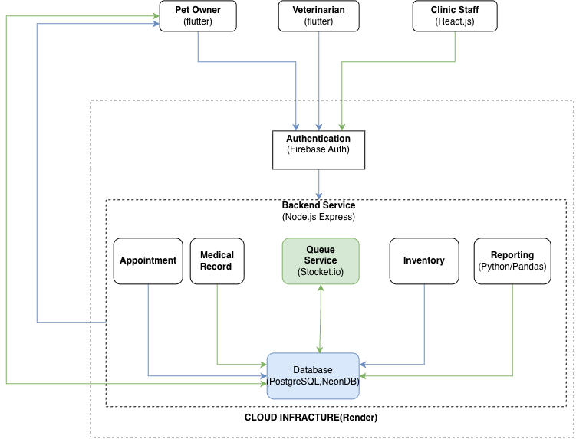
Fig : 48 System Architecture Diagram
The system follows a layered client-server architecture consisting of the presentation layer, application logic layer, and data layer. The architecture connects the user interfaces with the backend services, authentication service, database, and cloud infrastructure. The system architecture diagram shows Flutter interfaces for Pet Owners and Veterinarians, a React.js interface for Clinic Staff, Firebase Authentication, a Node.js and Express backend, PostgreSQL/NeonDB, and supporting services.
Presentation Layer
The presentation layer provides the user interface for the different system roles. The Pet Owner and Veterinarian applications are developed using Flutter, while the Clinic Staff interface is developed using React.js. The interfaces allow users to access functions according to their assigned roles, such as appointments, medical records, queue information, inventory, and management features.
Application Logic Layer
The application logic layer is handled by the Node.js and Express backend. It receives requests from the client applications, processes system logic, and coordinates the main services. These services include appointments, medical records, queue management, inventory, and reporting. Socket.io is used for the queue service to support real-time communication.
Data Layer
The data layer uses PostgreSQL through NeonDB as the main database shown in the system architecture. It stores and manages system information required by the application, including user information, pet data, appointments, medical records, inventory data, and other operational records. Python and Pandas are used for reporting and data processing.
Authentication and Cloud Infrastructure
Firebase Authentication provides authentication for system users. The backend and database services are deployed within the cloud infrastructure using Render. This structure allows the client applications to communicate with the backend while the backend communicates with the database and supporting services.
Overall Architecture:
• Pet Owner / Veterinarian → Flutter
• Clinic Staff → React.js
• Flutter / React.js → Firebase Authentication
• Flutter / React.js → Node.js + Express Backend
• Backend → Appointment | Medical Record | Queue | Inventory | Reporting
• Backend Services → PostgreSQL / NeonDB
• System → Render Cloud Infrastructure
4.4. Technology Used

Component | Technology | Purpose
Frontend | Flutter | Development of the Pet Owner and Veterinarian interfaces.
Staff Frontend | React.js | Development of the Clinic Staff web interface.
Authentication | Firebase Authentication | User authentication and account access.
Backend | Node.js + Express.js | API services, application logic, request processing, and communication.
Database | PostgreSQL / NeonDB | Storage and management of clinic and operational data.
Real-time Service | Socket.io | Real-time queue communication and updates.
Reporting | Python / Pandas | Reporting and data processing.
Cloud Infrastructure | Render | Cloud deployment and hosting of system services.
UI/UX Design | Figma | Interface design, wireframes, prototypes, and visual planning.
Table : 42 Technology Used Table
The selected technologies support the different parts of the Nway’s Love Vet Clinic Management System. Flutter provides the main cross-platform interfaces for Pet Owners and Veterinarians, while React.js is used for the Clinic Staff interface. Node.js with Express.js provides the backend services and application logic. Firebase Authentication manages user authentication, and PostgreSQL through NeonDB provides the main data storage. Socket.io supports real-time queue updates, while Python and Pandas are used for reporting and data processing. Render provides the cloud infrastructure for deployment. Figma is used during the UI/UX design stage to plan interfaces, layouts, and prototypes.
Flutter
Flutter is used to develop the Pet Owner and Veterinarian interfaces and provide a consistent cross-platform application experience.
React.js
React.js is used to develop the Clinic Staff web interface and provide access to clinic management functions.
Firebase Authentication
Firebase Authentication is used to manage user authentication and account access within the system.
Node.js and Express.js
Node.js and Express.js are used for the backend of the system. They handle application requests, system logic, and communication between the client applications and database services.
PostgreSQL / NeonDB
PostgreSQL through NeonDB is used as the main database for storing and managing system information and operational records.
Socket.io
Socket.io is used to support real-time communication for the queue service, allowing queue information to be updated between the system components.
Python / Pandas
Python and Pandas are used for reporting and data processing within the system.
Render
Render provides the cloud infrastructure used to deploy and host the system services.
Figma
Figma is used during the UI/UX design process to create and organize interface designs, wireframes, prototypes, and navigation flows before implementation.

4.5 Site / Navigation Structure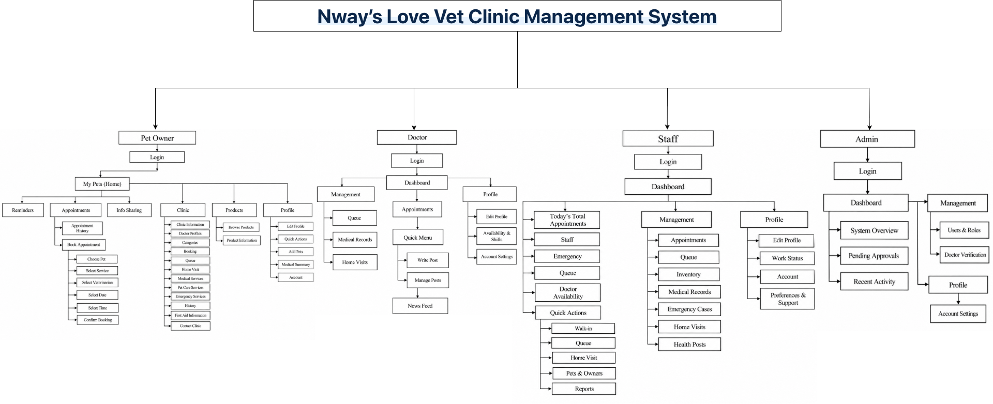
Fig : 49 Sitemap Diagram
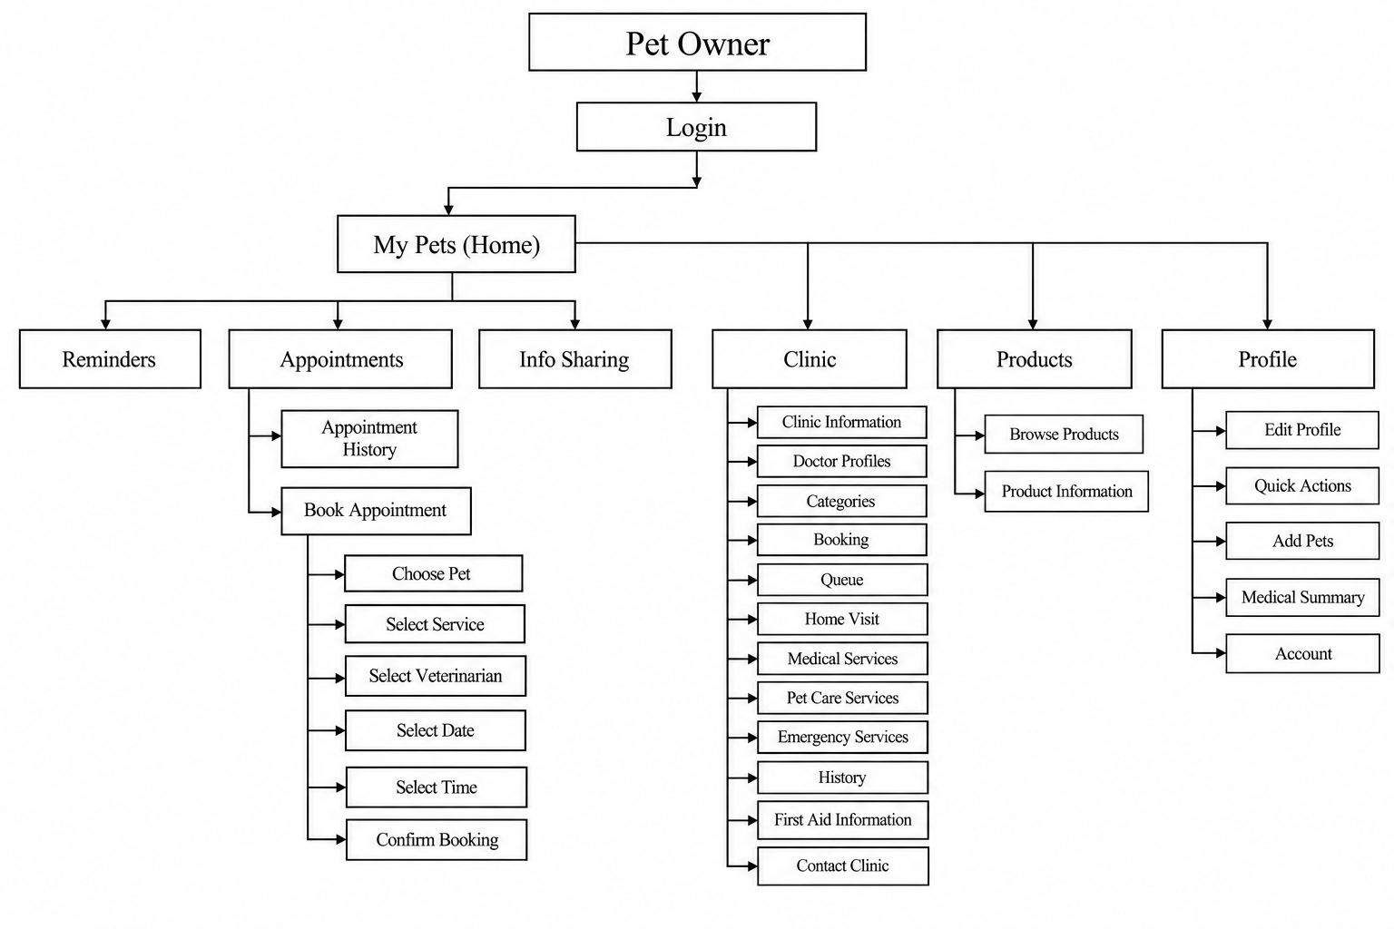
Fig : 50 Sitemap Diagram Detail 1 (Pet Owner)
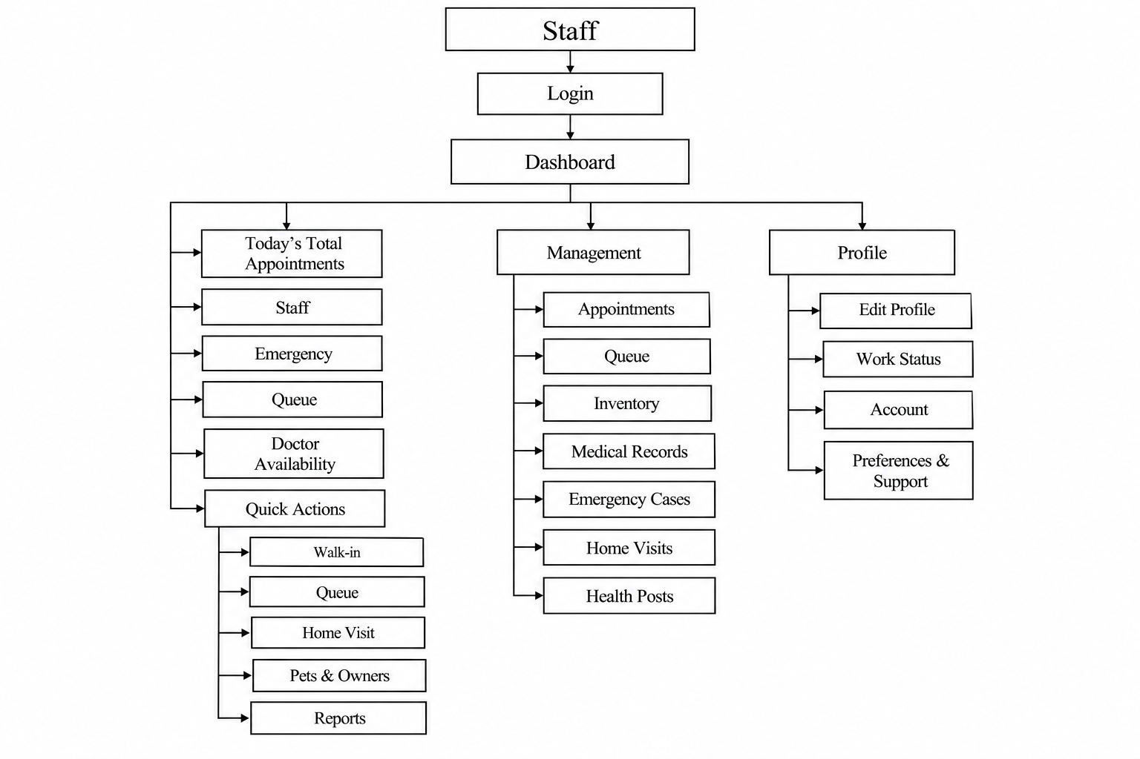
Fig : 51 Sitemap Diagram Detail 2 (Staff)

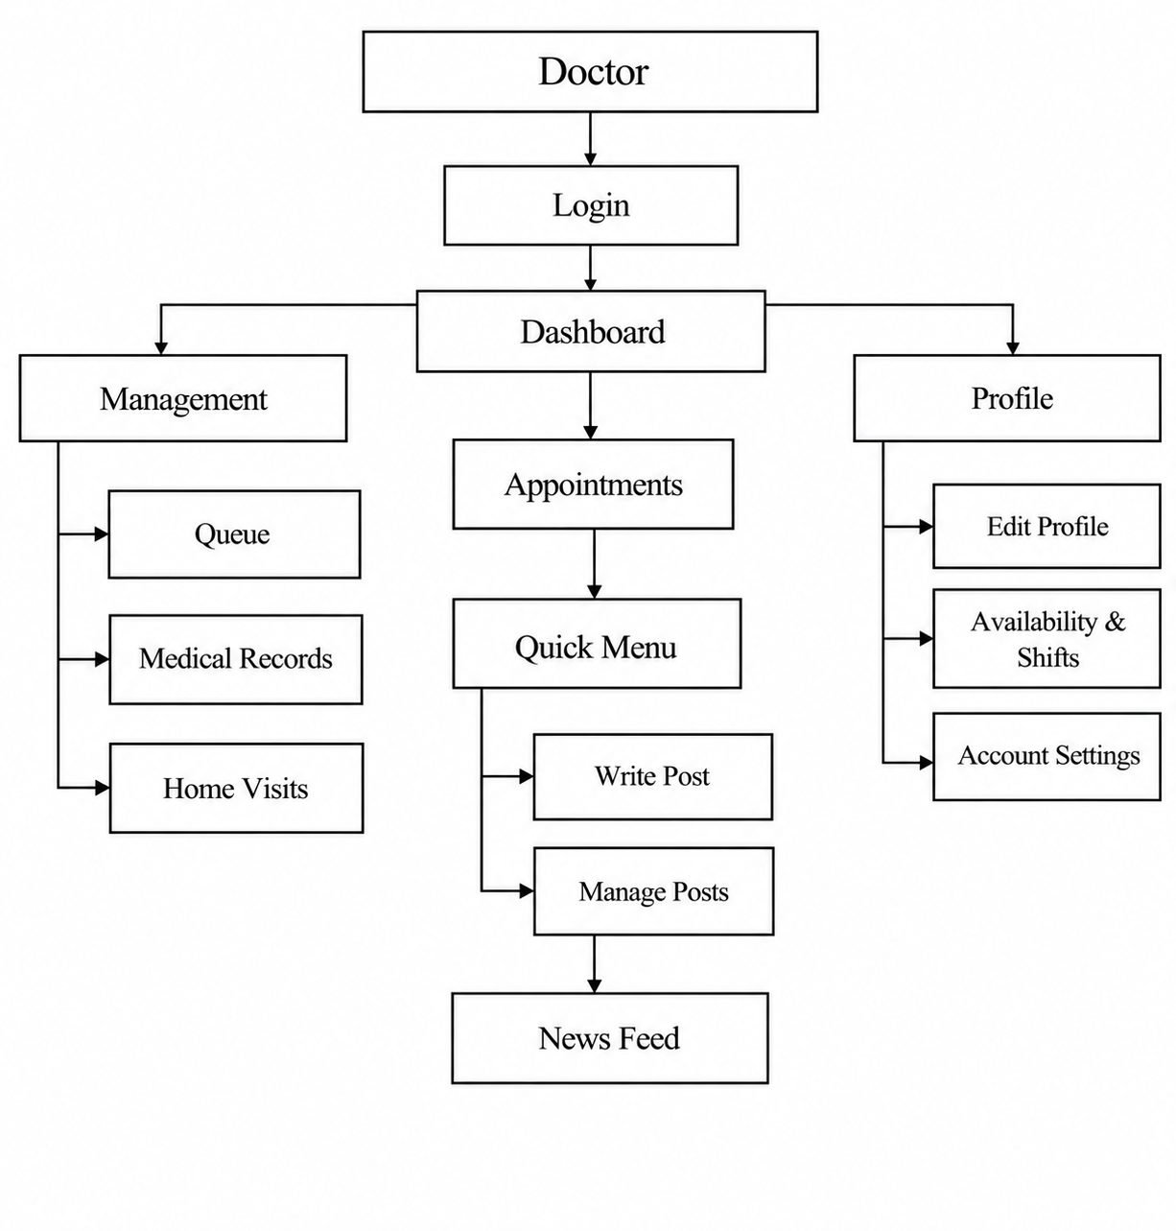
Fig : 52 Sitemap Diagram Detail 3 (Doctor)

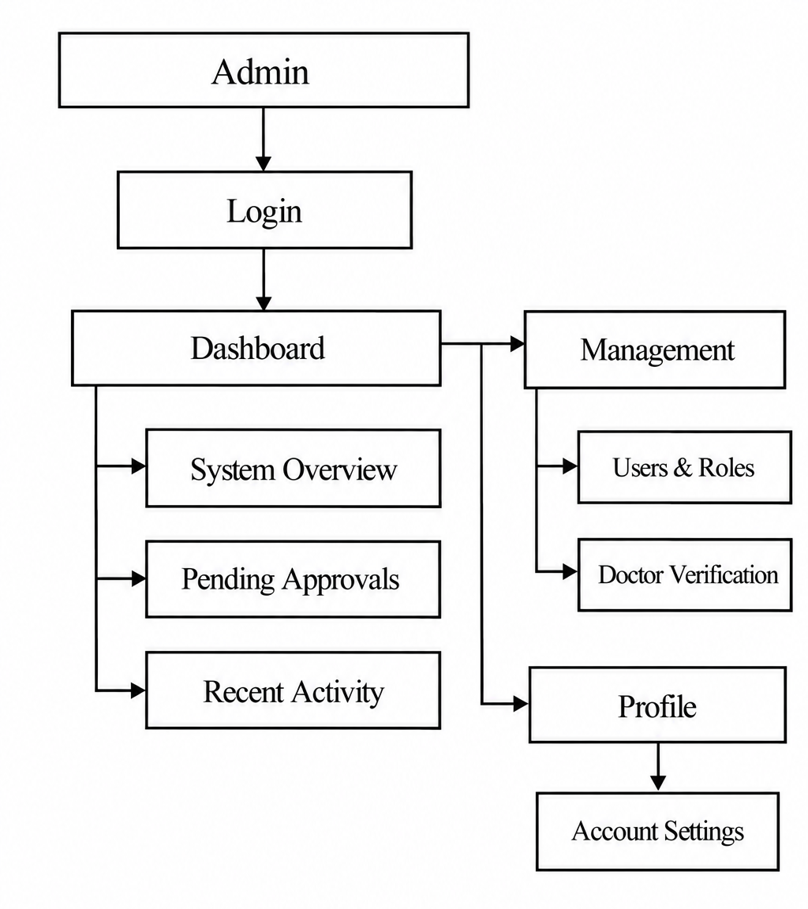
Fig : 53 Sitemap Diagram Detail 4 (Admin)
4.6 UX/UI Design
The UX/UI design focuses on making the system simple, organized, and easy to use for different types of users.
The design separates functions according to user roles so that each user can quickly access the features relevant to their responsibilities.

4.6.1 Login

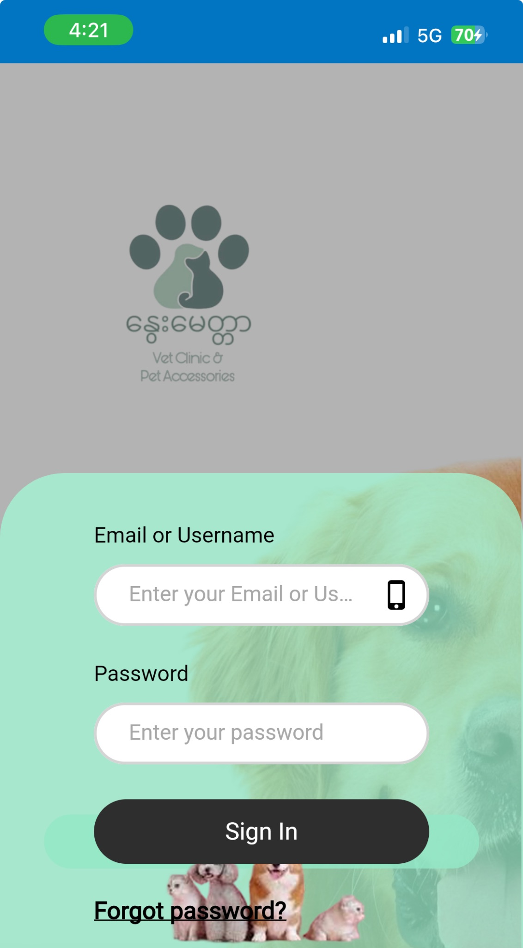
The system provides secure user authentication to ensure that only registered users can access the application. Users are required to log in using their registered credentials, while new users can create an account through the registration process. The system also implements role-based access control, which provides different permissions and features based on the user’s assigned role, such as pet owner, staff, doctor, or administrator. This helps protect sensitive information and ensures that each user can only access the functions relevant to their responsibilities.

4.6.2 Main UI Design of Pet Owners Side
4.6.2.1 My pets
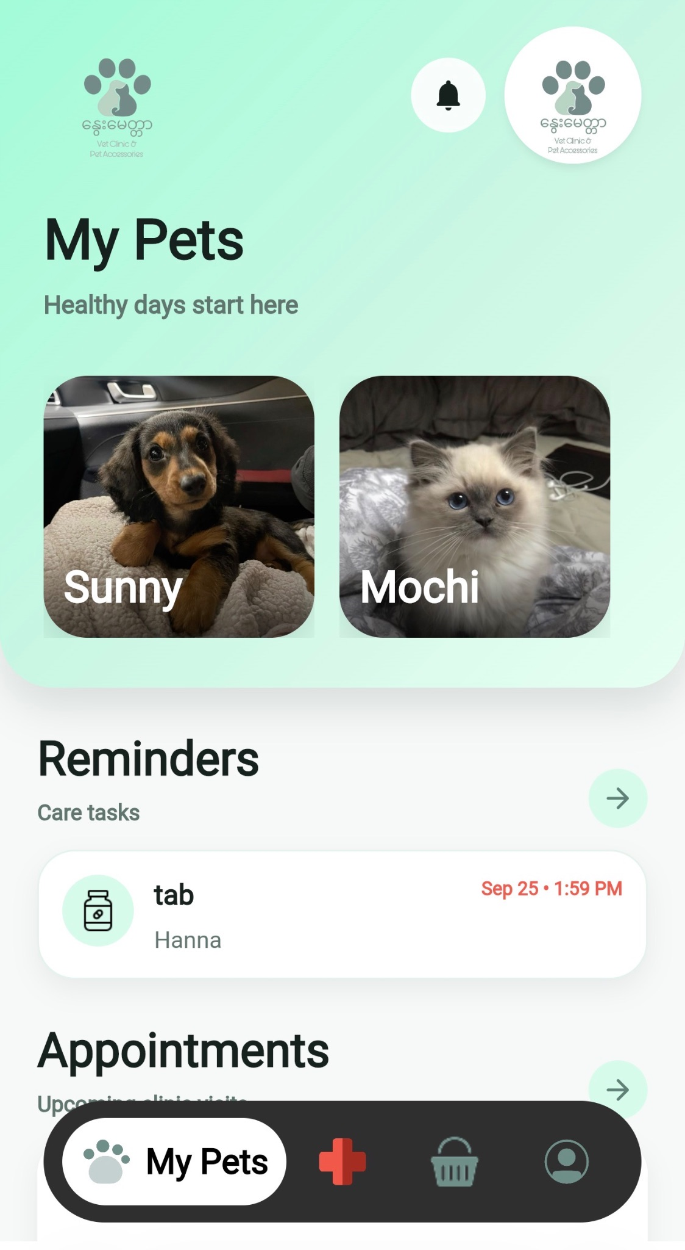

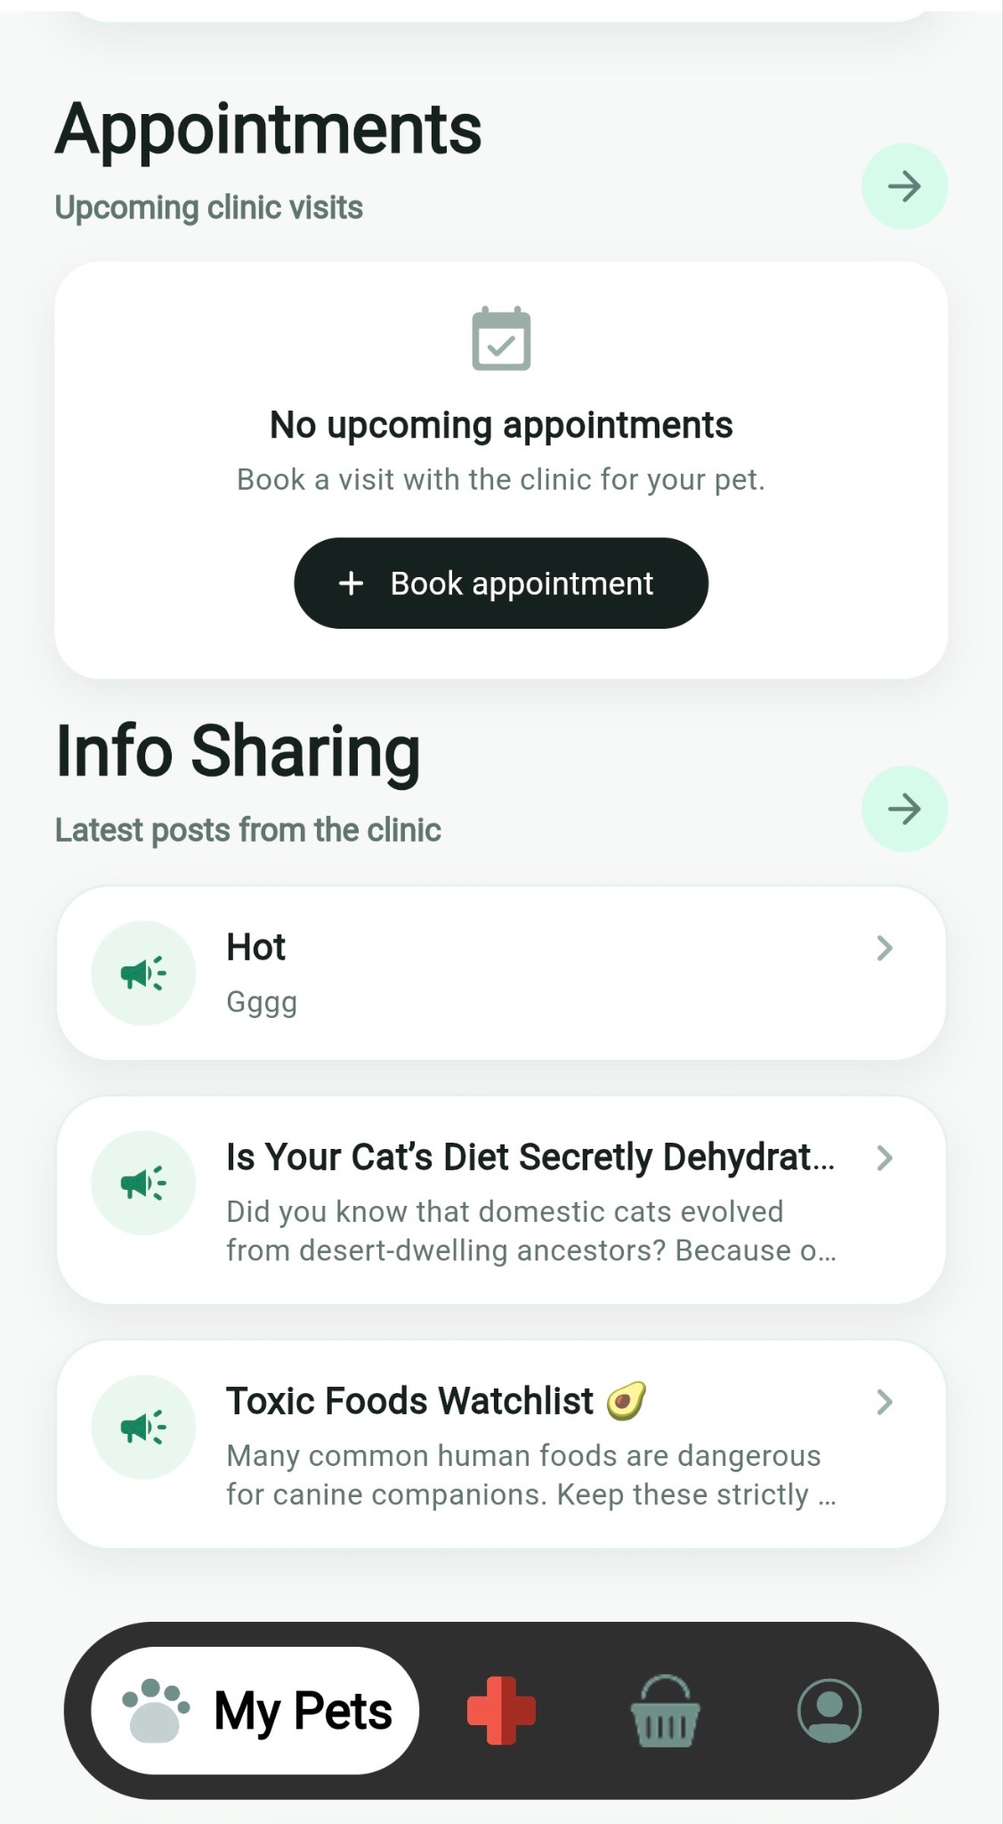
The My Pets (Home) section is the main area for pet owners. It provides access to Reminders, Appointments, and Info Sharing. Under Appointments, pet owners can view their Appointment History or book a new appointment.

4.6.2.2 Clinic Page
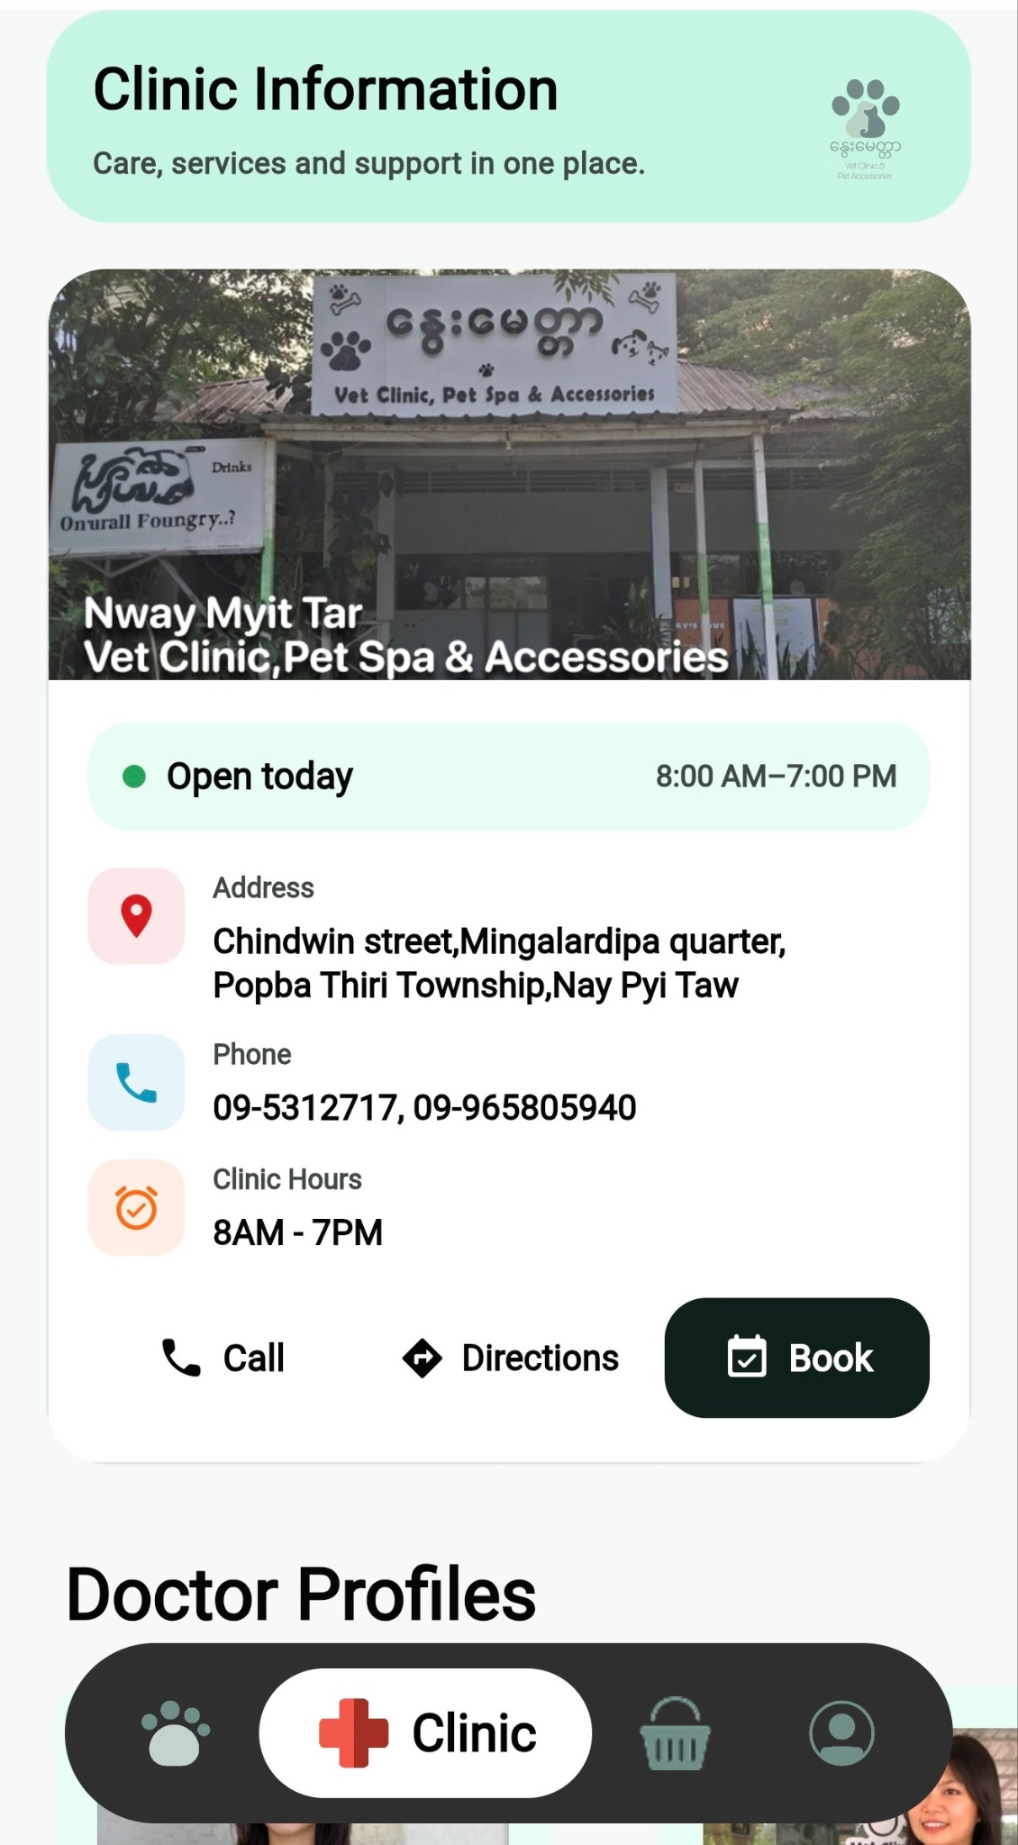
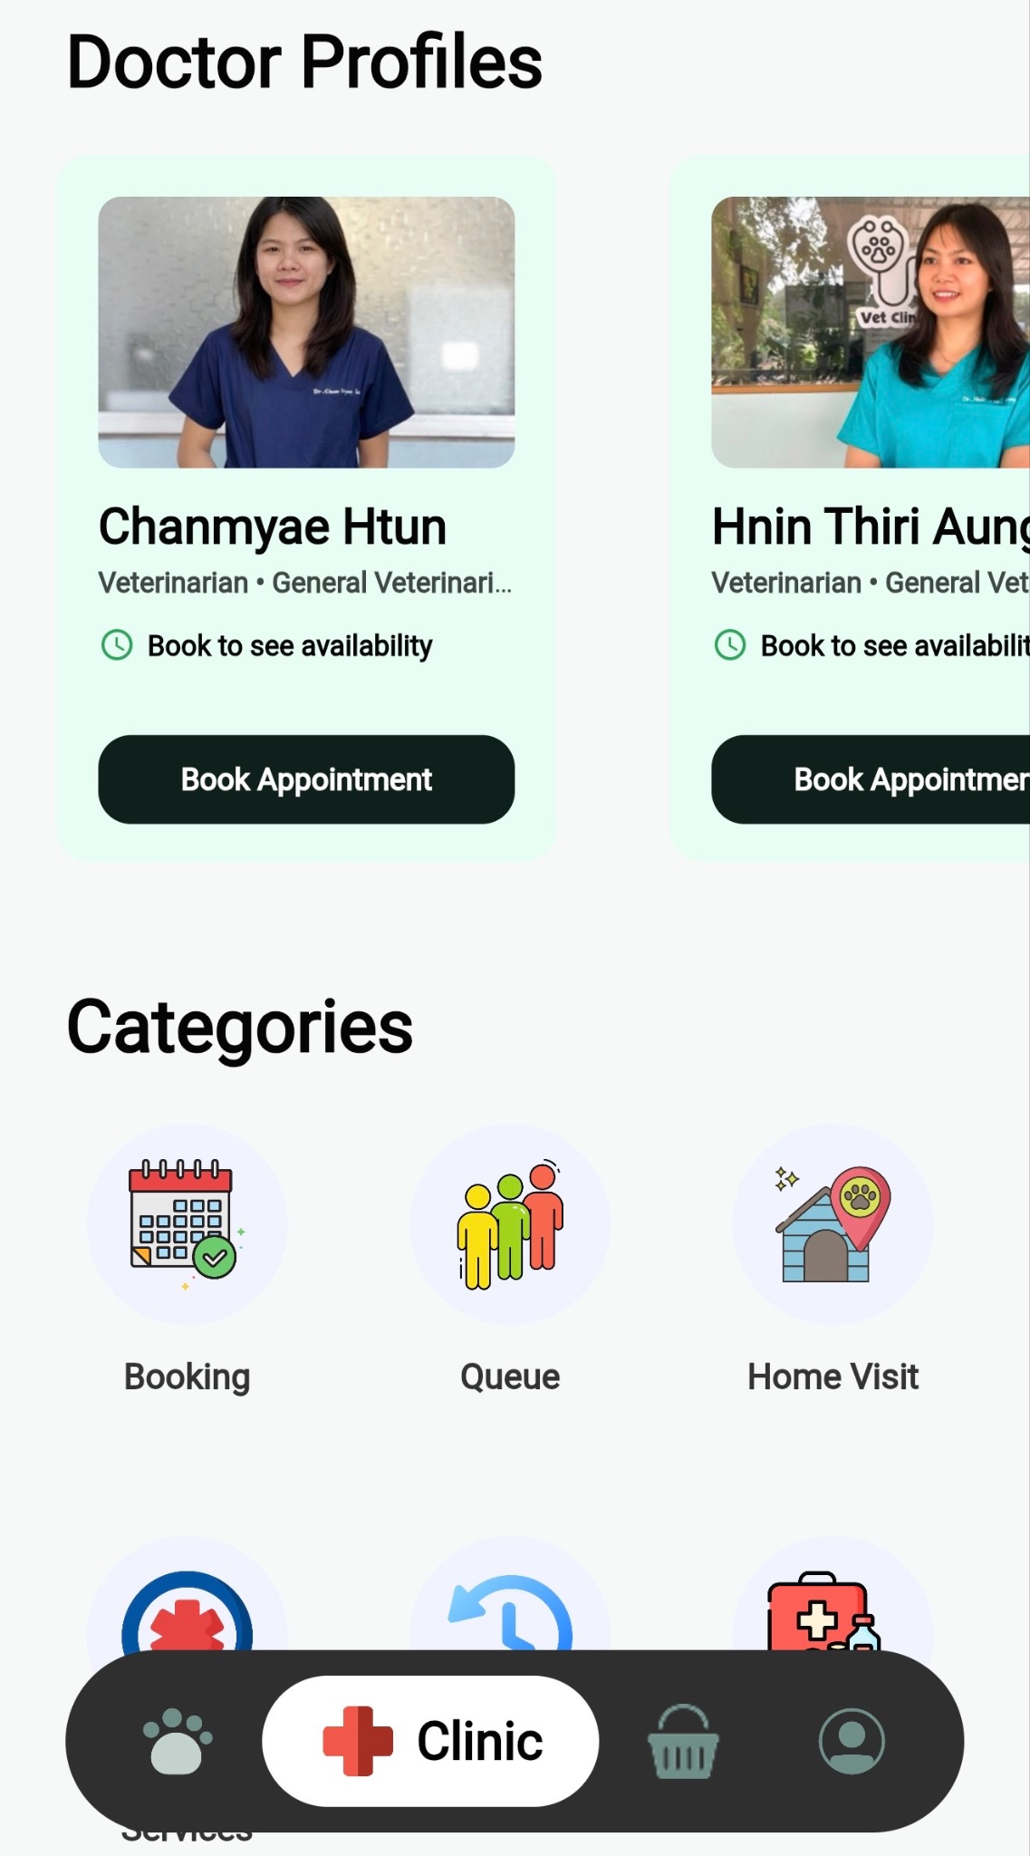
The Clinic Information section provides pet owners with important information about Nway Myit Tar Vet Clinic, including the clinic’s location, contact numbers, opening hours, and available services. Users can also view Doctor Profiles, where they can see veterinarian information and book an appointment with a selected doctor. The section includes different service categories such as Booking, Queue, Home Visit, and other clinic services. This allows pet owners to easily access clinic information, learn about available veterinarians and services, and make appropriate decisions before booking an appointment.

4.6.2.3 Booking Processes
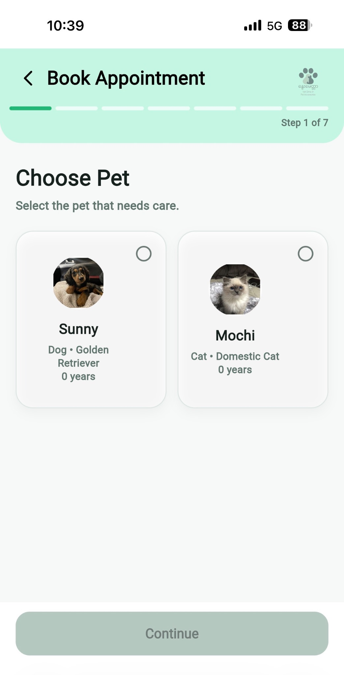
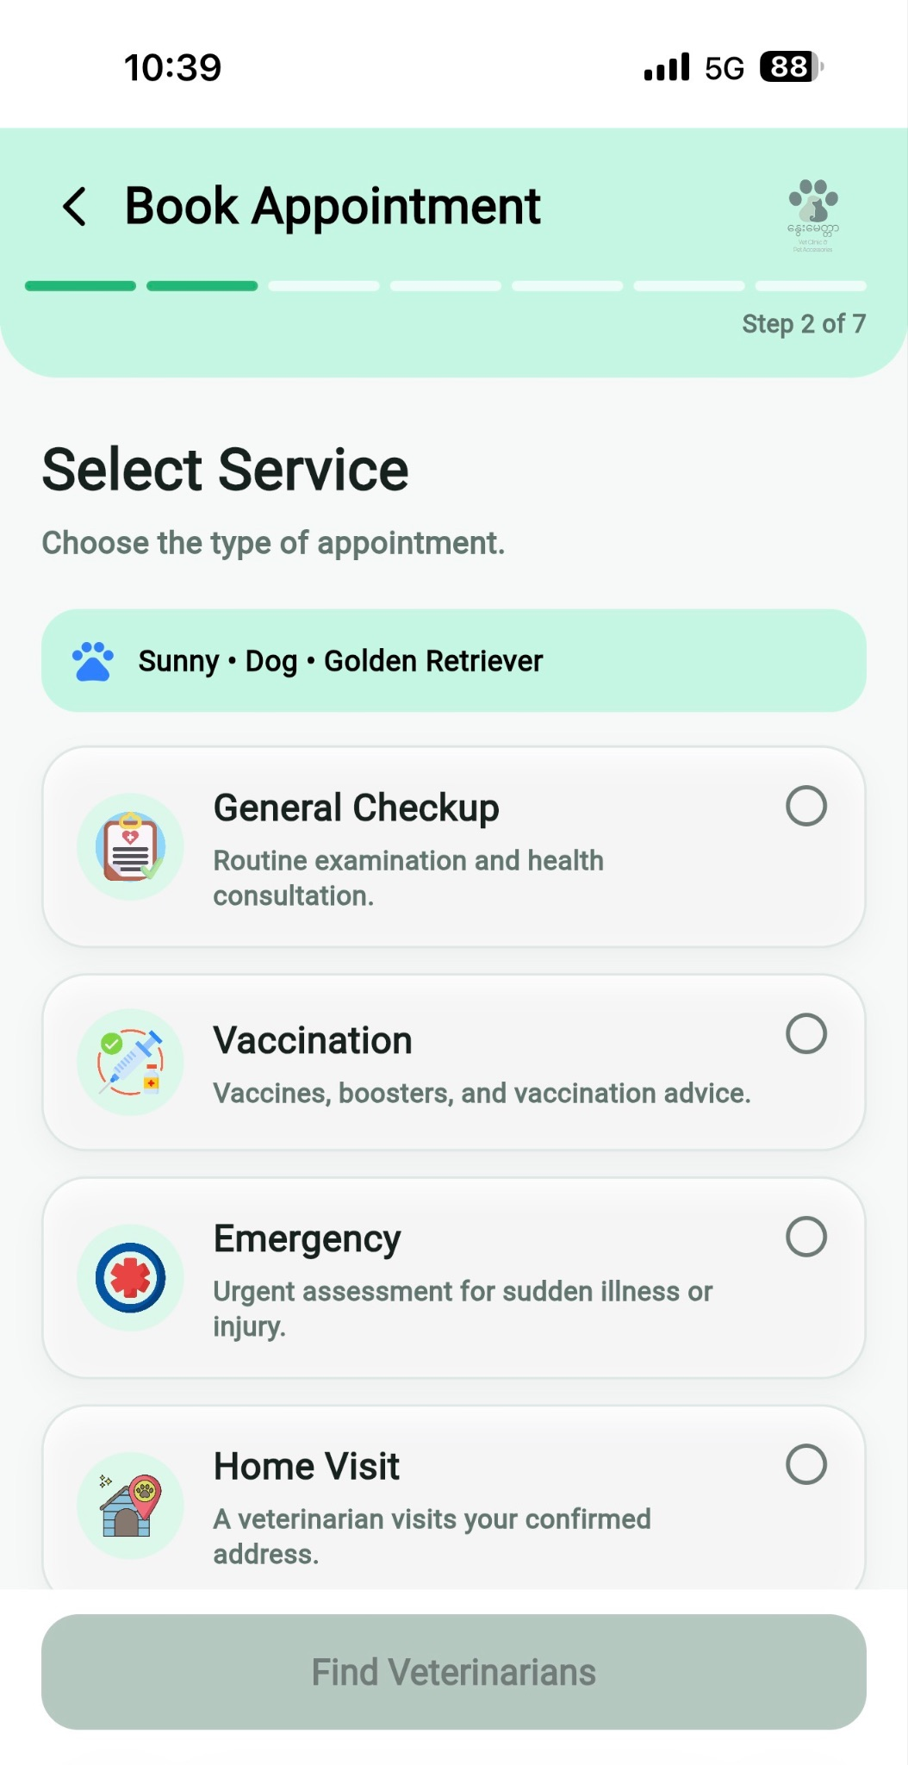
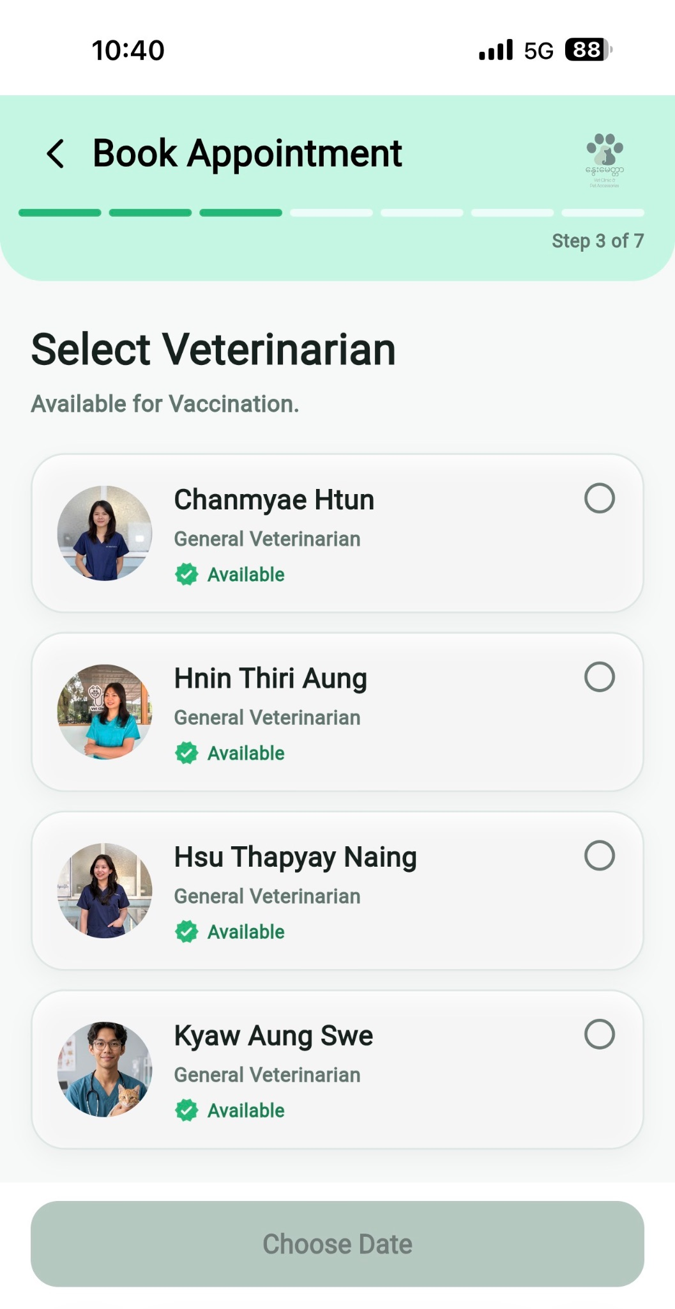
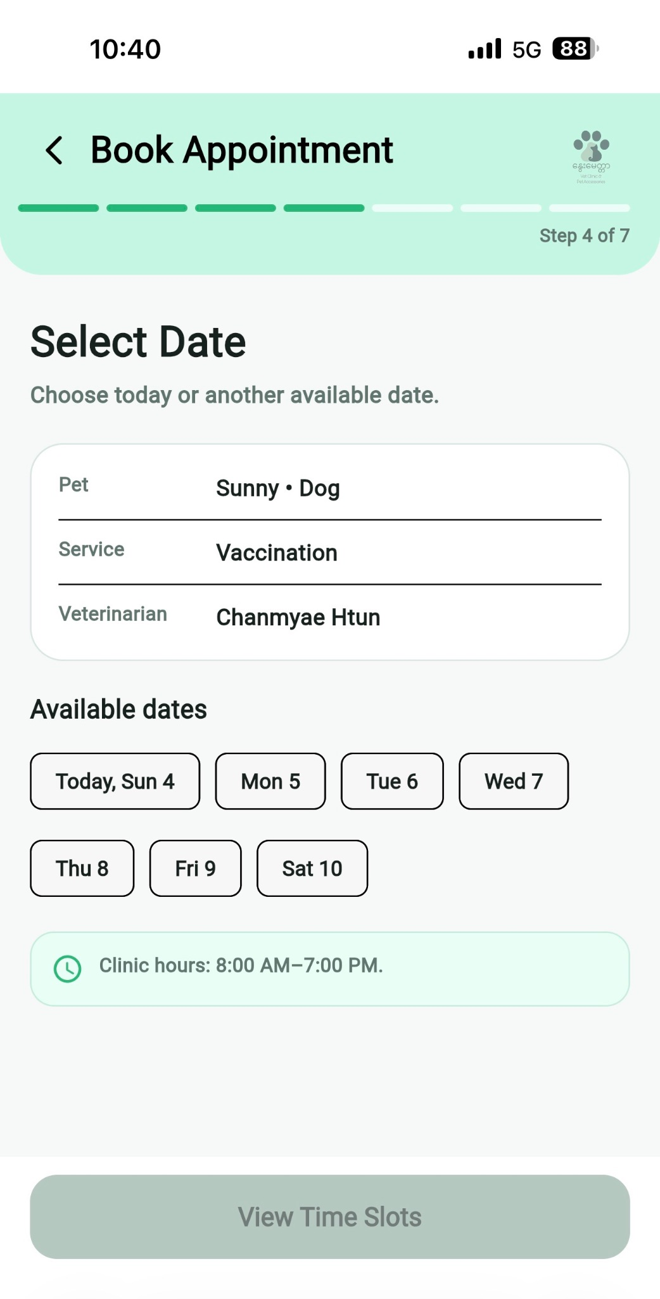
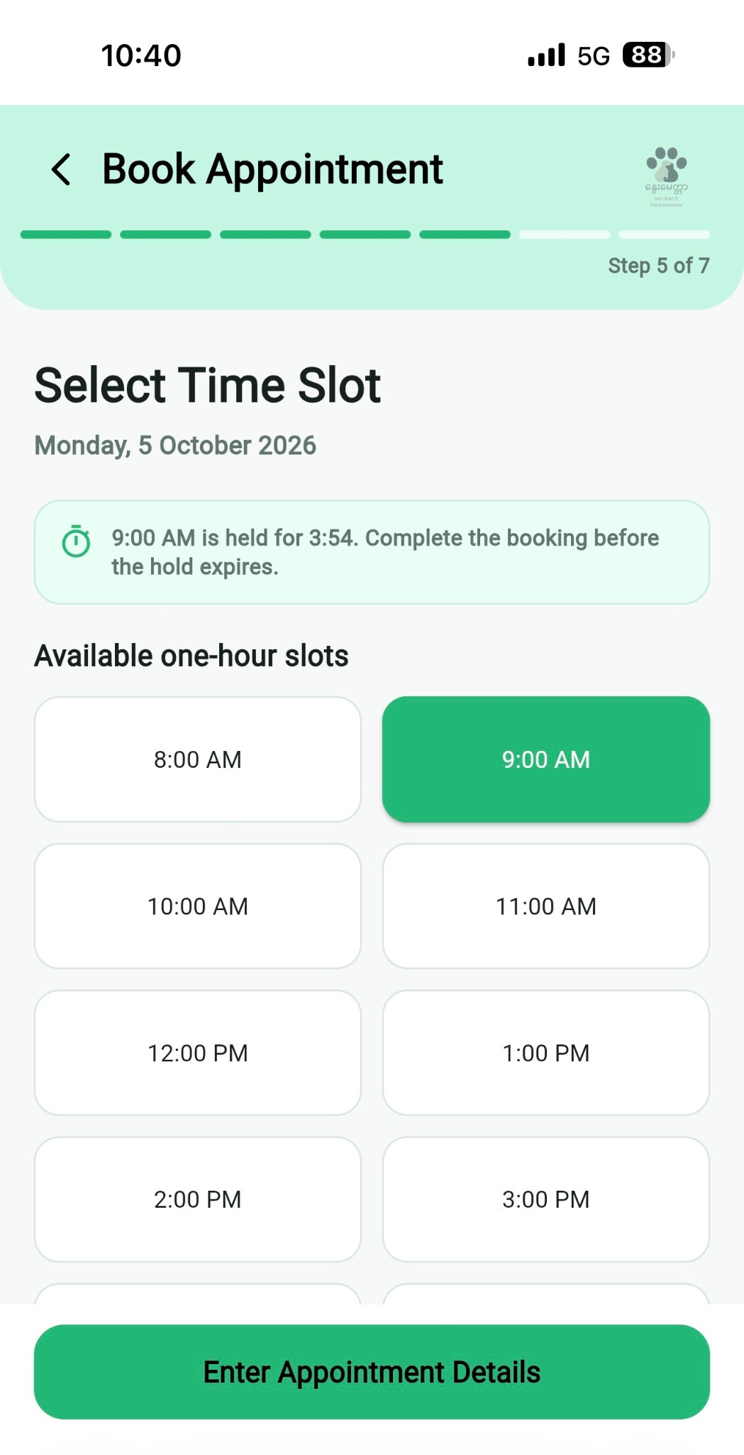
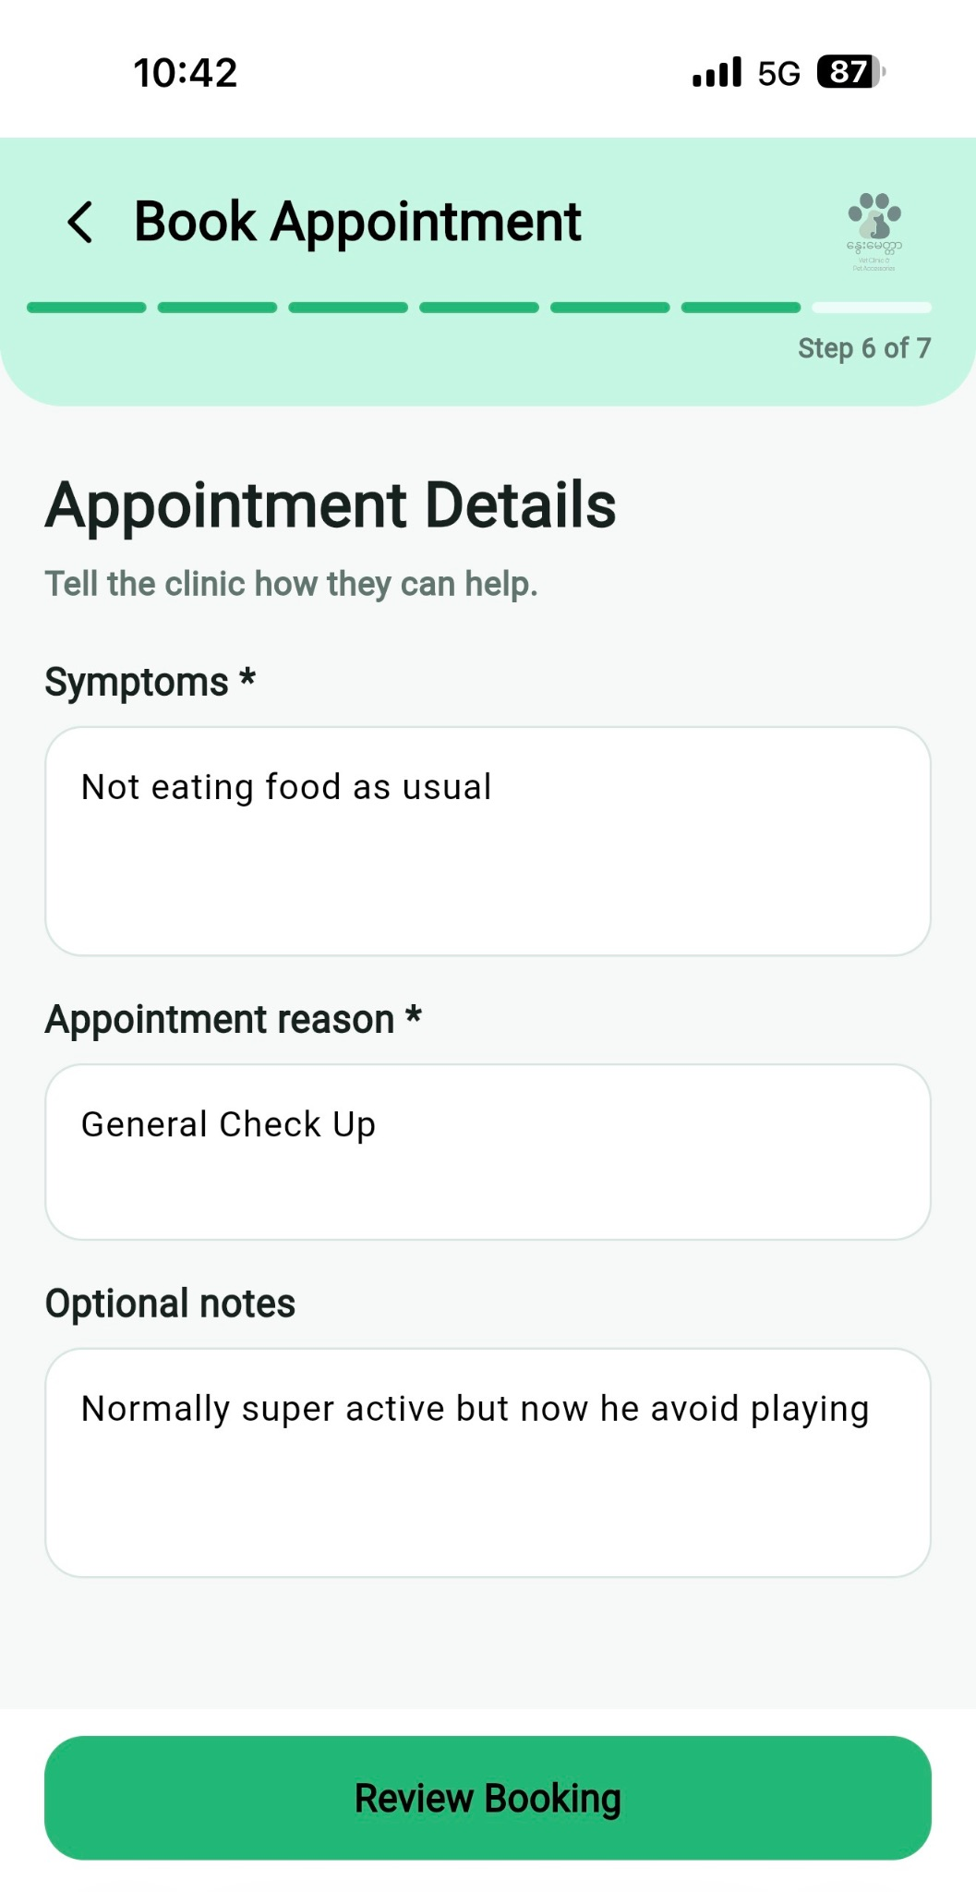
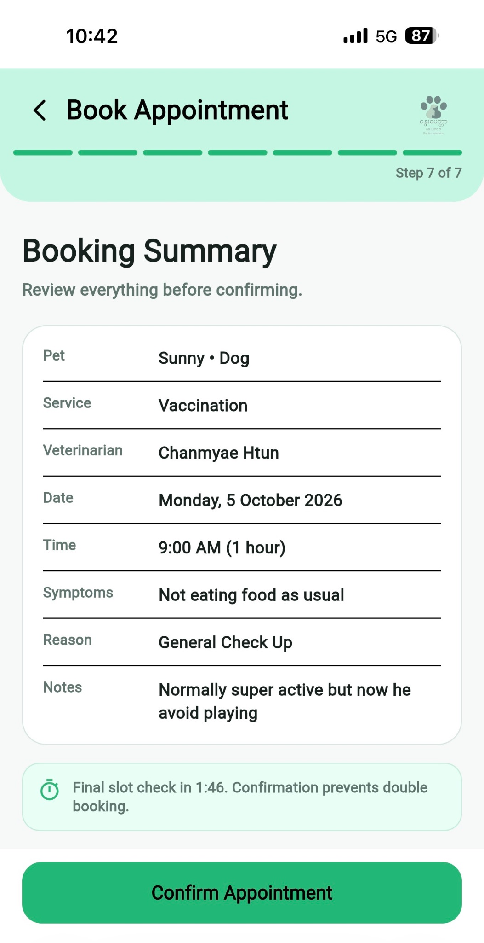
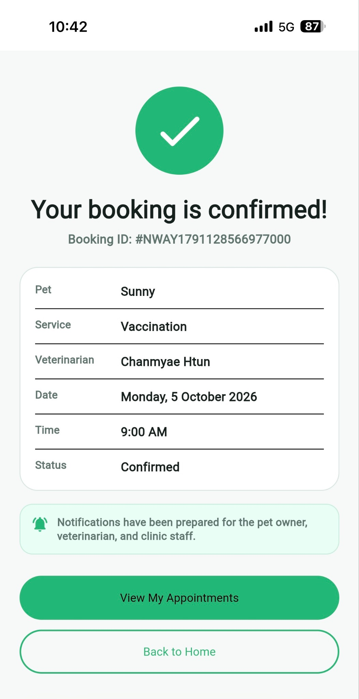
The booking process allows them to choose a pet, select a service, select a veterinarian, choose a date and time, and confirm the booking. This structure makes it easier for pet owners to manage their pets, appointments, and clinic-related information from one central location.

4.6.2.4 Product Page (Pet Owners)

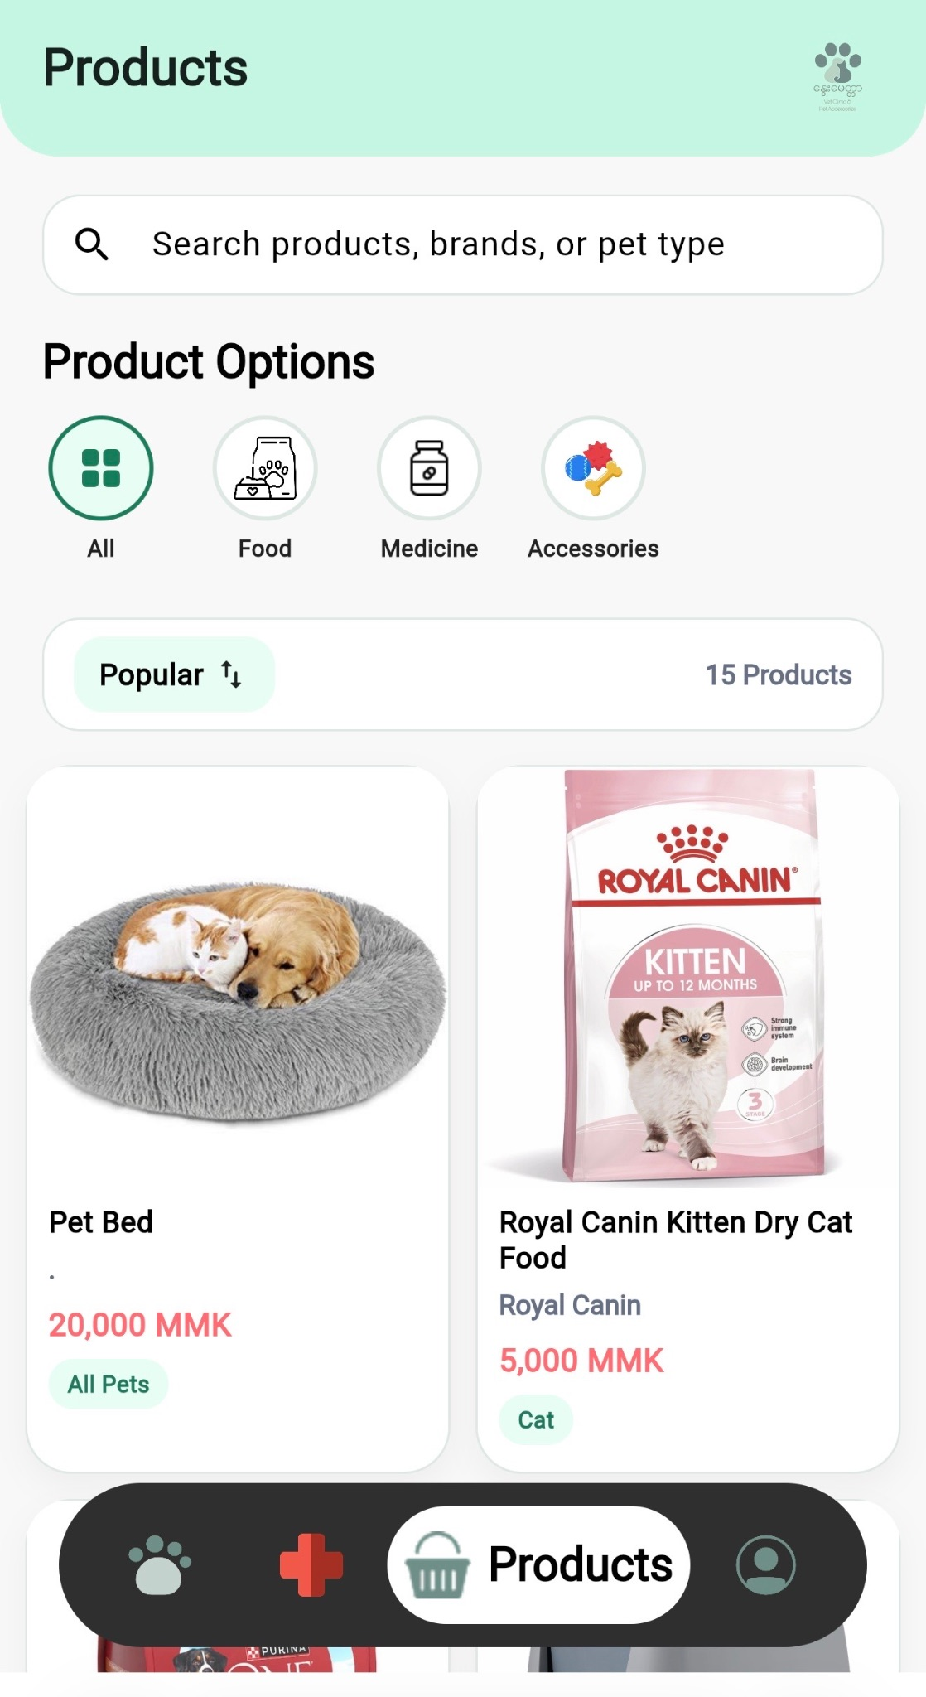
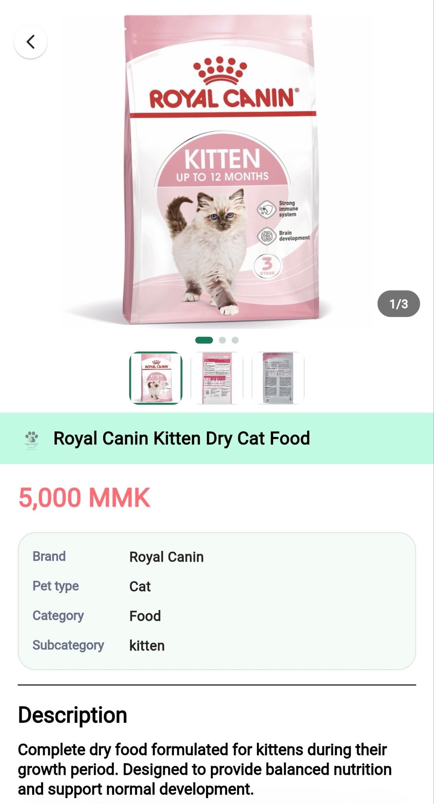
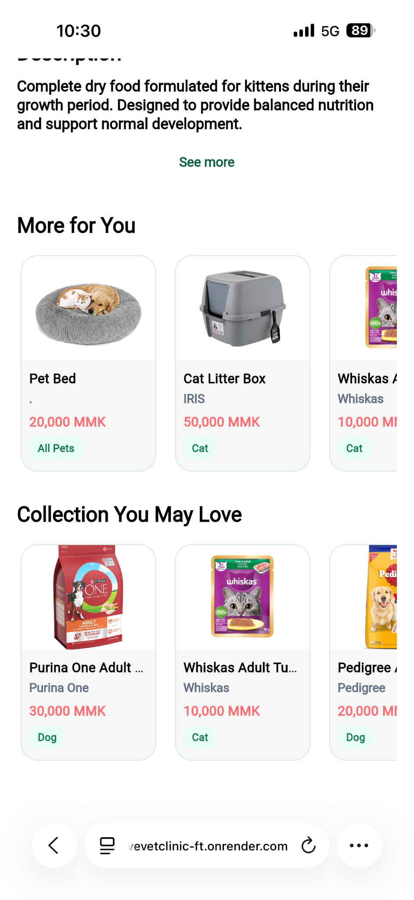
The Products section allows pet owners to browse and search for pet-related products available through the clinic system. Products are organized into categories such as Food, Medicine, and Accessories, with an option to view all products or search by product name, brand, or pet type. Users can select a product to view detailed information, including its price, brand, pet type, category, subcategory, product images, and description. The system also provides related product recommendations through sections such as “More for You” and “Collection You May Love,” making it easier for pet owners to discover other suitable products for their pets.

4.6.2.5 Profile Page (Pet Owners)
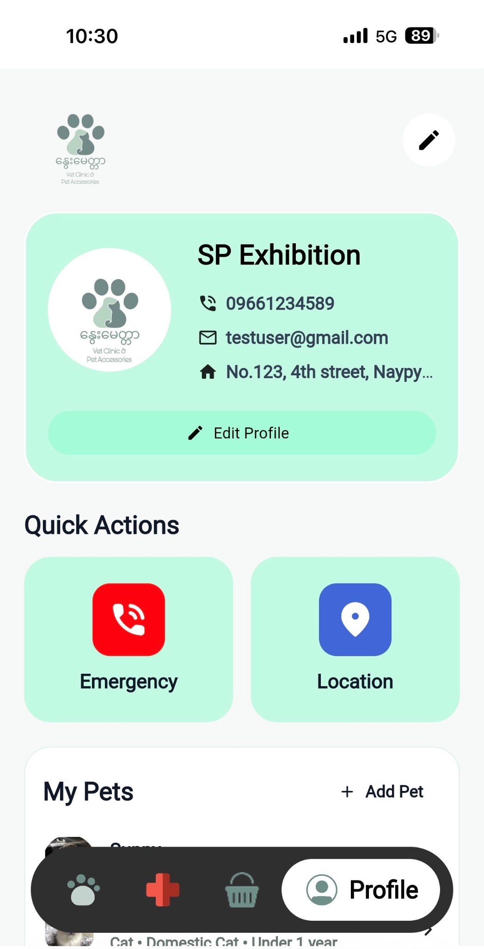
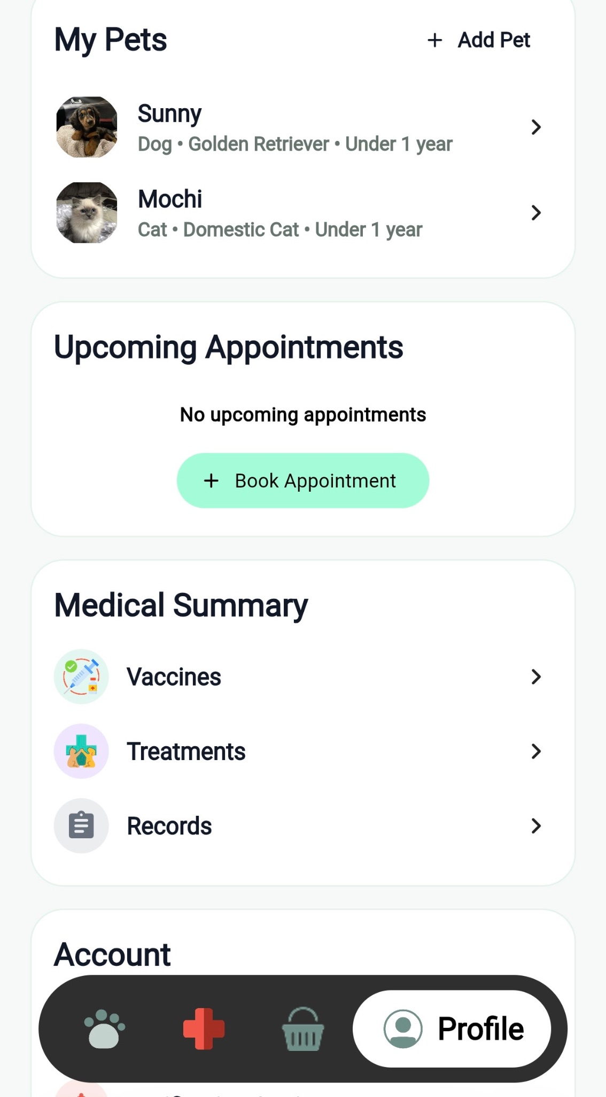
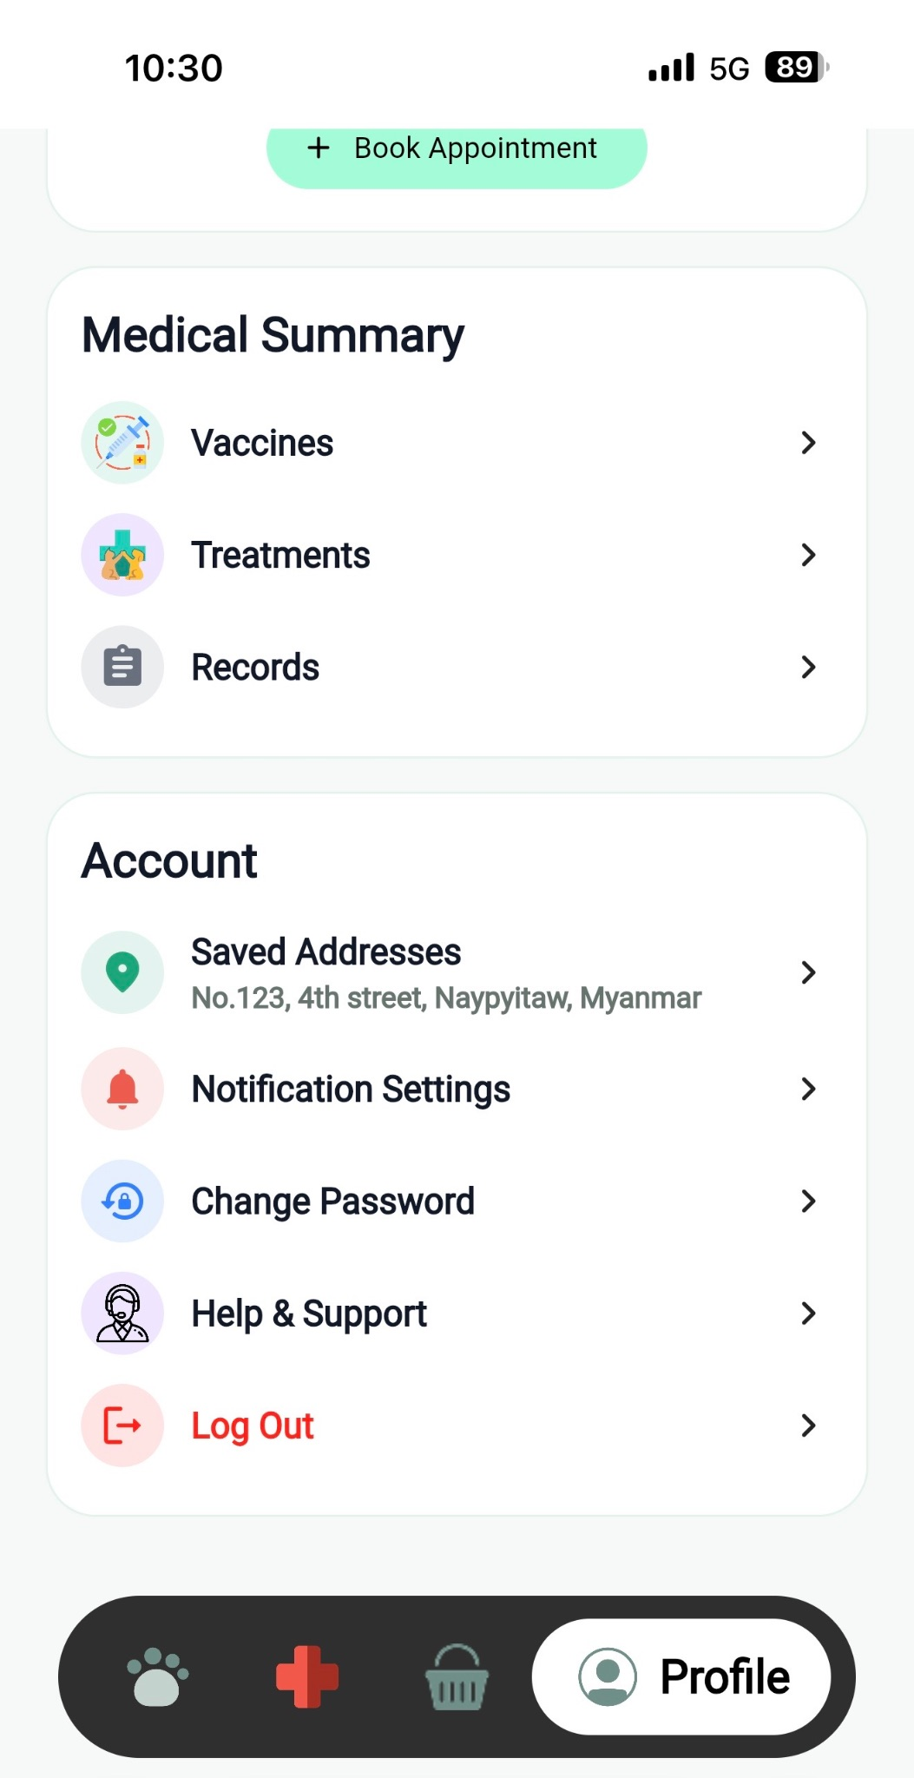
The Profile section allows pet owners to manage their personal information, pets, appointments, medical information, and account settings. Users can edit their profile information and access quick actions such as Emergency and Location. The My Pets section displays registered pets and allows users to add new pets. Users can also view Upcoming Appointmentsand book an appointment when needed. The Medical Summary provides access to Vaccines, Treatments, and Records for managing important pet health information. In addition, the Account section includes Saved Addresses, Notification Settings, Change Password, Help & Support, and Log Out, giving users control over their account and system preferences.

4.6.3 Main UI Design of Doctor Side
4.6.3.1 Dashboard
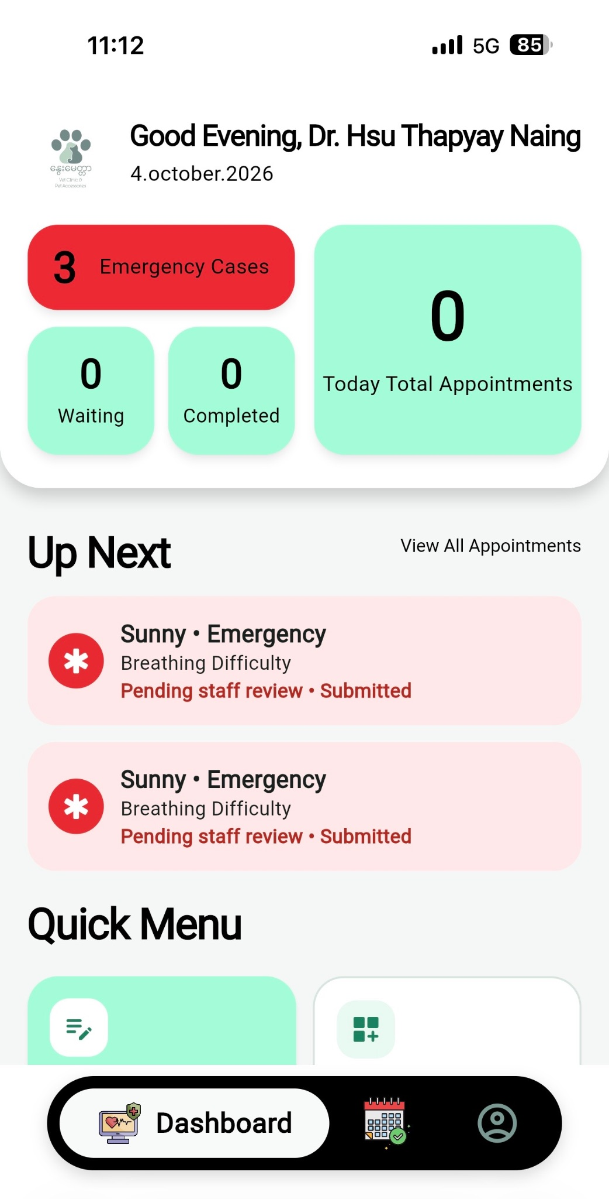
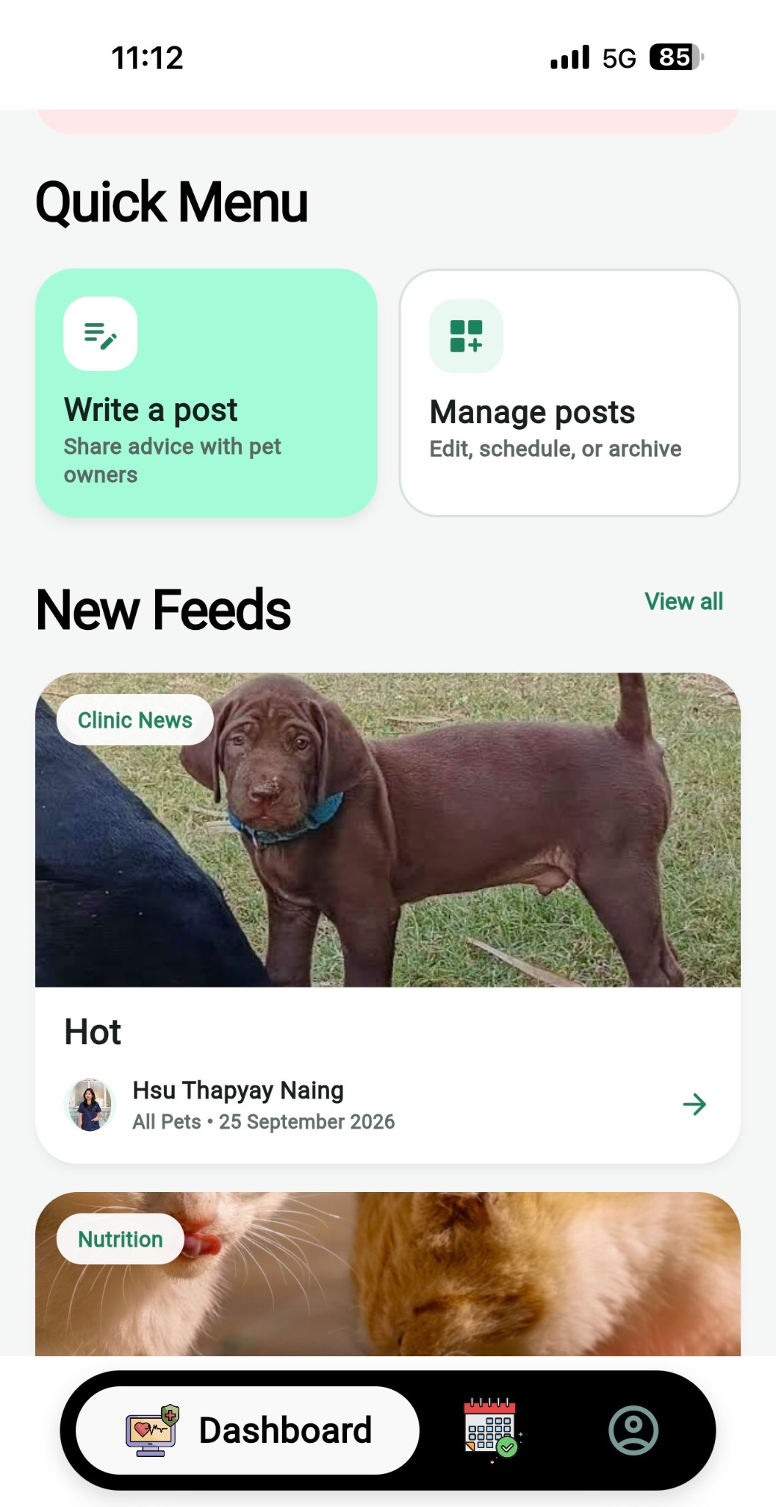
The Doctor Dashboard provides veterinarians with an overview of daily clinic activities and important patient information. The dashboard displays the number of emergency cases, waiting patients, completed cases, and total appointments for the day. The Up Next section highlights upcoming emergency cases and their current status, allowing doctors and staff to respond quickly to urgent situations. The Quick Menu provides access to functions such as creating and managing posts, while the New Feeds section allows clinic staff to share pet health advice, clinic news, and other useful information with pet owners.

4.6.3.2 Write a Post and Manage Posts
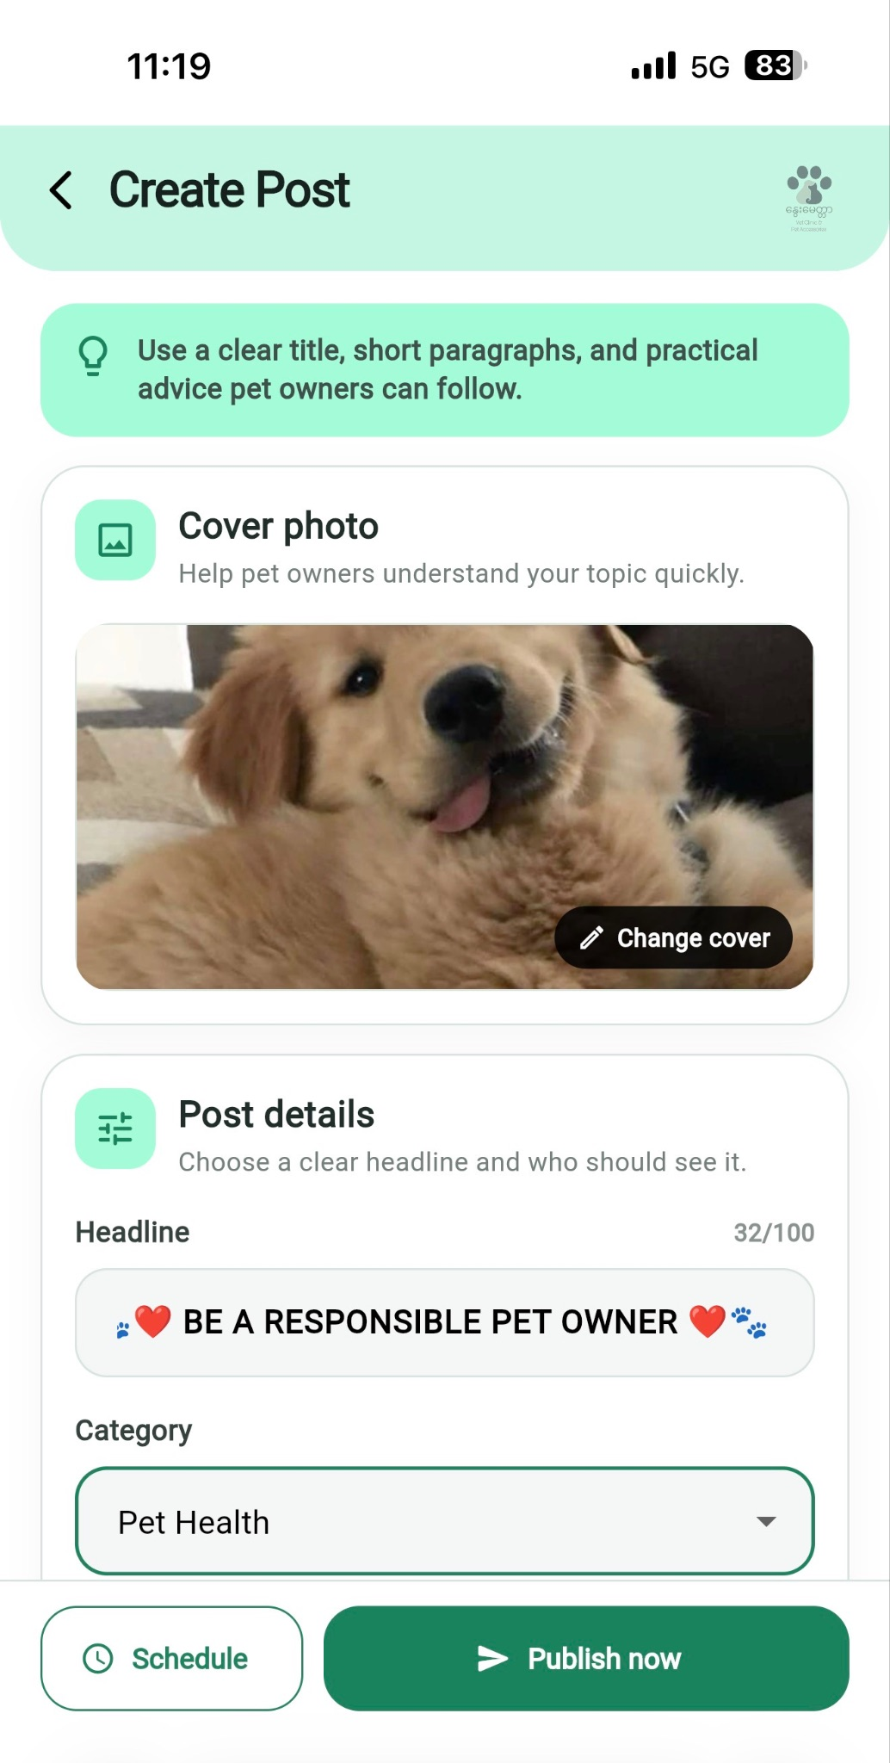
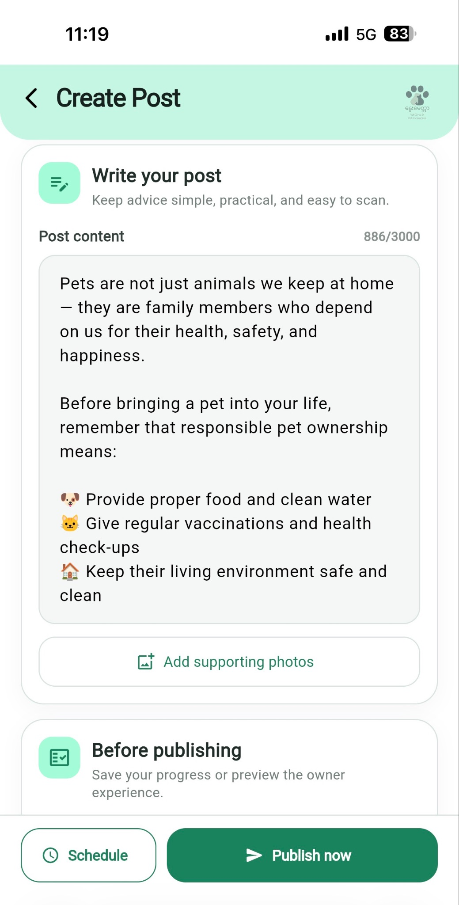
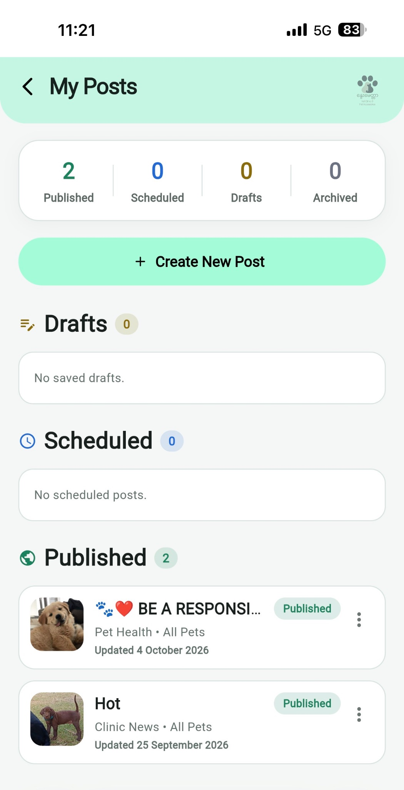
The system also includes a Post Management function. Doctors can create educational posts by adding a cover photo, headline, category, and post content. Posts can be published immediately or scheduled for a later time. The My Posts section allows staff to manage published, scheduled, draft, and archived posts. This helps the clinic share useful pet-care information, announcements, and health advice with pet owners through the system.

4.6.3.3 Appointments

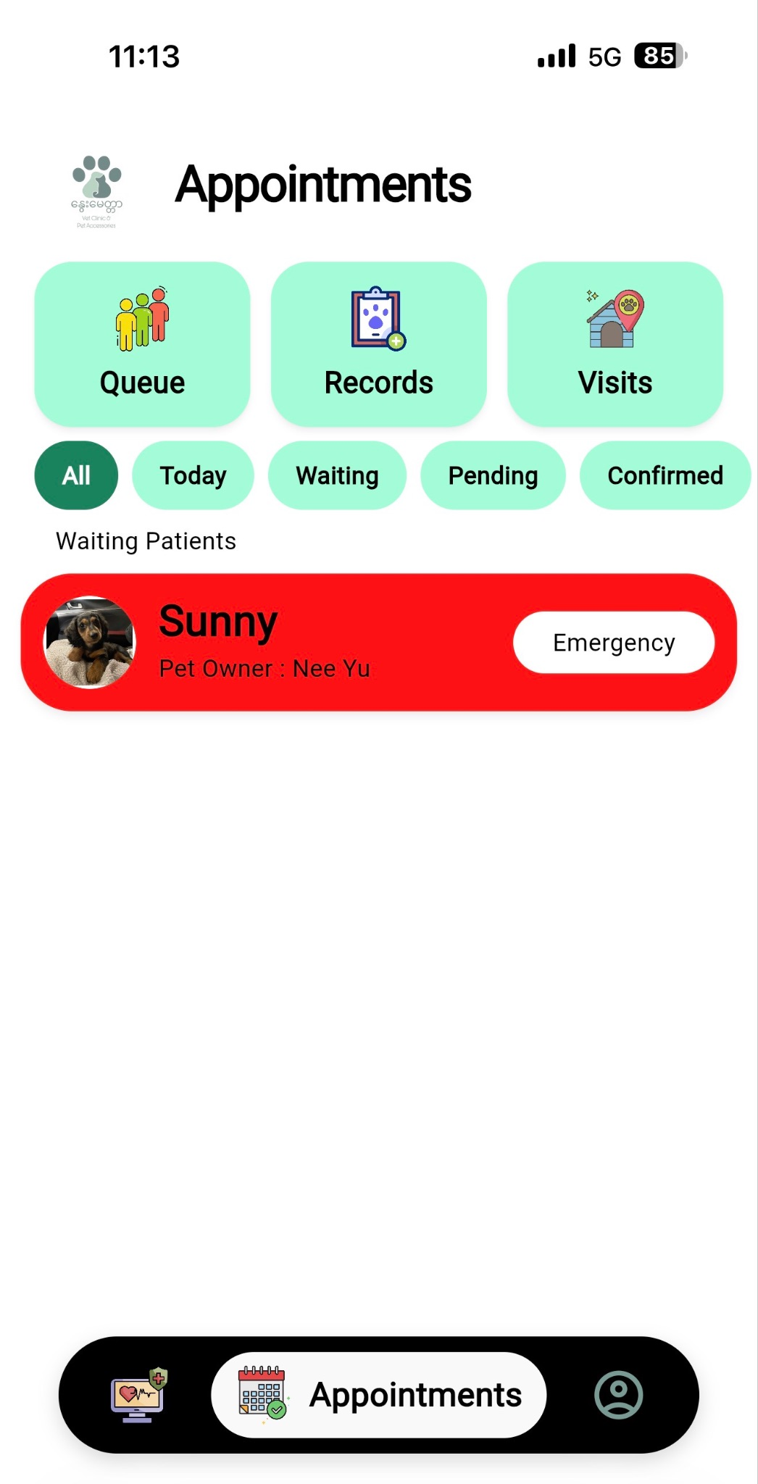

The Appointments section allows doctors to manage patient appointments through different filters, including All, Today, Waiting, Pending, and Confirmed. It also provides access to Queue, Records, and Visits, helping staff organize patient care and appointment information.

4.6.3.4 Profile

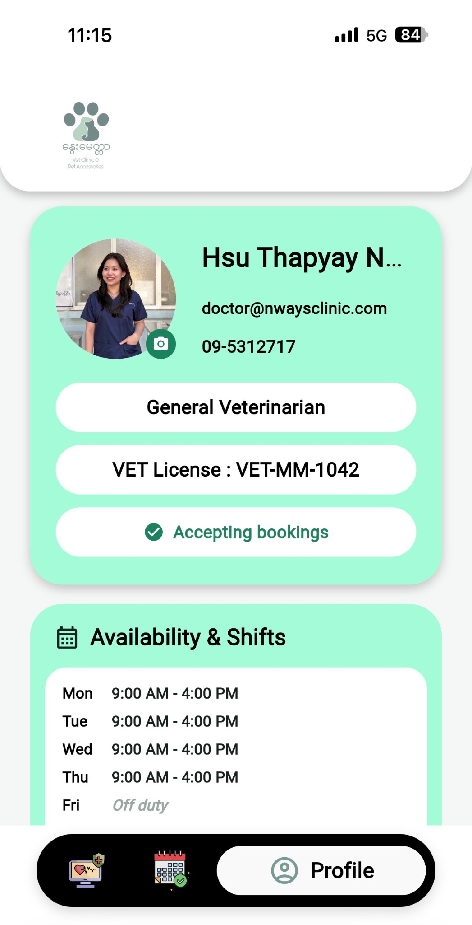
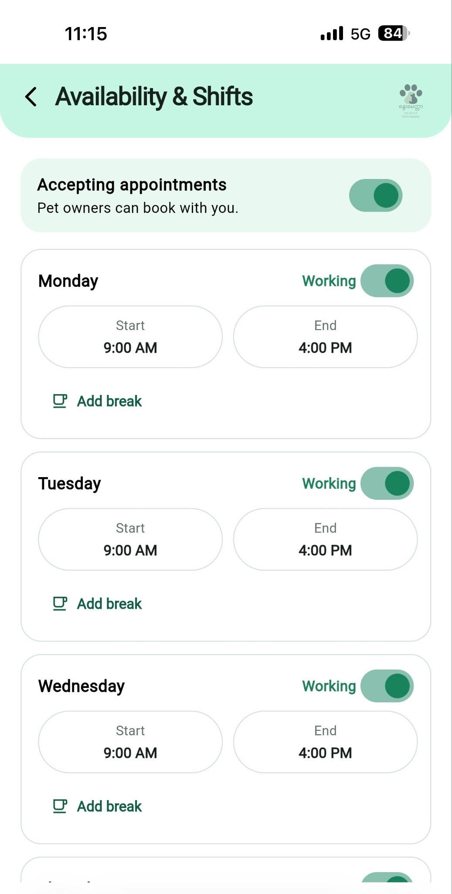

The Doctor Profile section displays the veterinarian's professional information, including their specialization, veterinary license, contact details, booking status, and working schedule. Through Availability & Shifts, doctors can set whether they are accepting appointments and configure their working hours for each day.

4.6.4 Main UI Design of Staff Side
4.6.4.1 Dashboard

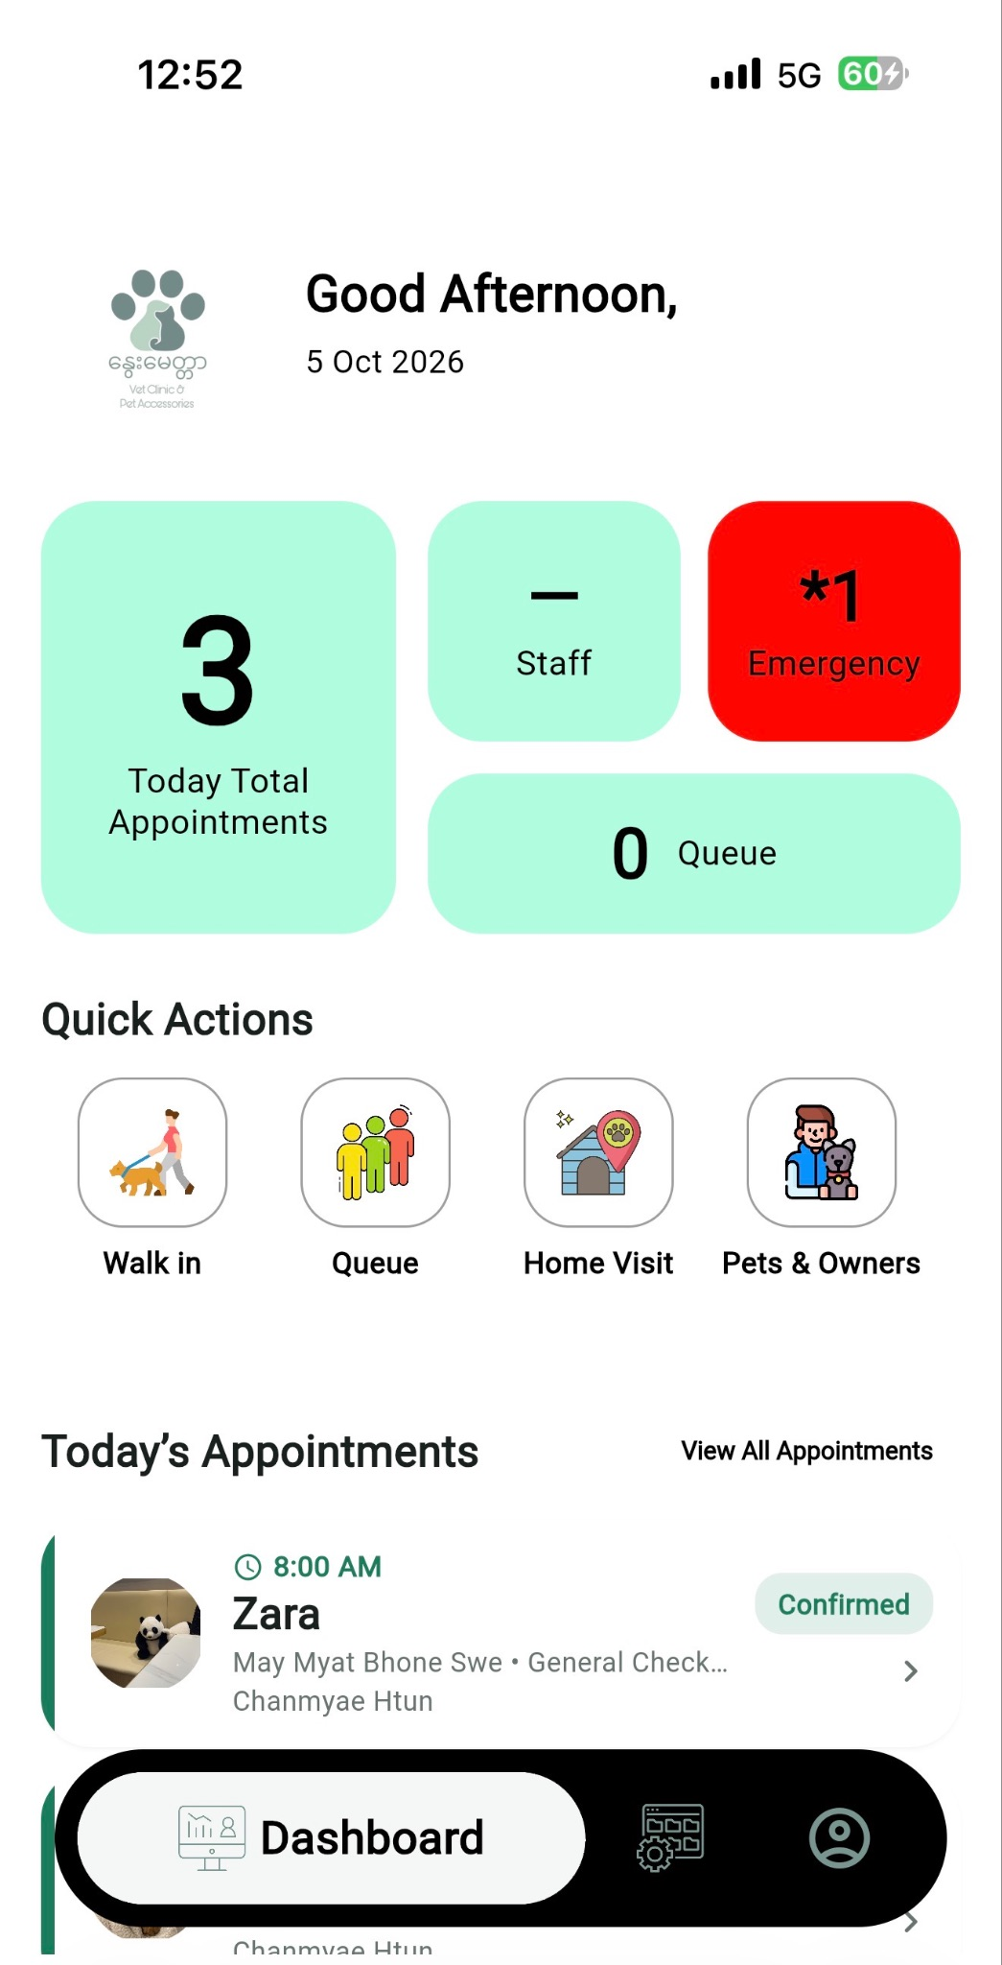
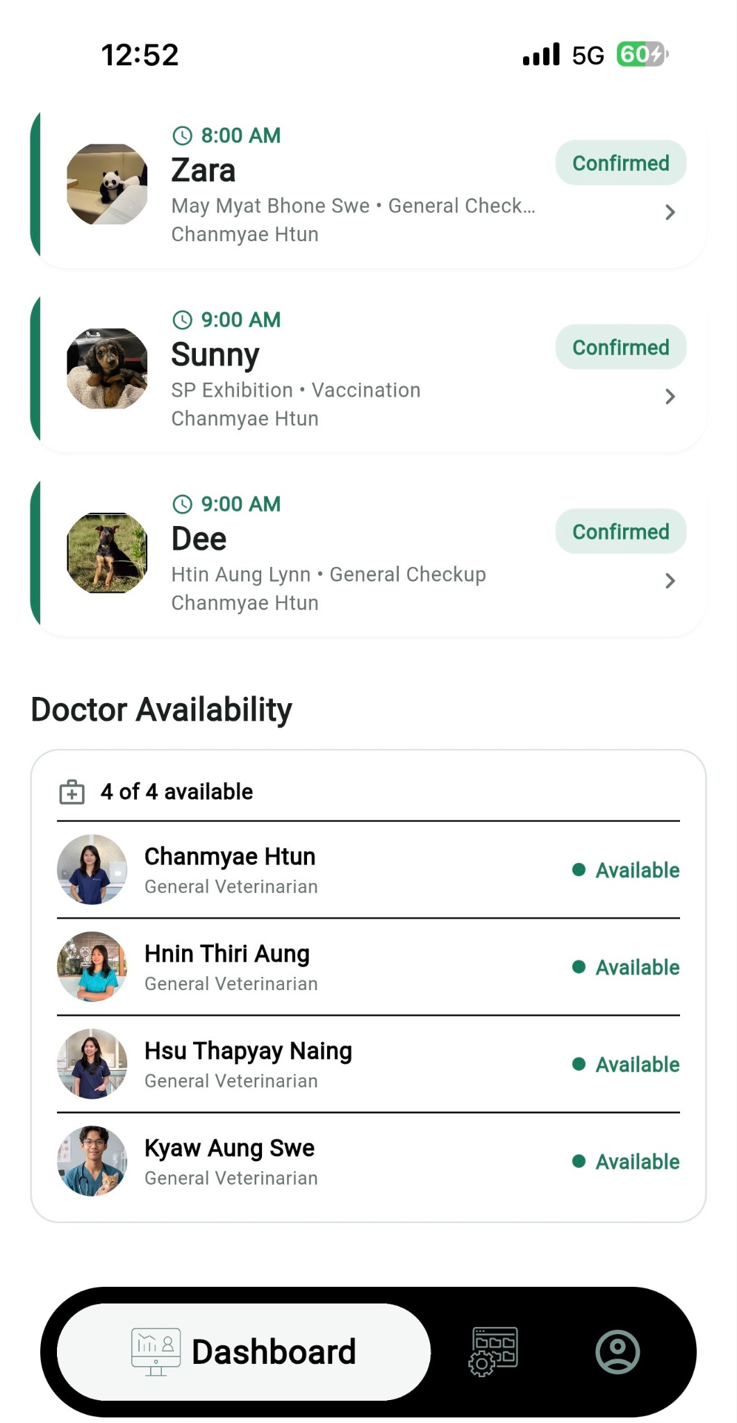
The dashboard provides staff with an overview of daily clinic activities, including appointments, emergency cases, queue status, and doctor availability. Quick actions allow staff to access common functions such as walk-ins, home visits, and pet information.

4.6.4.2 Management

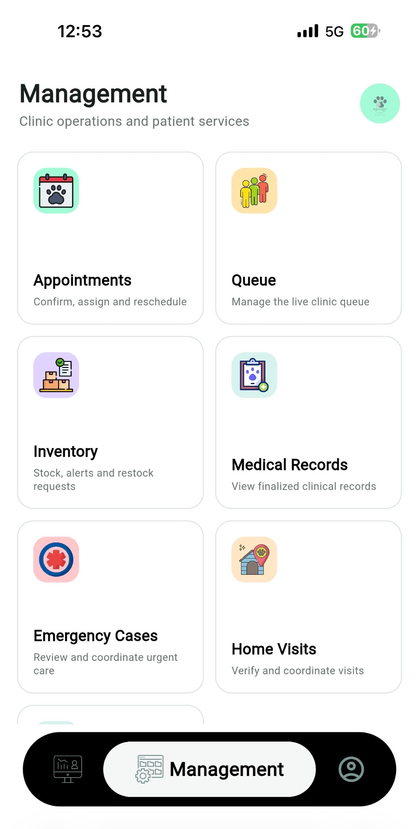
The Management section provides centralized access to appointments, queue management, inventory, medical records, emergency cases, and home visits, helping staff efficiently manage daily clinic operations.

4.6.4.3 Appointments, Home Visit & Emergency Cases

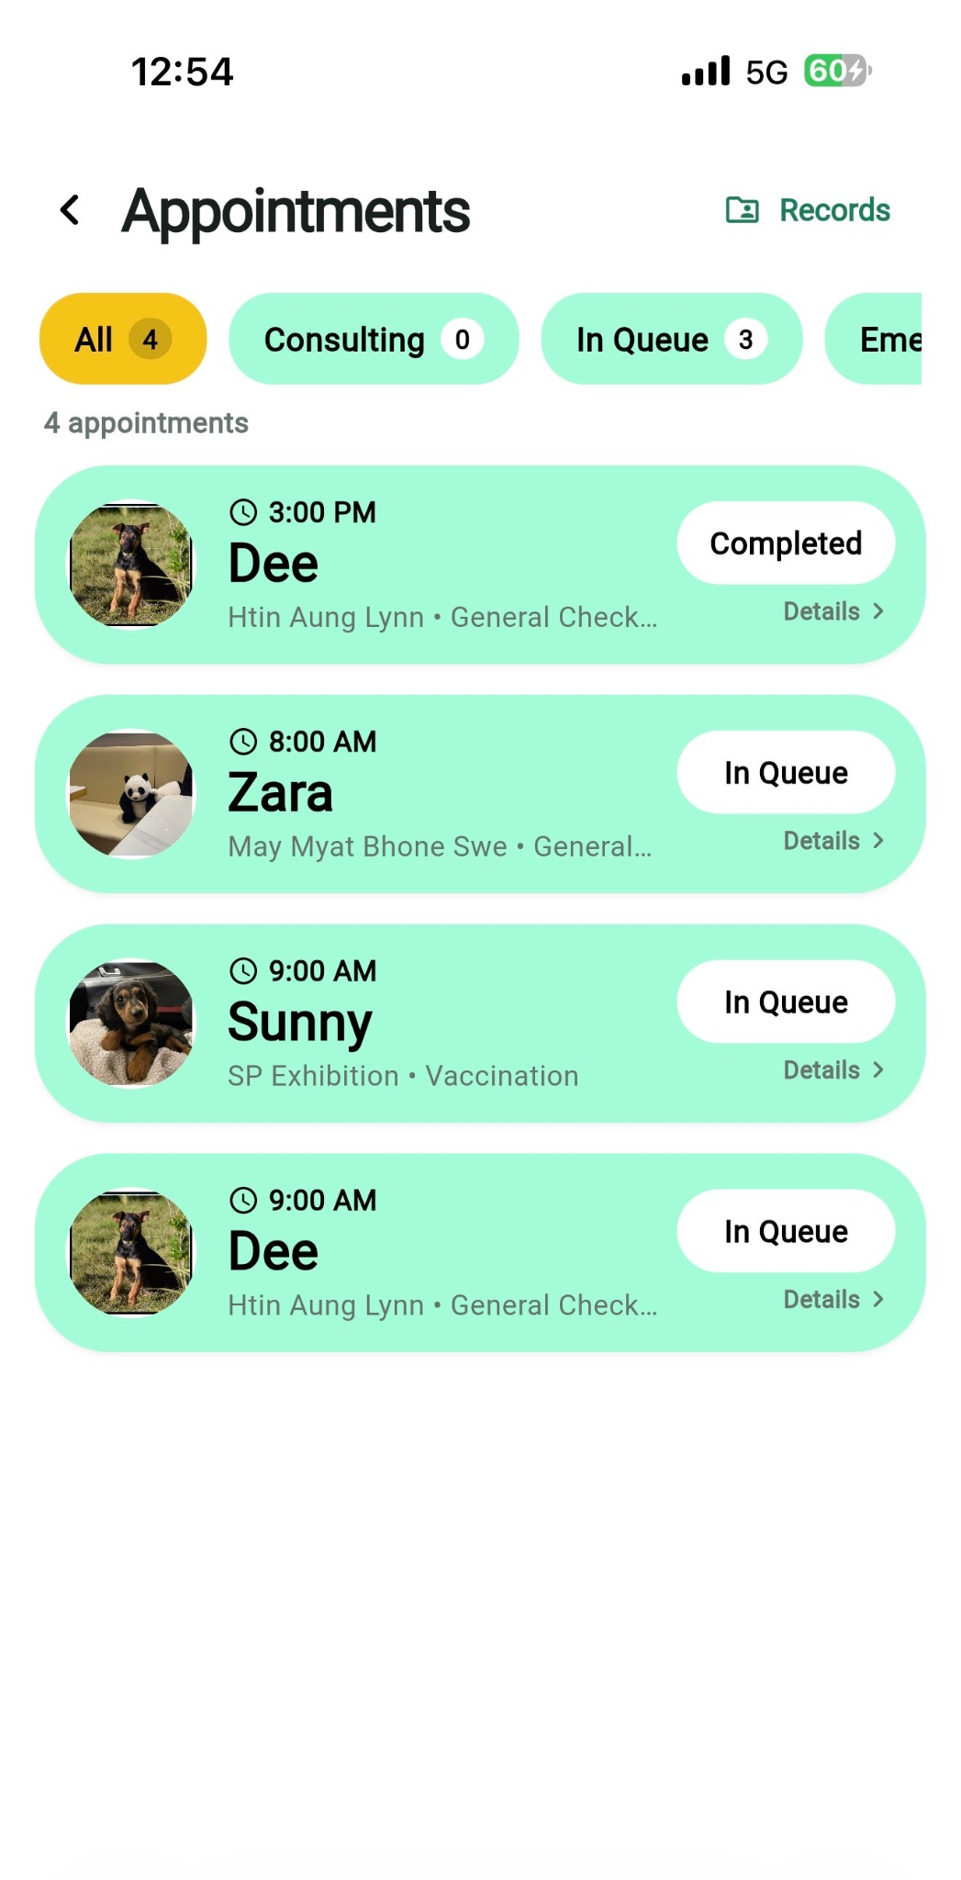
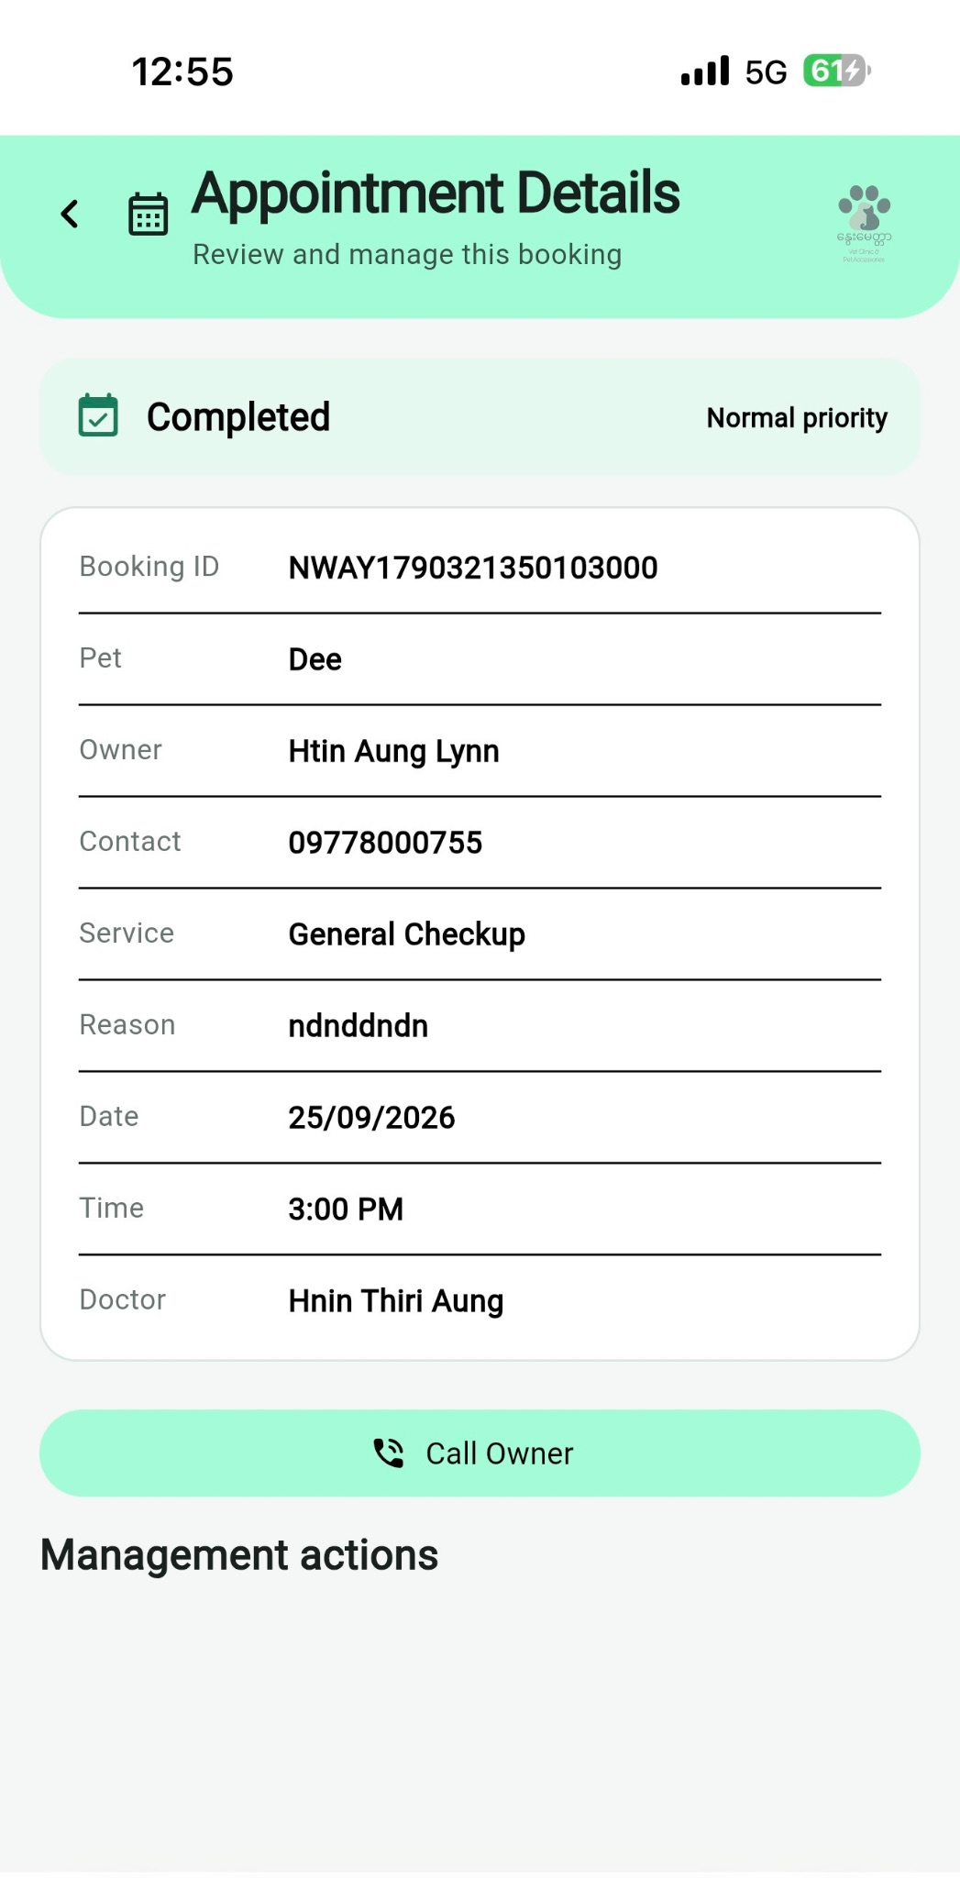
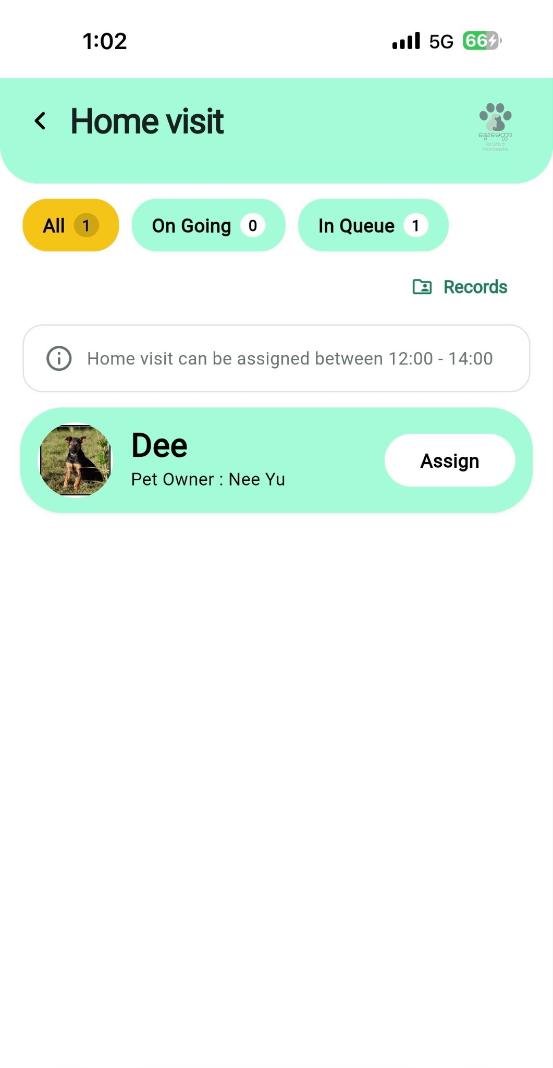
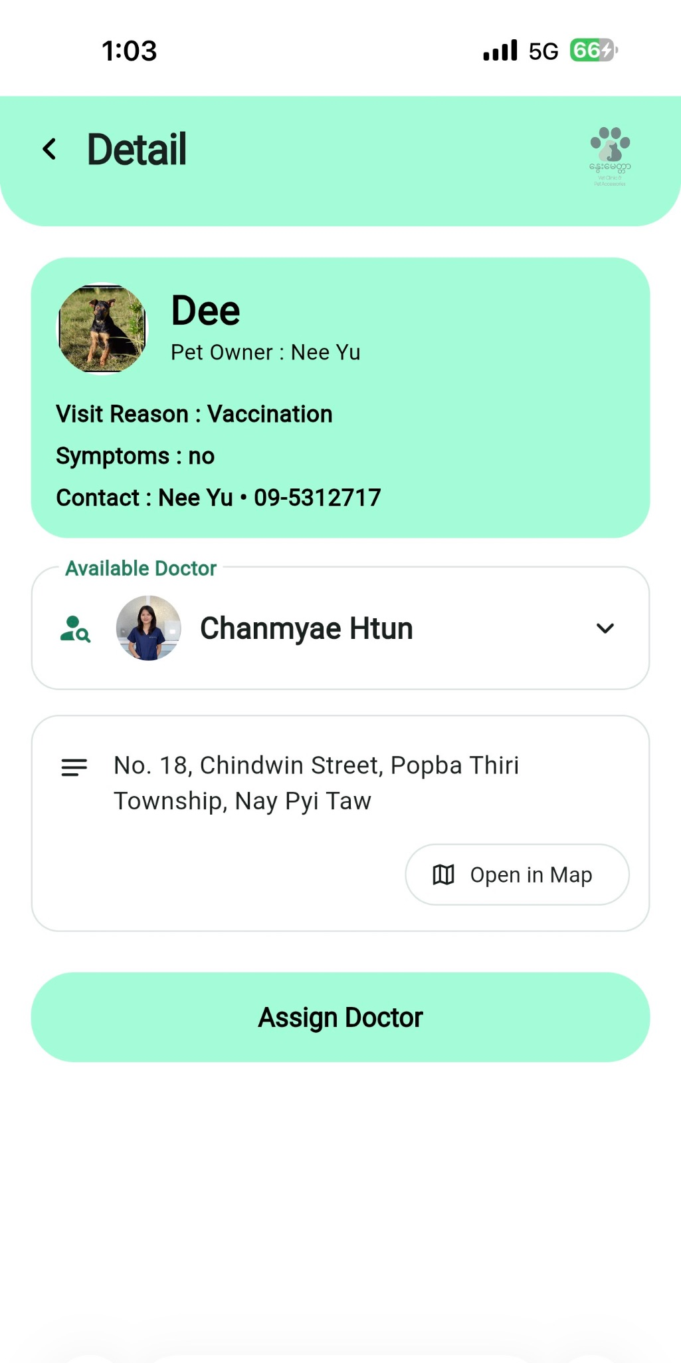
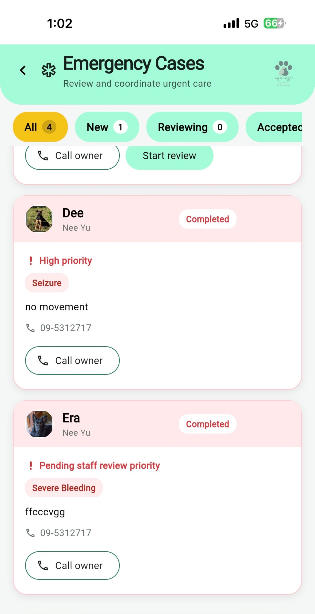

Staff can manage appointments, assign doctors, coordinate home visits, and review emergency cases. Emergency cases are prioritized and clearly highlighted to support faster response and appropriate veterinary care.

4.6.4.4 Inventory
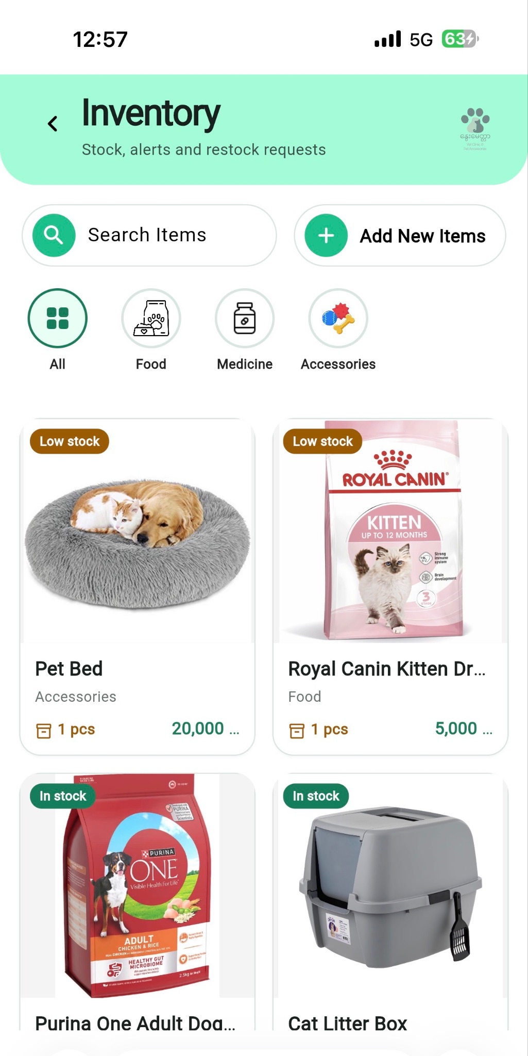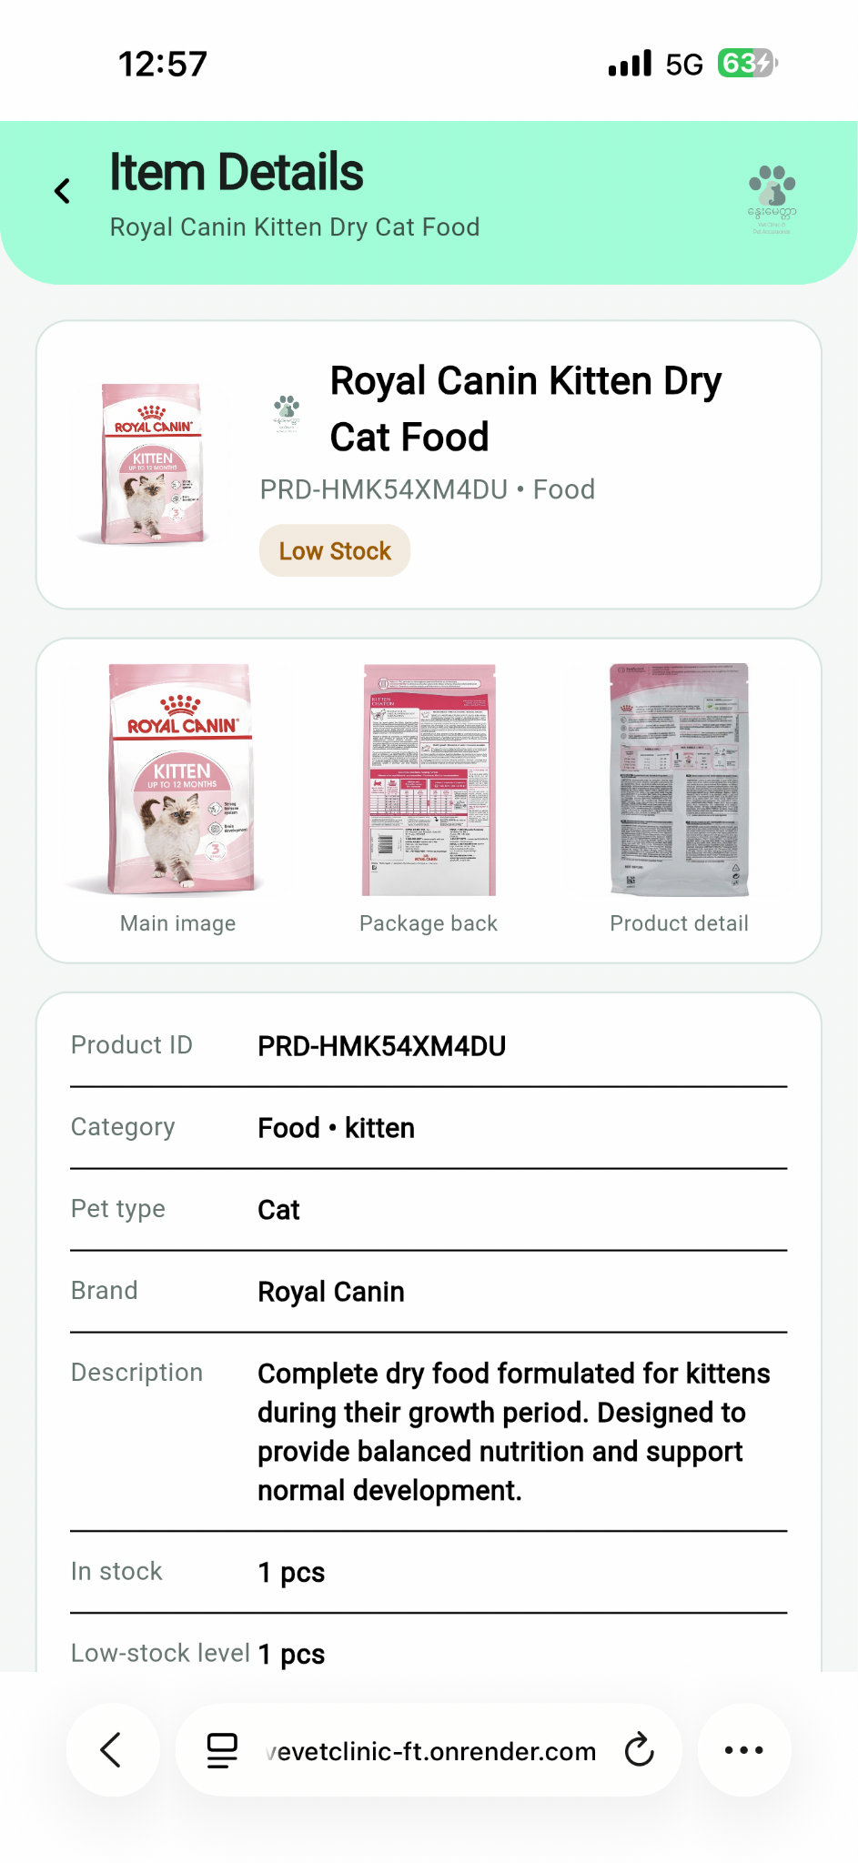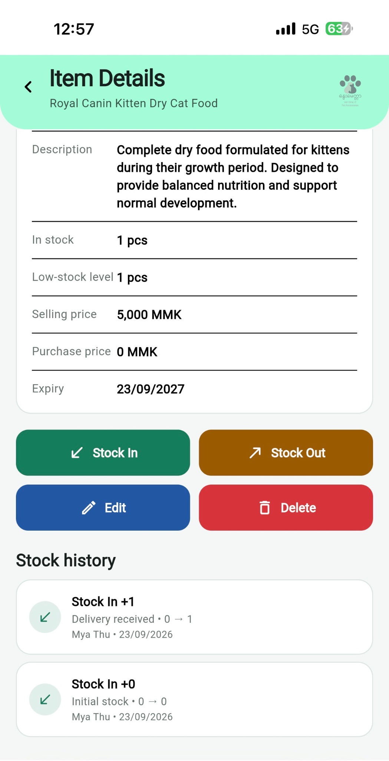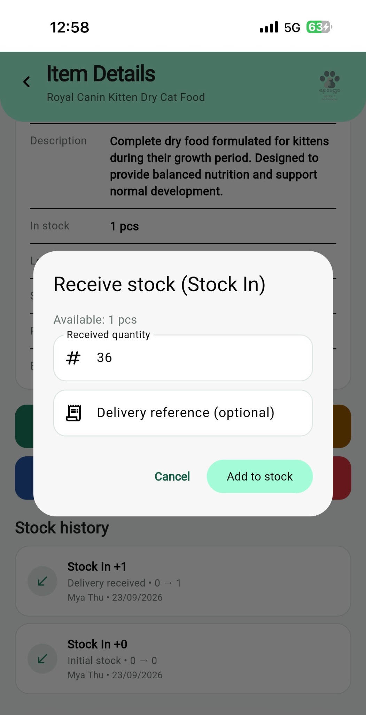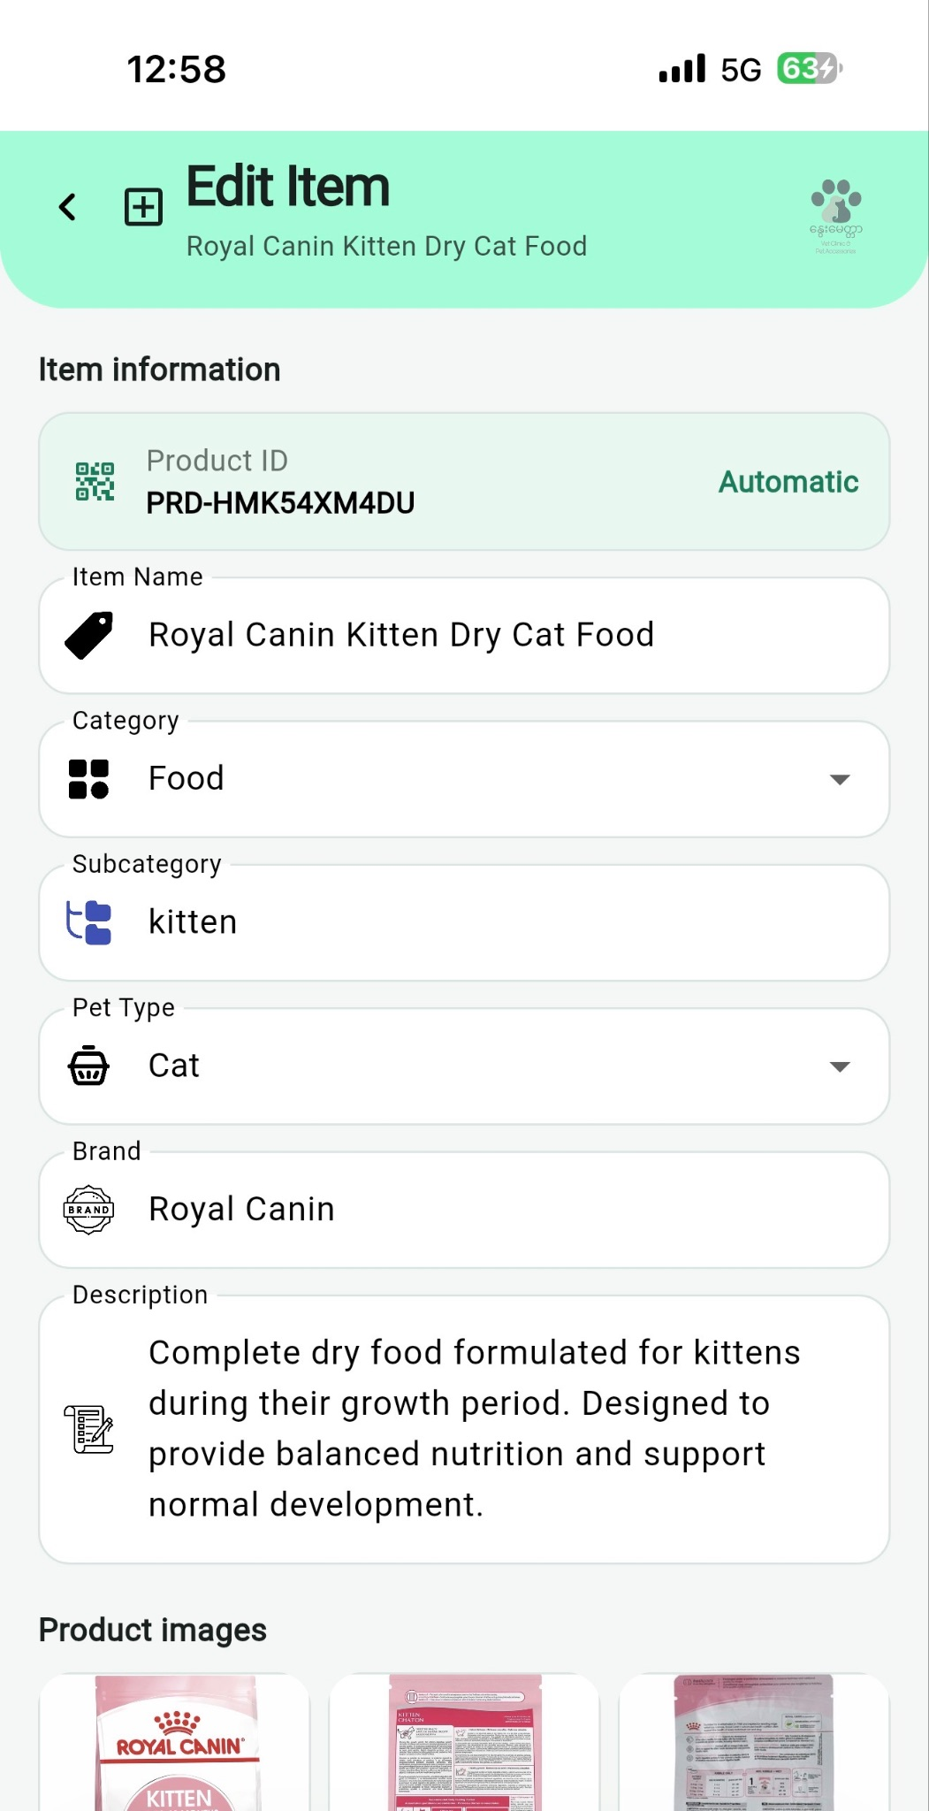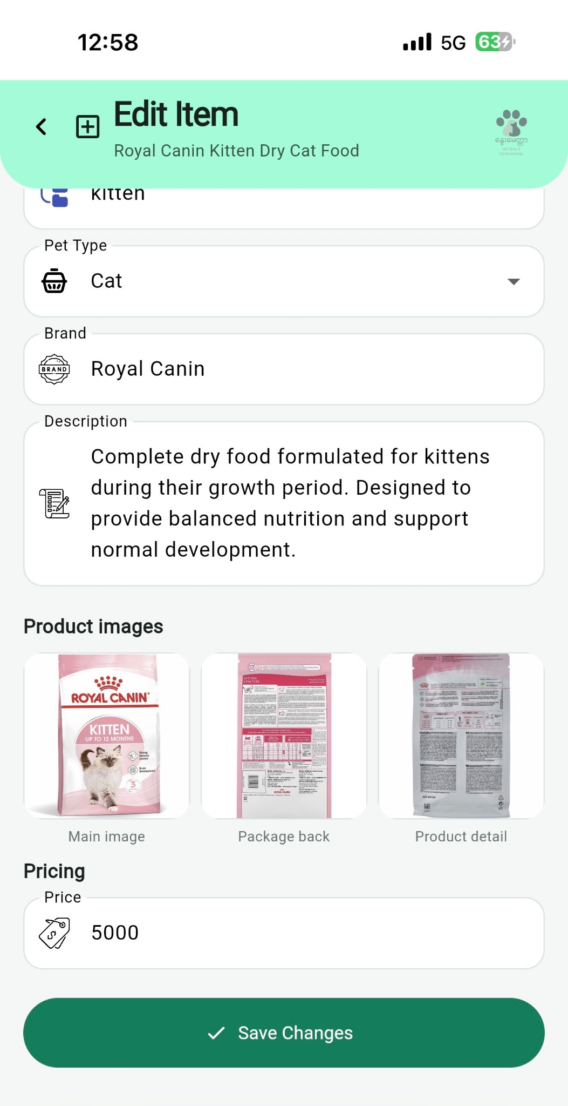
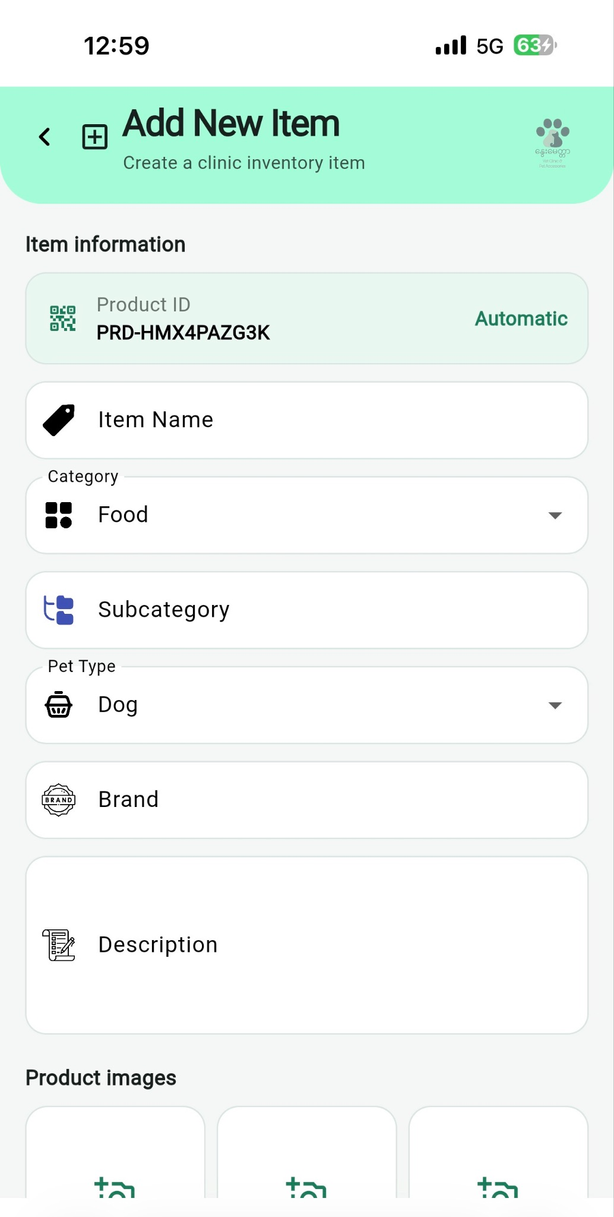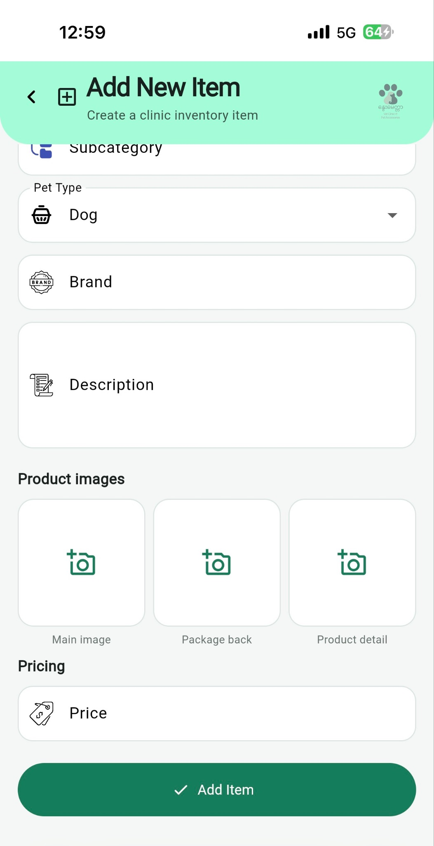

The Inventory module allows staff to add, edit, and monitor products, including food, medicine, and accessories. Staff can manage stock-in and stock-out transactions, view stock history, and identify low-stock items.

4.6.4.5 Medical Records

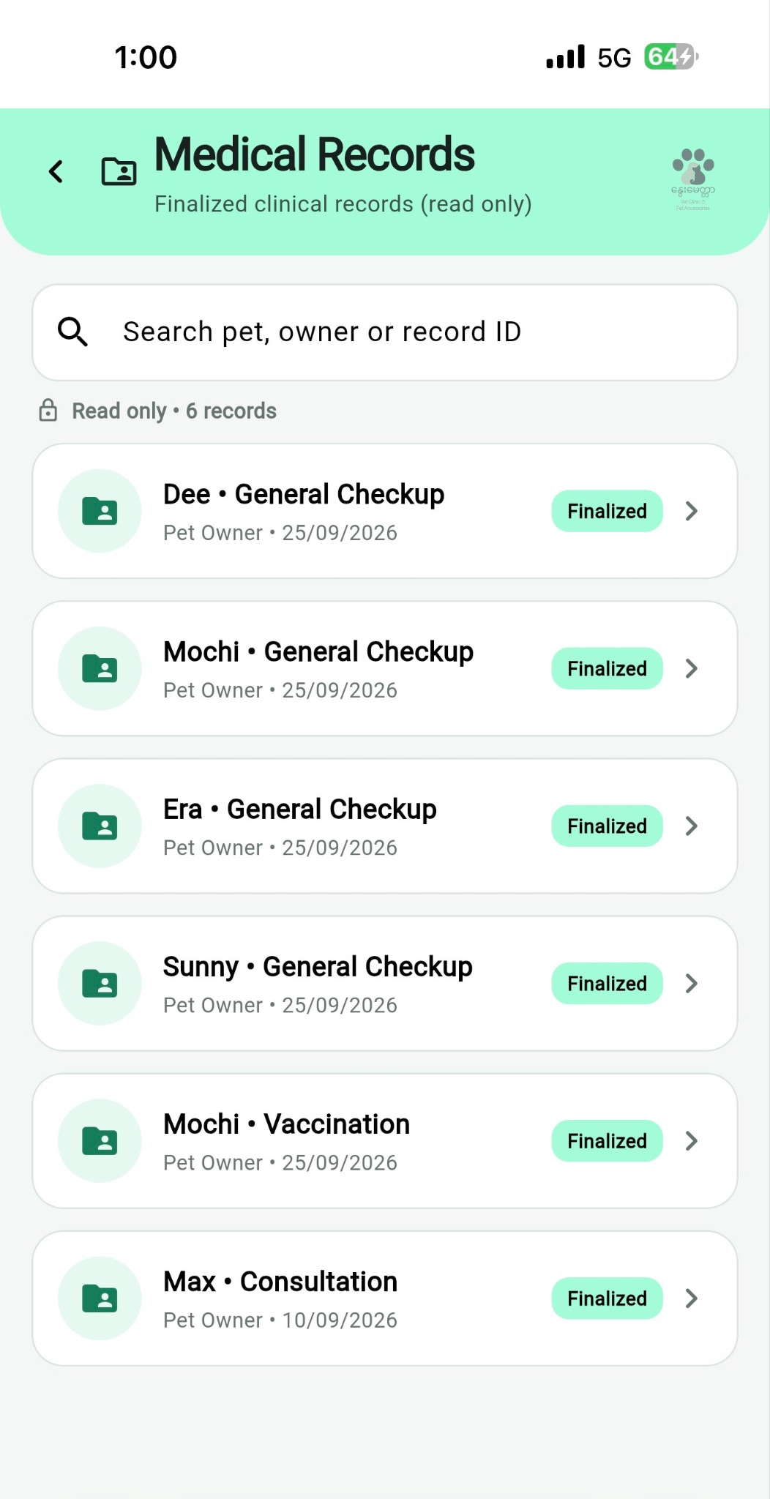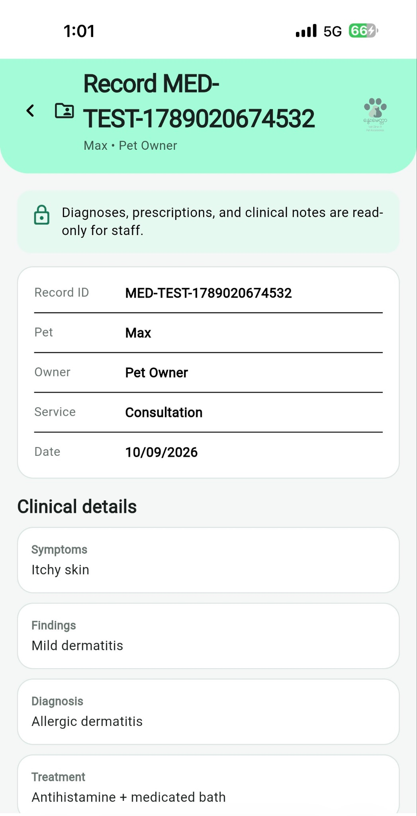

The Medical Records module allows staff to search and view finalized clinical records. Records contain patient information, symptoms, findings, diagnosis, and treatment details and are maintained as read-only information.

4.6.5 Main UI Design of Admin Side
4.6.5.1 Dashboard

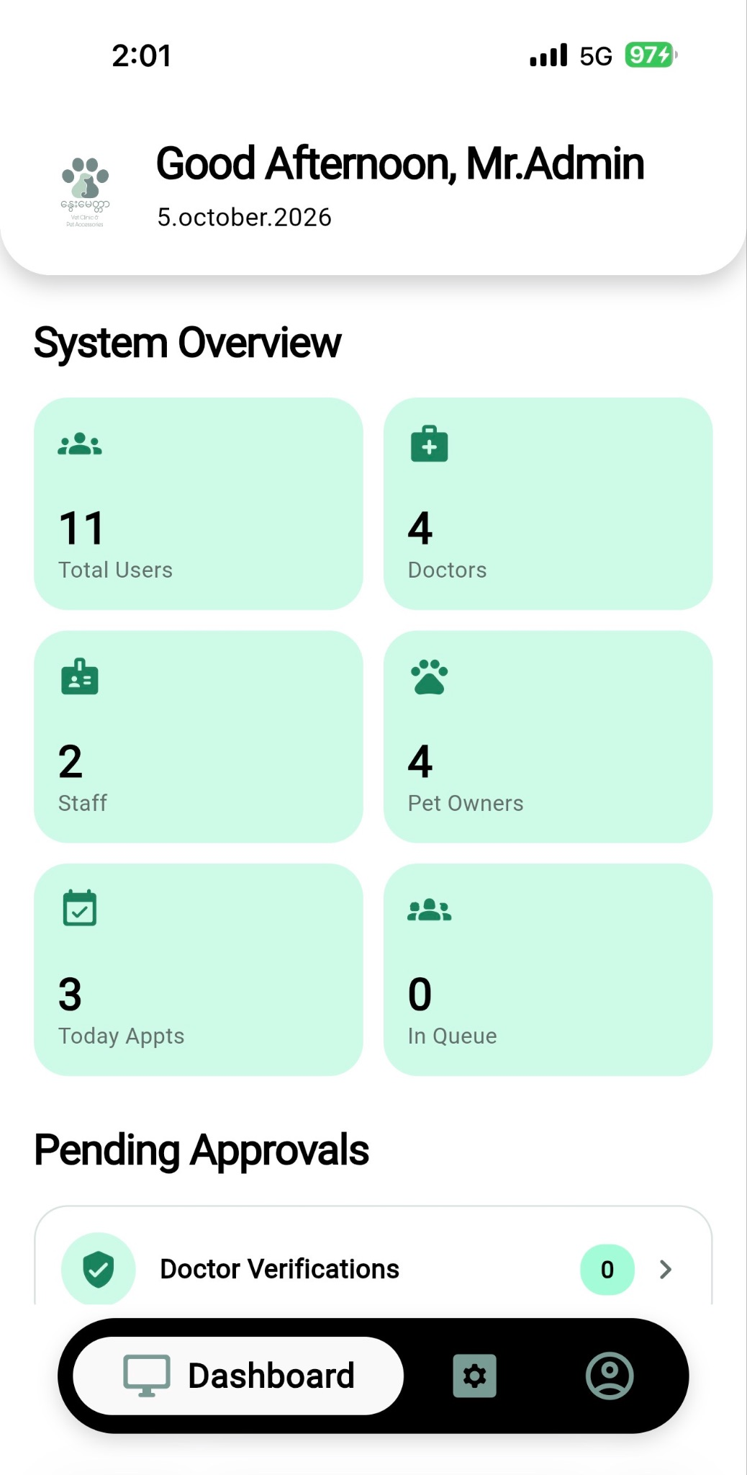
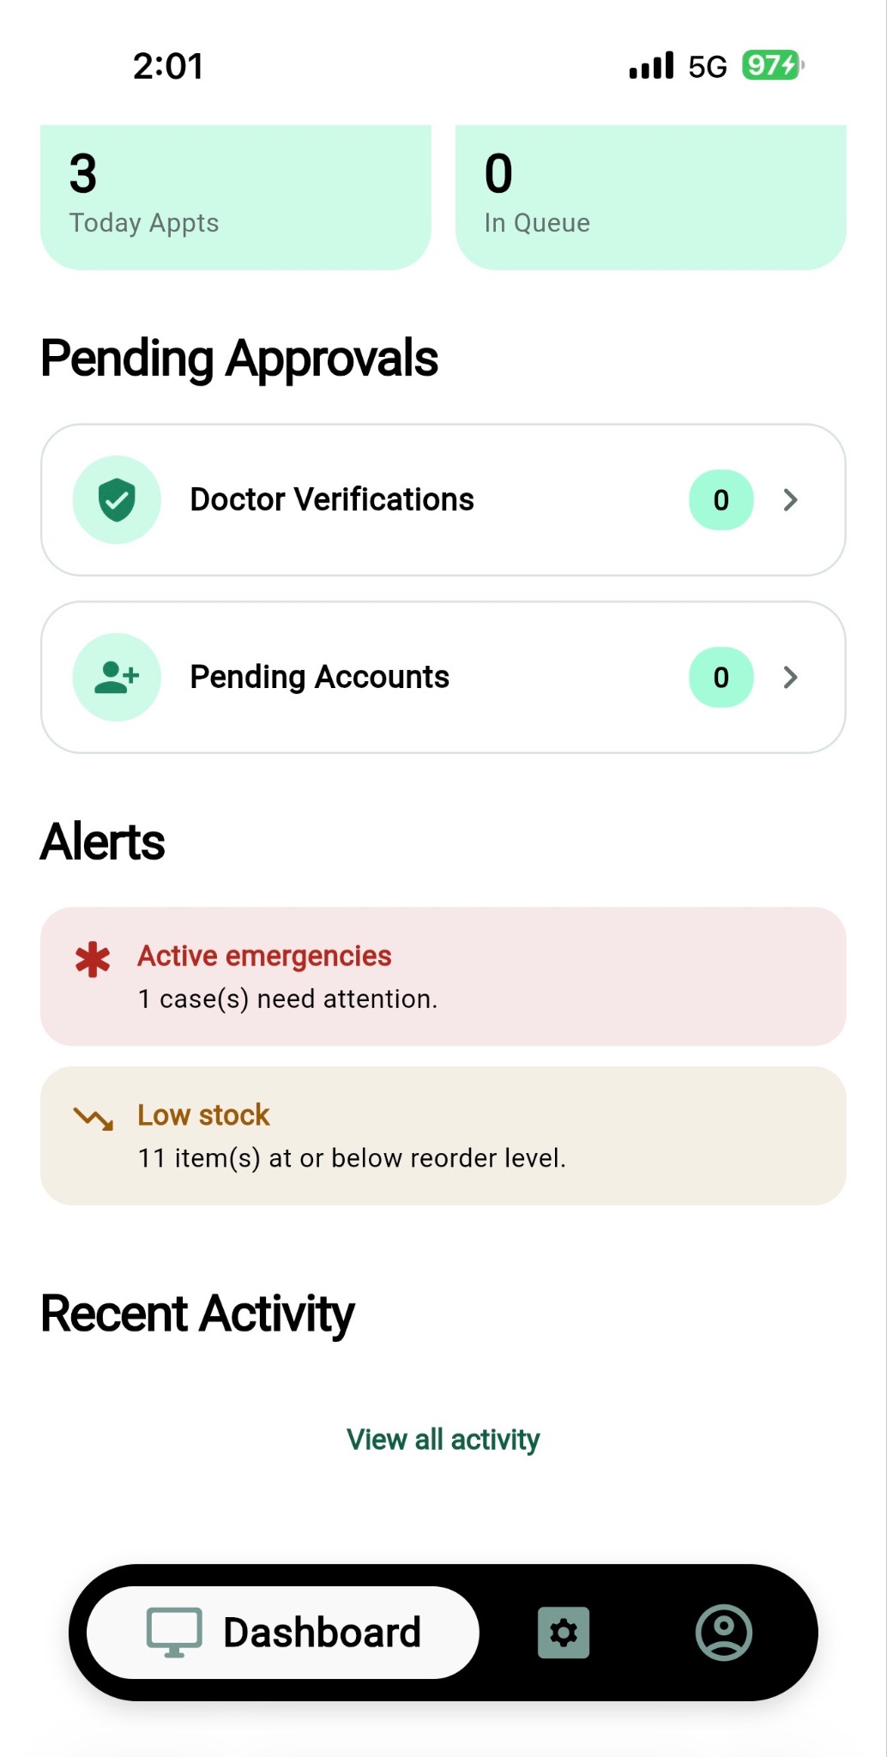

The Admin Dashboard provides an overview of system activities, including total users, doctors, staff, pet owners, appointments, and queue status. It also displays pending approvals, active emergencies, low-stock alerts, and recent system activity.

4.6.5.2 Management

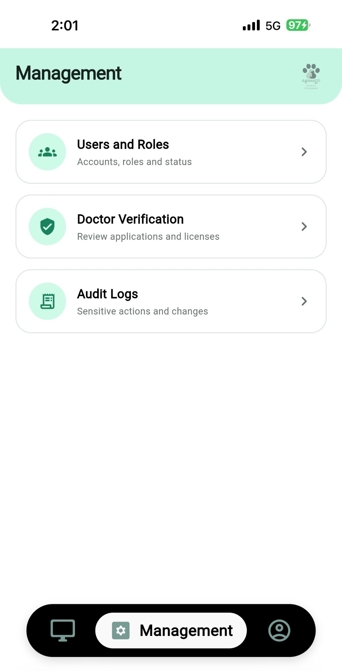

The Management section allows administrators to manage user accounts and roles, verify doctor applications and licenses, and review audit logs. These functions help maintain system security, user access control, and accountability.

4.6.5.3 Users and Roles

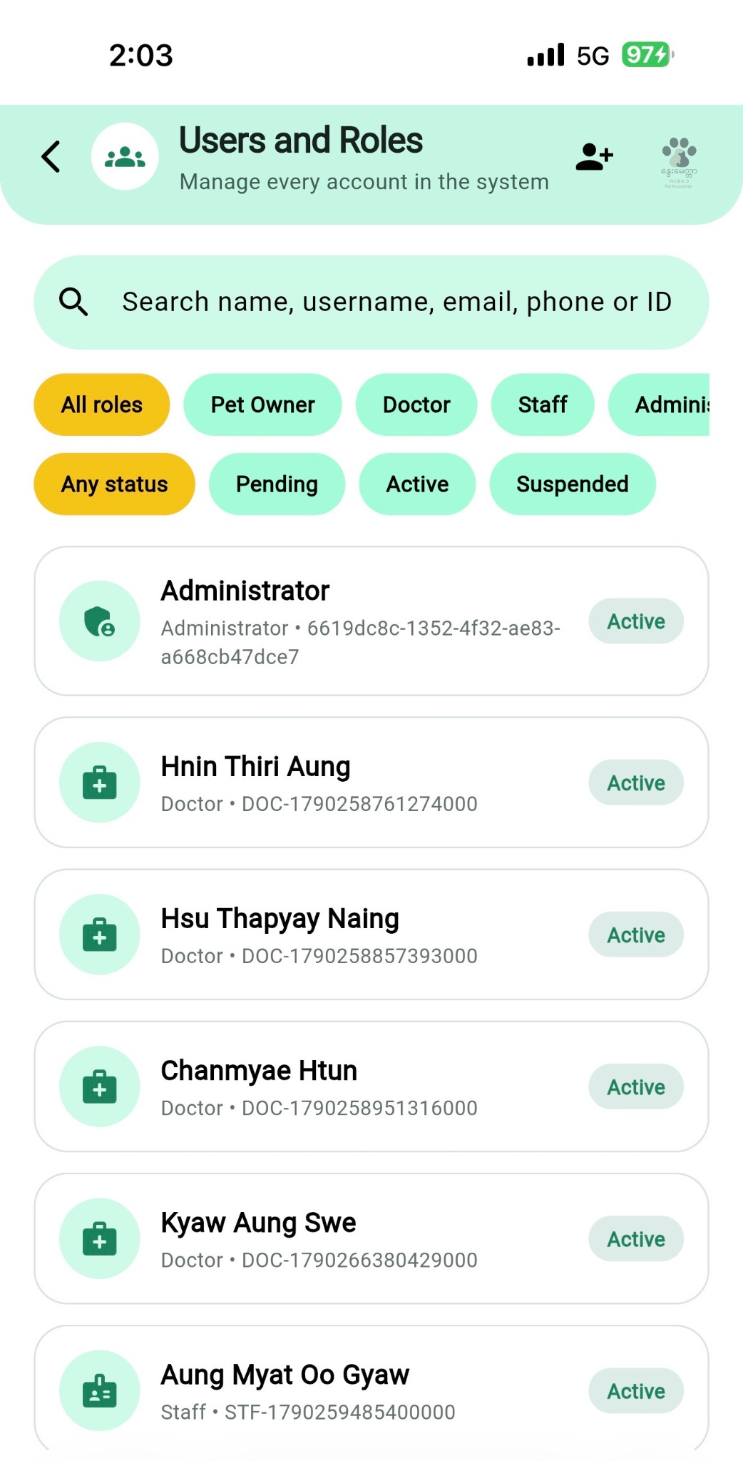
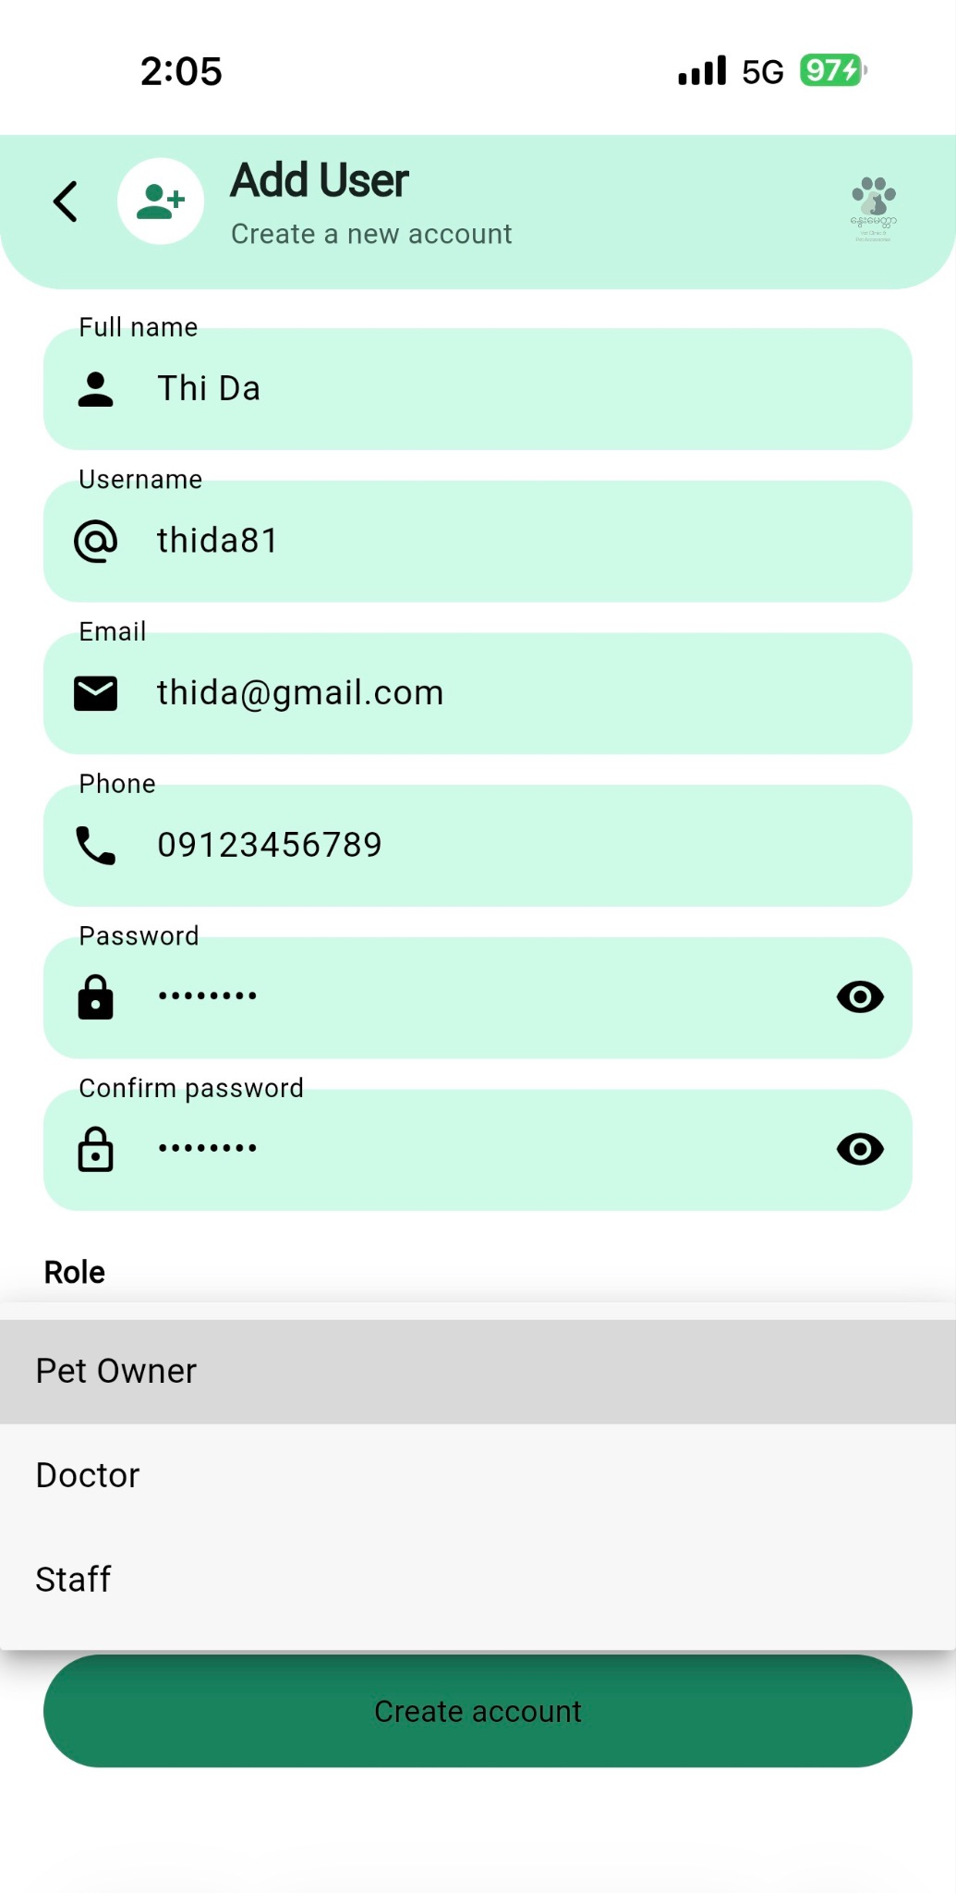

The Users and Roles module allows administrators to manage system accounts by searching and filtering users based on their roles and account status. Administrators can also create new accounts by entering personal information, login credentials, and assigning roles such as Pet Owner, Doctor, or Staff.

Chapter 5: Result and System Demonstration

5.1 Functionality Overview
The Nway’s Love Vet Clinic Management System is designed to provide a centralized platform for managing the main activities of the veterinary clinic. The system supports different functions according to the user's role, including pet owner, veterinarian, clinic staff, and administrator.
The main functions demonstrated in the system include user authentication, pet management, appointment booking, medical records, vaccination tracking, reminders, queue management, home visits, billing, product sales, inventory management, reporting, and administrative management.
The following sections demonstrate the main views and functions of the system.

5.2 Authentication View
The Authentication View provides the login function for users.
Users can enter their account information to access the system. After successful authentication, users are directed to the appropriate interface according to their role.
The authentication function helps protect clinic information by restricting access to authorized users.

5.3 Pet Owner Home View
The Pet Owner Home View provides pet owners with access to the main services of the clinic.
The home interface provides access to:
- Pet profiles
- Appointments
- Medical records
- Vaccination information
- Reminders
- Invoices
- Announcements
The dashboard is designed to allow pet owners to access important information without needing to contact clinic staff for every basic request.
5.4 Appointment View
The Appointment View allows users to manage veterinary appointments.
Pet owners can select an available date and time and request an appointment based on veterinarian availability. The system can also support appointment cancellation and rescheduling.
Clinic staff can manage appointment information and monitor the daily appointment schedule.

5.5 Pet Profile and Medical Record View
The Pet Profile View stores important information about each pet, including:
- Pet name
- Breed
- Age
- Weight
- Owner information
- Medical history
The Medical Record View allows authorized clinic personnel to record and access diagnosis, treatment, and other relevant medical information.
This provides a more organized alternative to maintaining medical information through paper records.

5.6 Vaccination and Reminder View
The Vaccination View allows the clinic to record and monitor a pet's vaccination information.
The system can store vaccination details and the next vaccination date. Reminder functions can notify pet owners about upcoming appointments or vaccinations.
This helps reduce the possibility of missed vaccination schedules and supports better follow-up care.

5.7 Queue and Emergency View
The Queue View helps the clinic organize patients waiting for consultation.
Normal cases can follow a first-come-first-served order, while emergency cases can receive priority when necessary.
The system provides clinic staff and veterinarians with clearer information about the current queue and appointment status.

5.8 Home Visit View
The Home Visit View supports the management of veterinary services provided at the pet owner's location.
Staff can record information related to the pet, owner, service, date, and visit.
Home visits are intended for appropriate treatments and services, while operations are excluded from this service according to the clinic's requirements.

5.9 Billing and Payment View
The Billing and Payment View provides digital billing and invoice management.
The system can record charges such as:
- Consultation fees
- Treatment fees
- Product purchases
- Other applicable service charges
A digital invoice provides a clearer record of the customer's transaction and helps clinic staff manage billing more efficiently.

5.10 Product and Inventory View
The Product and Inventory View allows clinic staff to manage products sold by the clinic, including medicine, pet food, and accessories.
Product information can include:
- Product name
- Category
- Price
- Stock quantity
- Expiry date
The system can update stock after a sale and provide low-stock information to help staff monitor inventory.

5.11 Reporting View
The Reporting View provides organized information about clinic activities.
The system can support reports related to:
- Daily appointments
- Emergency cases
- Vaccination due lists
- Services
- Product sales
- Inventory

5.12 Veterinarian View
The Veterinarian View provides veterinarians with functions related to patient care and appointment management.
Veterinarians can:
- View their appointments
- Check pet information
- Access medical records
- Record diagnosis and treatment
- Manage vaccination information
- Handle emergency cases
- View their schedules
The interface is designed to provide veterinarians with the information required during consultations.

5.13 Clinic Staff Dashboard
The Clinic Staff Dashboard provides access to the main operational functions required by clinic staff.
Staff can manage:
- Appointments
- Patient queues
- Home visits
- Billing
- Products
- Inventory
- Vaccination records
- Announcements
- Reports
The dashboard brings these functions together so that staff do not need to rely on separate manual records for each activity.

5.14 Admin Dashboard
The Admin Dashboard provides administrative control over the system.
The administrator can manage system users, staff access, clinic information, system data, reports, and settings.
The dashboard provides an overview of the system and supports the overall management of the clinic's digital platform.

5.15 Expected Benefits
The implementation of the Nway’s Love Vet Clinic Management System is expected to provide several benefits to the clinic.

Operational Benefits
- Reduces paperwork and manual record keeping.
- Reduces repetitive data entry.
- Makes appointment and queue management more organized.
- Provides faster access to pet medical records.
- Improves vaccination tracking and reminders.
- Provides better inventory visibility.
- Makes billing and invoice management more organized.
- Makes reports easier to retrieve and manage.

Benefits for Pet Owners
- Easier appointment management.
- Easier access to pet information.
- Better vaccination reminders.
- Clearer billing information.
- Improved communication with the clinic through announcements.
- More convenient access to clinic services.

Benefits for Clinic Staff and Veterinarians
- Easier access to appointment schedules.
- More organized medical information.
- Better coordination between clinic roles.
- Reduced manual administrative work.
- Improved access to inventory and billing information.
Overall, the system is expected to improve the efficiency and organization of Nway’s Love Vet Clinic while providing a more convenient service experience for pet owners.

Chapter 6: Conclusion

6.1 Achievements
The Nway’s Love Vet Clinic Management System provides a centralized approach to managing the clinic's main activities.
The project addresses the problems associated with manual appointment booking, paper-based medical records, vaccination tracking, queue management, inventory management, billing, and reporting.
The proposed system brings these activities together in one platform and provides different functions for pet owners, veterinarians, clinic staff, and administrators.
The project also establishes a structured system architecture using Flutter, Node.js, and MySQL, with Figma used for the UI/UX design process.

6.2 Future Work
Future development can improve the system by adding or expanding several functions.
Potential future improvements include:
- More advanced online appointment booking.
- SMS and push notification services.
- More detailed analytics and dashboards.
- Additional digital payment methods.
- Expanded laboratory and inpatient management.
- More advanced inventory and supplier management.
- More detailed financial reporting.
- Improved data backup and recovery.
- Additional security features.
- Additional communication functions if required by the clinic.
These improvements could further expand the system and provide additional support for the clinic's future operations.

6.3 Conclusion
The Nway’s Love Vet Clinic Management System is designed to provide a centralized digital solution for managing veterinary clinic operations. It addresses several limitations of manual processes by organizing appointments, pet information, medical records, vaccination tracking, queues, billing, inventory, and reporting within one system.
The system provides different interfaces and functions according to the responsibilities of pet owners, veterinarians, clinic staff, and administrators. By reducing dependence on paper records and repetitive manual processes, the system is expected to improve operational efficiency, information management, and service quality.
Overall, the project provides a foundation for Nway’s Love Vet Clinic to move toward a more organized and efficient digital management process while allowing the system to be expanded with additional features in the future.

7.References
Coronel, C., & Morris, S. (2023). Database systems: Design, implementation, & management (14th ed.). Cengage Learning. https://www.cengage.com/c/database-systems-design-implementation-management-14e-coronel-morris/9780357673034/
draw.io. (n.d.). Crow’s foot notation for entity relationship diagrams. https://www.drawio.com/docs/tutorials/crows-foot-notation/
Elmasri, R., & Navathe, S. B. (2016). Fundamentals of database systems (7th ed.). Pearson. https://www.pearson.com/en-us/subject-catalog/p/redirected-product/P200000003546/9780133970777
Express.js. (n.d.). Express web framework documentation. https://expressjs.com/
Figma. (n.d.). Guide to prototyping in Figma. https://help.figma.com/hc/en-us/articles/360040314193-Guide-to-prototyping-in-Figma
Firebase. (n.d.). Firebase Authentication. Google. https://firebase.google.com/docs/auth/
Flutter. (n.d.). Flutter documentation. Google. https://docs.flutter.dev/
Meta Platforms, Inc. (n.d.). React documentation. https://react.dev/learn
Neon. (n.d.). Neon documentation. https://neon.com/docs/introduction
Node.js. (n.d.). Introduction to Node.js. OpenJS Foundation. https://nodejs.org/en/learn/getting-started/introduction-to-nodejs
pandas development team. (2026). pandas documentation. https://pandas.pydata.org/docs/
PostgreSQL Global Development Group. (2026). PostgreSQL 18 documentation. https://www.postgresql.org/docs/current/
Python Software Foundation. (n.d.). Python documentation. https://docs.python.org/3/
Render. (n.d.). Web services documentation. https://render.com/docs/web-services
Socket.IO. (n.d.). Socket.IO documentation: Introduction. https://socket.io/docs/v4/

